Why Every DevOps Engineer Should Understand Networking

[(10) Activity | Nusrath Nufais | LinkedIn](https://www.linkedin.com/in/nusrath-nufais-a3308a368/recent-activity/all/)

You can automate, containerise, and deploy all you want...

**[Nusrath Nufais](https://www.linkedin.com/in/nusrath-nufais-a3308a368/)**

| Microsoft Azure | Devops (Docker, Kubernetes , Github, Jenkins, Maven, Linux, Bash and Basic Networking [CCNA]) |

but if you don’t understand networking, you’re flying blind.  
  
Networking isn’t just about IPs and ports. It’s about understanding how your systems actually talk to each other.  
  
Here’s why it matters:  
  
- Debugging: When a service “just won’t connect”, packet flow and DNS knowledge will save you hours.  
  
- Security: Misconfigured ingress rules or open ports can expose your entire stack.  
  
- Performance: Knowing how load balancers, VPCs, and subnets work helps you build faster, more reliable architectures.  
  
- Cloud costs: Data transfer fees between regions and networks add up and networking knowledge helps you design smarter.  
  
You don’t need to be a CCNA-level expert, but you should know enough to understand what’s really happening under the hood.  
  
[**hashtag#devops**](https://www.linkedin.com/search/results/all/?keywords=%23devops&origin=HASH_TAG_FROM_FEED) [**hashtag#networking**](https://www.linkedin.com/search/results/all/?keywords=%23networking&origin=HASH_TAG_FROM_FEED) [**hashtag#cloudengineering**](https://www.linkedin.com/search/results/all/?keywords=%23cloudengineering&origin=HASH_TAG_FROM_FEED)  
[**hashtag#AWS**](https://www.linkedin.com/search/results/all/?keywords=%23aws&origin=HASH_TAG_FROM_FEED) [**hashtag#DevOps**](https://www.linkedin.com/search/results/all/?keywords=%23devops&origin=HASH_TAG_FROM_FEED) [**hashtag#Terraform**](https://www.linkedin.com/search/results/all/?keywords=%23terraform&origin=HASH_TAG_FROM_FEED) [**hashtag#Jenkins**](https://www.linkedin.com/search/results/all/?keywords=%23jenkins&origin=HASH_TAG_FROM_FEED) [**hashtag#Kubernetes**](https://www.linkedin.com/search/results/all/?keywords=%23kubernetes&origin=HASH_TAG_FROM_FEED) [**hashtag#CloudComputing**](https://www.linkedin.com/search/results/all/?keywords=%23cloudcomputing&origin=HASH_TAG_FROM_FEED) [**hashtag#CareerGrowth**](https://www.linkedin.com/search/results/all/?keywords=%23careergrowth&origin=HASH_TAG_FROM_FEED) [**hashtag#InterviewPreparation**](https://www.linkedin.com/search/results/all/?keywords=%23interviewpreparation&origin=HASH_TAG_FROM_FEED)

AWS vs Azure vs Google Cloud – The Ultimate Cloud Comparison Cheat Sheet!   
  
If you’re in Cloud, DevOps, or IT, this one visual will save you hours of confusion.  
  
👉 Compute, Storage, Databases, Networking, Security, DevOps, AI/ML & more – all mapped clearly!  
  
🔑 Whether you’re an engineer, architect, or fresher entering cloud, knowing how services compare across providers is a game-changer.  
  
💡 Save it. Share it. Bookmark it.  
Because the future is multi-cloud and those who master it will lead!  
  
⚡ Which cloud do you prefer — AWS, Azure, or Google Cloud? Comment below!  
  
[**hashtag#CloudComputing**](https://www.linkedin.com/search/results/all/?keywords=%23cloudcomputing&origin=HASH_TAG_FROM_FEED) [**hashtag#AWS**](https://www.linkedin.com/search/results/all/?keywords=%23aws&origin=HASH_TAG_FROM_FEED) [**hashtag#Azure**](https://www.linkedin.com/search/results/all/?keywords=%23azure&origin=HASH_TAG_FROM_FEED) [**hashtag#GoogleCloud**](https://www.linkedin.com/search/results/all/?keywords=%23googlecloud&origin=HASH_TAG_FROM_FEED) [**hashtag#DevOps**](https://www.linkedin.com/search/results/all/?keywords=%23devops&origin=HASH_TAG_FROM_FEED) [**hashtag#MultiCloud**](https://www.linkedin.com/search/results/all/?keywords=%23multicloud&origin=HASH_TAG_FROM_FEED) [**hashtag#CloudEngineer**](https://www.linkedin.com/search/results/all/?keywords=%23cloudengineer&origin=HASH_TAG_FROM_FEED) [**hashtag#CloudArchitecture**](https://www.linkedin.com/search/results/all/?keywords=%23cloudarchitecture&origin=HASH_TAG_FROM_FEED) [**hashtag#CloudCommunity**](https://www.linkedin.com/search/results/all/?keywords=%23cloudcommunity&origin=HASH_TAG_FROM_FEED) [**hashtag#DataEngineering**](https://www.linkedin.com/search/results/all/?keywords=%23dataengineering&origin=HASH_TAG_FROM_FEED) [**hashtag#SaaS**](https://www.linkedin.com/search/results/all/?keywords=%23saas&origin=HASH_TAG_FROM_FEED) [**hashtag#AI**](https://www.linkedin.com/search/results/all/?keywords=%23ai&origin=HASH_TAG_FROM_FEED) [**hashtag#MachineLearning**](https://www.linkedin.com/search/results/all/?keywords=%23machinelearning&origin=HASH_TAG_FROM_FEED) [**hashtag#Kubernetes**](https://www.linkedin.com/search/results/all/?keywords=%23kubernetes&origin=HASH_TAG_FROM_FEED) [**hashtag#Serverless**](https://www.linkedin.com/search/results/all/?keywords=%23serverless&origin=HASH_TAG_FROM_FEED) [**hashtag#TechCommunity**](https://www.linkedin.com/search/results/all/?keywords=%23techcommunity&origin=HASH_TAG_FROM_FEED) [**hashtag#CloudSecurity**](https://www.linkedin.com/search/results/all/?keywords=%23cloudsecurity&origin=HASH_TAG_FROM_FEED) [**hashtag#ITCareer**](https://www.linkedin.com/search/results/all/?keywords=%23itcareer&origin=HASH_TAG_FROM_FEED) [**hashtag#BigData**](https://www.linkedin.com/search/results/all/?keywords=%23bigdata&origin=HASH_TAG_FROM_FEED)

Activate to view larger image,

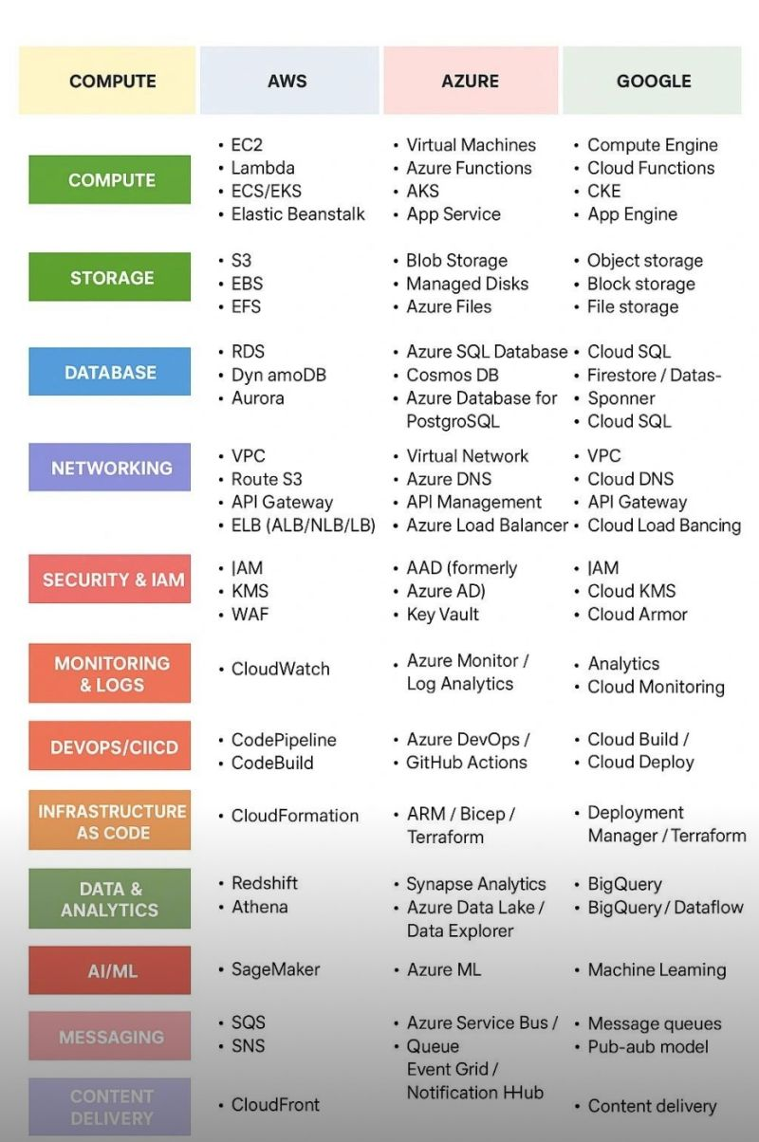

Want to Build a Career in Cloud, DevOps or SRE .But Don’t Know Where to Start?  
  
You’re not alone. Most people jump straight into Kubernetes, Terraform, or AWS certifications… and end up feeling overwhelmed.  
  
The truth is the cloud has layers. And when you learn in the wrong order, everything feels confusing.  
  
That’s why this visual is powerful:  
It lays out the exact progression path to master Cloud roles:  
1. Linux — Terminal, File system, Shell scripting  
2. Networking — DNS, TLS, HTTP/S, Ports, Load Balancing  
3. Cloud Platforms — AWS / Azure / GCP core services  
4. Security — IAM, Encryption, Zero Trust fundamentals  
5. Containers & Orchestration — Docker → Kubernetes → Service Mesh  
6. Infrastructure as Code — Terraform, Ansible, CloudFormation  
7. Observability — Metrics, Logging, Tracing (Grafana, Prometheus, ELK)  
8. CI/CD & GitOps — Jenkins, GitHub Actions, ArgoCD, Flux.  
  
If you’re serious about Cloud / DevOps / Site Reliability Engineering:  
Focus on understanding the each layer not just the tools. Because tools change but foundations don’t.  
  
  
[**hashtag#cloudcomputing**](https://www.linkedin.com/search/results/all/?keywords=%23cloudcomputing&origin=HASH_TAG_FROM_FEED) [**hashtag#devops**](https://www.linkedin.com/search/results/all/?keywords=%23devops&origin=HASH_TAG_FROM_FEED) [**hashtag#sre**](https://www.linkedin.com/search/results/all/?keywords=%23sre&origin=HASH_TAG_FROM_FEED) [**hashtag#aws**](https://www.linkedin.com/search/results/all/?keywords=%23aws&origin=HASH_TAG_FROM_FEED) [**hashtag#azure**](https://www.linkedin.com/search/results/all/?keywords=%23azure&origin=HASH_TAG_FROM_FEED) [**hashtag#gcp**](https://www.linkedin.com/search/results/all/?keywords=%23gcp&origin=HASH_TAG_FROM_FEED) [**hashtag#kubernetes**](https://www.linkedin.com/search/results/all/?keywords=%23kubernetes&origin=HASH_TAG_FROM_FEED) [**hashtag#learning**](https://www.linkedin.com/search/results/all/?keywords=%23learning&origin=HASH_TAG_FROM_FEED) [**hashtag#career**](https://www.linkedin.com/search/results/all/?keywords=%23career&origin=HASH_TAG_FROM_FEED) [**hashtag#techjobs**](https://www.linkedin.com/search/results/all/?keywords=%23techjobs&origin=HASH_TAG_FROM_FEED) [**hashtag#cloudarchitecture**](https://www.linkedin.com/search/results/all/?keywords=%23cloudarchitecture&origin=HASH_TAG_FROM_FEED) [**hashtag#infrastructureascode**](https://www.linkedin.com/search/results/all/?keywords=%23infrastructureascode&origin=HASH_TAG_FROM_FEED) [**hashtag#observability**](https://www.linkedin.com/search/results/all/?keywords=%23observability&origin=HASH_TAG_FROM_FEED) [**hashtag#cicd**](https://www.linkedin.com/search/results/all/?keywords=%23cicd&origin=HASH_TAG_FROM_FEED)

Activate to view larger image,



DevOps isn’t just about tools - it’s about engineering depth, automation discipline, and cross-functional ownership. After years of mentoring engineers and building DevOps teams, I’ve distilled a 9-phase roadmap for becoming a top-tier DevOps professional:  
  
--> Roadmap Overview  
1) OS, Networking, Scripting & Git  
2) Virtualization & Containers  
3) Cloud Fundamentals  
4) Infrastructure as Code  
5) CI/CD Automation  
6) Kubernetes (Self + Managed)  
7) Observability & Reliability  
8) DevSecOps & FinOps  
9) Platform Engineering & Leadership  
  
  
[**hashtag#DevOps**](https://www.linkedin.com/search/results/all/?keywords=%23devops&origin=HASH_TAG_FROM_FEED)  
  
[**hashtag#EngineeringLeadership**](https://www.linkedin.com/search/results/all/?keywords=%23engineeringleadership&origin=HASH_TAG_FROM_FEED)  
  
[**hashtag#Cloud**](https://www.linkedin.com/search/results/all/?keywords=%23cloud&origin=HASH_TAG_FROM_FEED)  
  
[**hashtag#Kubernetes**](https://www.linkedin.com/search/results/all/?keywords=%23kubernetes&origin=HASH_TAG_FROM_FEED)  
  
[**hashtag#InfrastructureAsCode**](https://www.linkedin.com/search/results/all/?keywords=%23infrastructureascode&origin=HASH_TAG_FROM_FEED)  
  
[**hashtag#Automation**](https://www.linkedin.com/search/results/all/?keywords=%23automation&origin=HASH_TAG_FROM_FEED)  
  
[**hashtag#DevSecOps**](https://www.linkedin.com/search/results/all/?keywords=%23devsecops&origin=HASH_TAG_FROM_FEED)  
  
[**hashtag#CareerGrowth**](https://www.linkedin.com/search/results/all/?keywords=%23careergrowth&origin=HASH_TAG_FROM_FEED)

-->what do you actually do in DevOps?  
  
That’s probably one of the most common questions people ask DevOps Engineers  
  
So here’s a little bit of what I’ve learned so far  
As a SRE/ DevOps Engineer, so yes — I make mistakes.  
But honestly, every mistake has taught me something new, and that’s the best part of this journey  
  
In DevOps, I have mostly work with cloud providers like AWS, Azure, or GCP.  
Were I provision infrastructure, which isn’t just spinning up a few servers — it’s like building an entire virtual private data center in the cloud  
 (And yeah, I use Terraform for that!)  
A few years ago, most companies ran everything on-premises.  
But now, almost everyone’s moving to the cloud — it’s faster, more scalable, and so much easier to manage.  
  
Once the infrastructure is ready, we move on to server configuration, that’s where Ansible comes in   
  
Then we deploy the applications using CI/CD tools like Jenkins, GitLab CI, or ArgoCD.  
  
Whether it’s a monolithic app or a microservices setup, SRE/ DevOps keeps everything running smoothly. Most modern systems now run on Kubernetes, which handles scaling, load balancing, and automation like magic  
  
After that comes one of the most important parts monitoring. We use Grafana and Prometheus to keep an eye on everything and if something breaks (because something always does), we fix or optimize it as quickly as possible.  
  
At the end of the day, our main goals are simple:  
 1. Keep everything running efficiently  
 2. Ensure apps are always available (24/7 uptime!)  
 3. Continuously improve performance and reliability  
  
That’s the world of SRE/ DevOps from my side. not just coding or deploying, but making sure the entire system behind the scenes runs like clockwork  
  
[**hashtag#DevOps**](https://www.linkedin.com/search/results/all/?keywords=%23devops&origin=HASH_TAG_FROM_FEED) [**hashtag#SRE**](https://www.linkedin.com/search/results/all/?keywords=%23sre&origin=HASH_TAG_FROM_FEED) [**hashtag#CloudComputing**](https://www.linkedin.com/search/results/all/?keywords=%23cloudcomputing&origin=HASH_TAG_FROM_FEED) [**hashtag#AWS**](https://www.linkedin.com/search/results/all/?keywords=%23aws&origin=HASH_TAG_FROM_FEED) [**hashtag#Kubernetes**](https://www.linkedin.com/search/results/all/?keywords=%23kubernetes&origin=HASH_TAG_FROM_FEED) [**hashtag#InfrastructureAsCode**](https://www.linkedin.com/search/results/all/?keywords=%23infrastructureascode&origin=HASH_TAG_FROM_FEED) [**hashtag#Automation**](https://www.linkedin.com/search/results/all/?keywords=%23automation&origin=HASH_TAG_FROM_FEED) [**hashtag#Terraform**](https://www.linkedin.com/search/results/all/?keywords=%23terraform&origin=HASH_TAG_FROM_FEED) [**hashtag#Ansible**](https://www.linkedin.com/search/results/all/?keywords=%23ansible&origin=HASH_TAG_FROM_FEED) [**hashtag#Jenkins**](https://www.linkedin.com/search/results/all/?keywords=%23jenkins&origin=HASH_TAG_FROM_FEED) [**hashtag#GitLabCI**](https://www.linkedin.com/search/results/all/?keywords=%23gitlabci&origin=HASH_TAG_FROM_FEED) [**hashtag#ArgoCD**](https://www.linkedin.com/search/results/all/?keywords=%23argocd&origin=HASH_TAG_FROM_FEED) [**hashtag#Grafana**](https://www.linkedin.com/search/results/all/?keywords=%23grafana&origin=HASH_TAG_FROM_FEED) [**hashtag#Prometheus**](https://www.linkedin.com/search/results/all/?keywords=%23prometheus&origin=HASH_TAG_FROM_FEED)

Monitoring Tools — The Backbone of DevOps Reliability  
In DevOps, monitoring isn’t optional — it’s essential.  
 You can’t improve what you don’t measure.  
A strong monitoring setup helps detect issues early, optimize performance, and reduce downtime. It turns chaos into clarity.  
Here are some go-to tools every DevOps engineer should know:  
 --> Prometheus + Grafana – for real-time metrics and dashboards  
 --> Datadog / Dynatrace / New Relic – for deep application insights  
 --> ELK Stack – for centralized log analytics  
 --> CloudWatch / Azure Monitor / GCP Operations Suite – for cloud-native visibility  
--> Monitoring is not just about uptime — it’s about understanding system behavior.  
Which tools are part of your monitoring stack?  
  
[**hashtag#DevOps**](https://www.linkedin.com/search/results/all/?keywords=%23devops&origin=HASH_TAG_FROM_FEED)  
[**hashtag#Monitoring**](https://www.linkedin.com/search/results/all/?keywords=%23monitoring&origin=HASH_TAG_FROM_FEED)   
[**hashtag#Observability**](https://www.linkedin.com/search/results/all/?keywords=%23observability&origin=HASH_TAG_FROM_FEED)   
[**hashtag#SRE**](https://www.linkedin.com/search/results/all/?keywords=%23sre&origin=HASH_TAG_FROM_FEED)   
[**hashtag#CloudEngineering**](https://www.linkedin.com/search/results/all/?keywords=%23cloudengineering&origin=HASH_TAG_FROM_FEED)  
[**hashtag#Automation**](https://www.linkedin.com/search/results/all/?keywords=%23automation&origin=HASH_TAG_FROM_FEED)

**Reliability Is a Culture, Not Just a Metric  
In every SRE role I’ve worked in, one pattern stands out — reliability doesn’t come from tools alone. It comes from culture.  
You can have the best monitoring stack, the most efficient pipelines, and perfectly written runbooks — but if teams don’t share a mindset of ownership, continuous improvement, and learning from incidents, reliability will always be reactive, not proactive.  
-->Reliability is built when:  
Engineers treat incidents as opportunities, not failures.  
Teams measure user experience, not just uptime.  
Postmortems focus on insights, not blame.  
Tools evolve, platforms change — but a culture of reliability makes every system stronger.--> How does your team reinforce reliability culture beyond the dashboards?**[**hashtag#SRE**](https://www.linkedin.com/search/results/all/?keywords=%23sre&origin=HASH_TAG_FROM_FEED) [**hashtag#DevOps**](https://www.linkedin.com/search/results/all/?keywords=%23devops&origin=HASH_TAG_FROM_FEED) [**hashtag#ReliabilityEngineering**](https://www.linkedin.com/search/results/all/?keywords=%23reliabilityengineering&origin=HASH_TAG_FROM_FEED) [**hashtag#IncidentManagement**](https://www.linkedin.com/search/results/all/?keywords=%23incidentmanagement&origin=HASH_TAG_FROM_FEED) [**hashtag#Observability**](https://www.linkedin.com/search/results/all/?keywords=%23observability&origin=HASH_TAG_FROM_FEED) [**hashtag#Culture**](https://www.linkedin.com/search/results/all/?keywords=%23culture&origin=HASH_TAG_FROM_FEED)

Cost Optimization in the Cloud:  
\*\* “Scalability means nothing if it’s not cost-efficient.”  
As DevOps Engineers, we can make a big business impact by:  
Right-sizing EC2/VMs  
Using Spot Instances or Preemptible VMs  
Automating unused resource cleanup  
Implementing budgets & alerts  
--> Cloud efficiency isn’t about cutting costs; it’s about spending smarter.  
hashtag  
  
[**hashtag#FinOps**](https://www.linkedin.com/search/results/all/?keywords=%23finops&origin=HASH_TAG_FROM_FEED) [**hashtag#CloudCostOptimization**](https://www.linkedin.com/search/results/all/?keywords=%23cloudcostoptimization&origin=HASH_TAG_FROM_FEED) [**hashtag#DevOps**](https://www.linkedin.com/search/results/all/?keywords=%23devops&origin=HASH_TAG_FROM_FEED) [**hashtag#AWS**](https://www.linkedin.com/search/results/all/?keywords=%23aws&origin=HASH_TAG_FROM_FEED) [**hashtag#GCP**](https://www.linkedin.com/search/results/all/?keywords=%23gcp&origin=HASH_TAG_FROM_FEED) [**hashtag#Azure**](https://www.linkedin.com/search/results/all/?keywords=%23azure&origin=HASH_TAG_FROM_FEED)

**Automation Isn’t Just About Speed — It’s About Reliability  
One thing I’ve learned in my DevOps/SRE journey is that automation isn’t just about doing things faster — it’s about doing them consistently and reliably.  
When systems grow, manual intervention becomes a bottleneck. That’s where tools like Terraform, Cloud Build, and CI/CD pipelines change the game — enabling repeatable, version-controlled, and scalable infrastructure.  
But the real value of automation comes when it’s tied to observability — integrating monitoring, alerting, and self-healing mechanisms so systems can react before humans need to.  
--> Whether it’s auto-scaling clusters, running serverless workflows, or orchestrating data pipelines, automation builds the foundation for resilient and predictable systems.  
How are you using automation to improve reliability in your environment?**[**hashtag#DevOps**](https://www.linkedin.com/search/results/all/?keywords=%23devops&origin=HASH_TAG_FROM_FEED)[**hashtag#SRE**](https://www.linkedin.com/search/results/all/?keywords=%23sre&origin=HASH_TAG_FROM_FEED)[**hashtag#Automation**](https://www.linkedin.com/search/results/all/?keywords=%23automation&origin=HASH_TAG_FROM_FEED)[**hashtag#InfrastructureAsCode**](https://www.linkedin.com/search/results/all/?keywords=%23infrastructureascode&origin=HASH_TAG_FROM_FEED)[**hashtag#Terraform**](https://www.linkedin.com/search/results/all/?keywords=%23terraform&origin=HASH_TAG_FROM_FEED)[**hashtag#Cloud**](https://www.linkedin.com/search/results/all/?keywords=%23cloud&origin=HASH_TAG_FROM_FEED)[**hashtag#ReliabilityEngineering**](https://www.linkedin.com/search/results/all/?keywords=%23reliabilityengineering&origin=HASH_TAG_FROM_FEED)

**Scaling Reliability in the Cloud Era  
One of the most exciting parts of working in DevOps/SRE is solving challenges that sit at the intersection of scalability, performance, and cost efficiency.  
Over time, I’ve learned that:  
🔹 Kubernetes/EKS optimization isn’t just about autoscaling—it’s about right-sizing workloads, leveraging spot instances effectively, and aligning resource usage with real demand.  
🔹 Serverless (AWS Lambda & beyond) brings incredible agility, but true value comes from designing event-driven architectures that are resilient under unpredictable traffic spikes.  
🔹 Data platforms (like Redshift ML) aren’t just storage—they can be turned into powerful engines for real-time analytics and detection, provided we integrate models seamlessly into the pipeline.  
For me, Site Reliability Engineering is less about keeping the lights on and more about building self-healing, cost-aware, and intelligent systems that adapt as the business grows.  
💡 Curious to know: What’s one optimization or automation you’ve implemented recently that made a big impact on your systems?**[**hashtag#SRE**](https://www.linkedin.com/search/results/all/?keywords=%23sre&origin=HASH_TAG_FROM_FEED)[**hashtag#DevOps**](https://www.linkedin.com/search/results/all/?keywords=%23devops&origin=HASH_TAG_FROM_FEED)[**hashtag#Cloud**](https://www.linkedin.com/search/results/all/?keywords=%23cloud&origin=HASH_TAG_FROM_FEED)[**hashtag#Kubernetes**](https://www.linkedin.com/search/results/all/?keywords=%23kubernetes&origin=HASH_TAG_FROM_FEED)[**hashtag#AWS**](https://www.linkedin.com/search/results/all/?keywords=%23aws&origin=HASH_TAG_FROM_FEED)[**hashtag#ReliabilityEngineering**](https://www.linkedin.com/search/results/all/?keywords=%23reliabilityengineering&origin=HASH_TAG_FROM_FEED)

**Speed with Stability — The DevOps Balance  
In today’s world, businesses need to move fast. But as DevOps & SRE professionals, we know speed without stability is chaos.  
The real challenge? Delivering faster releases while keeping systems reliable, scalable, and secure.  
That balance comes from:  
 --> Strong CI/CD pipelines  
 --> Scalable cloud infrastructure  
 --> Proactive monitoring & observability  
 --> Continuous learning from incidents  
It’s not about choosing between speed or stability — it’s about building a culture where both thrive together.  
How does your team balance speed and reliability?**[**hashtag#DevOps**](https://www.linkedin.com/search/results/all/?keywords=%23devops&origin=HASH_TAG_FROM_FEED)[**hashtag#SRE**](https://www.linkedin.com/search/results/all/?keywords=%23sre&origin=HASH_TAG_FROM_FEED)[**hashtag#Cloud**](https://www.linkedin.com/search/results/all/?keywords=%23cloud&origin=HASH_TAG_FROM_FEED)[**hashtag#CI\_CD**](https://www.linkedin.com/search/results/all/?keywords=%23ci_cd&origin=HASH_TAG_FROM_FEED)[**hashtag#ReliabilityEngineering**](https://www.linkedin.com/search/results/all/?keywords=%23reliabilityengineering&origin=HASH_TAG_FROM_FEED)[**hashtag#ContinuousImprovement**](https://www.linkedin.com/search/results/all/?keywords=%23continuousimprovement&origin=HASH_TAG_FROM_FEED)

**Activate to view larger image,**

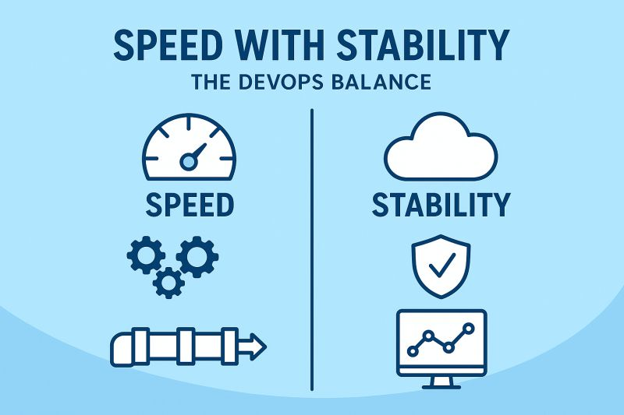

Optimizing Cloud & Driving Reliability at Scale  
In my journey as an SRE/DevOps engineer, I’ve had the chance to work on projects where performance, cost, and reliability were at the center of every decision.  
🔹 I optimized EKS clusters by tuning autoscaling, improving resource utilization, and applying cost-aware scheduling. This not only reduced spend but also enhanced reliability for large-scale workloads.  
🔹 I implemented serverless solutions with AWS Lambda to streamline critical workflows. These solutions improved scalability and responsiveness, especially during peak demand.  
🔹 I also worked with Amazon Redshift ML to build and integrate fraud detection models directly into data pipelines. This proactive approach significantly reduced risks while keeping performance overhead low.  
What I’ve realized is that true Site Reliability Engineering isn’t just about uptime—it’s about building systems that are scalable, cost-efficient, and intelligent enough to adapt to evolving business needs.  
I’d love to hear from others in the community:  
 👉 How do you balance cost, performance, and reliability in your cloud journey?  
[**hashtag#DevOps**](https://www.linkedin.com/search/results/all/?keywords=%23devops&origin=HASH_TAG_FROM_FEED) [**hashtag#SRE**](https://www.linkedin.com/search/results/all/?keywords=%23sre&origin=HASH_TAG_FROM_FEED) [**hashtag#AWS**](https://www.linkedin.com/search/results/all/?keywords=%23aws&origin=HASH_TAG_FROM_FEED) [**hashtag#Kubernetes**](https://www.linkedin.com/search/results/all/?keywords=%23kubernetes&origin=HASH_TAG_FROM_FEED) [**hashtag#Serverless**](https://www.linkedin.com/search/results/all/?keywords=%23serverless&origin=HASH_TAG_FROM_FEED) [**hashtag#CloudEngineering**](https://www.linkedin.com/search/results/all/?keywords=%23cloudengineering&origin=HASH_TAG_FROM_FEED)

Embracing the Future of Cloud & DevOps!  
  
In today’s fast-paced tech world, building resilient, scalable, and secure infrastructure is more critical than ever. As a Cloud & DevOps/SRE professional, I focus on:  
Automating deployment pipelines for faster, error-free releases  
Implementing robust monitoring & observability for reliable systems  
Ensuring security at every stage with DevSecOps practices  
Optimizing cloud-native architectures for performance and cost-efficiency  
The journey to continuous improvement in infrastructure and operations never stops, and collaboration is key to delivering value consistently.  
Remember: Automation is not just a tool—it’s a mindset.  
  
[**hashtag#DevOps**](https://www.linkedin.com/search/results/all/?keywords=%23devops&origin=HASH_TAG_FROM_FEED) [**hashtag#SRE**](https://www.linkedin.com/search/results/all/?keywords=%23sre&origin=HASH_TAG_FROM_FEED) [**hashtag#CloudEngineering**](https://www.linkedin.com/search/results/all/?keywords=%23cloudengineering&origin=HASH_TAG_FROM_FEED) [**hashtag#DevSecOps**](https://www.linkedin.com/search/results/all/?keywords=%23devsecops&origin=HASH_TAG_FROM_FEED) [**hashtag#Kubernetes**](https://www.linkedin.com/search/results/all/?keywords=%23kubernetes&origin=HASH_TAG_FROM_FEED) [**hashtag#Terraform**](https://www.linkedin.com/search/results/all/?keywords=%23terraform&origin=HASH_TAG_FROM_FEED) [**hashtag#CI\_CD**](https://www.linkedin.com/search/results/all/?keywords=%23ci_cd&origin=HASH_TAG_FROM_FEED) [**hashtag#CloudComputing**](https://www.linkedin.com/search/results/all/?keywords=%23cloudcomputing&origin=HASH_TAG_FROM_FEED) [**hashtag#Automation**](https://www.linkedin.com/search/results/all/?keywords=%23automation&origin=HASH_TAG_FROM_FEED) [**hashtag#Observability**](https://www.linkedin.com/search/results/all/?keywords=%23observability&origin=HASH_TAG_FROM_FEED) [**hashtag#InfrastructureAsCode**](https://www.linkedin.com/search/results/all/?keywords=%23infrastructureascode&origin=HASH_TAG_FROM_FEED) [**hashtag#SecurityByDesign**](https://www.linkedin.com/search/results/all/?keywords=%23securitybydesign&origin=HASH_TAG_FROM_FEED)

**Reliability is everyone’s responsibility  
In Site Reliability Engineering and DevOps, success isn’t just about tools—it’s about collaboration.  
 No single person can guarantee 99.9% uptime alone. It takes:  
--> Developers building with reliability in mind  
--> Ops teams automating and scaling infrastructure  
--> Product teams prioritizing user experience  
--> A culture where learning from incidents is encouraged, not blamed  
When teams work together with shared responsibility, reliability becomes part of the DNA, not just an afterthought.  
  
What’s one way your team encourages a reliability-first mindset?**[**hashtag#DevOps**](https://www.linkedin.com/search/results/all/?keywords=%23devops&origin=HASH_TAG_FROM_FEED)[**hashtag#SRE**](https://www.linkedin.com/search/results/all/?keywords=%23sre&origin=HASH_TAG_FROM_FEED)[**hashtag#Collaboration**](https://www.linkedin.com/search/results/all/?keywords=%23collaboration&origin=HASH_TAG_FROM_FEED)[**hashtag#ReliabilityEngineering**](https://www.linkedin.com/search/results/all/?keywords=%23reliabilityengineering&origin=HASH_TAG_FROM_FEED)[**hashtag#Cloud**](https://www.linkedin.com/search/results/all/?keywords=%23cloud&origin=HASH_TAG_FROM_FEED)[**hashtag#Teamwork**](https://www.linkedin.com/search/results/all/?keywords=%23teamwork&origin=HASH_TAG_FROM_FEED)

Cloud isn’t just infrastructure — it’s innovation  
Over the years, I’ve seen how cloud platforms (AWS, Azure, GCP) have transformed the way we think about scalability, automation, and reliability.  
It’s no longer about just running servers — it’s about:  
 --> Building resilient, self-healing systems  
 --> Scaling globally in minutes, not months  
 --> Designing with security and compliance in mind  
 --> Leveraging observability to make smarter decisions  
For DevOps & SRE, cloud isn’t only a platform — it’s the foundation of reliability and speed.  
What’s your go-to cloud practice that makes the biggest difference in your systems?  
[**hashtag#DevOps**](https://www.linkedin.com/search/results/all/?keywords=%23devops&origin=HASH_TAG_FROM_FEED) [**hashtag#SRE**](https://www.linkedin.com/search/results/all/?keywords=%23sre&origin=HASH_TAG_FROM_FEED) [**hashtag#Cloud**](https://www.linkedin.com/search/results/all/?keywords=%23cloud&origin=HASH_TAG_FROM_FEED) [**hashtag#AWS**](https://www.linkedin.com/search/results/all/?keywords=%23aws&origin=HASH_TAG_FROM_FEED) [**hashtag#Azure**](https://www.linkedin.com/search/results/all/?keywords=%23azure&origin=HASH_TAG_FROM_FEED) [**hashtag#GCP**](https://www.linkedin.com/search/results/all/?keywords=%23gcp&origin=HASH_TAG_FROM_FEED) [**hashtag#Automation**](https://www.linkedin.com/search/results/all/?keywords=%23automation&origin=HASH_TAG_FROM_FEED) [**hashtag#Reliability**](https://www.linkedin.com/search/results/all/?keywords=%23reliability&origin=HASH_TAG_FROM_FEED)

* 3

As a DevOps & SRE professional, I’ve learned that automation isn’t just about saving time—it’s about creating consistency, reducing risk, and building confidence in every deployment.  
Whether it’s:  
\*\*Automating infrastructure with Terraform and Ansible  
\*\*Streamlining CI/CD pipelines with Jenkins and GitHub Actions  
\*\*Or scaling Kubernetes clusters to handle unpredictable workloads  
…every automated workflow is a step toward a more resilient system.  
The real value? Teams can innovate faster while knowing the foundation is strong.   
  
-->What’s one process you’ve automated recently that made the biggest impact?  
[**hashtag#DevOps**](https://www.linkedin.com/search/results/all/?keywords=%23devops&origin=HASH_TAG_FROM_FEED) [**hashtag#SRE**](https://www.linkedin.com/search/results/all/?keywords=%23sre&origin=HASH_TAG_FROM_FEED) [**hashtag#Automation**](https://www.linkedin.com/search/results/all/?keywords=%23automation&origin=HASH_TAG_FROM_FEED) [**hashtag#CI\_CD**](https://www.linkedin.com/search/results/all/?keywords=%23ci_cd&origin=HASH_TAG_FROM_FEED) [**hashtag#Kubernetes**](https://www.linkedin.com/search/results/all/?keywords=%23kubernetes&origin=HASH_TAG_FROM_FEED) [**hashtag#Cloud**](https://www.linkedin.com/search/results/all/?keywords=%23cloud&origin=HASH_TAG_FROM_FEED) [**hashtag#ReliabilityEngineering**](https://www.linkedin.com/search/results/all/?keywords=%23reliabilityengineering&origin=HASH_TAG_FROM_FEED)

Activate to view larger image,

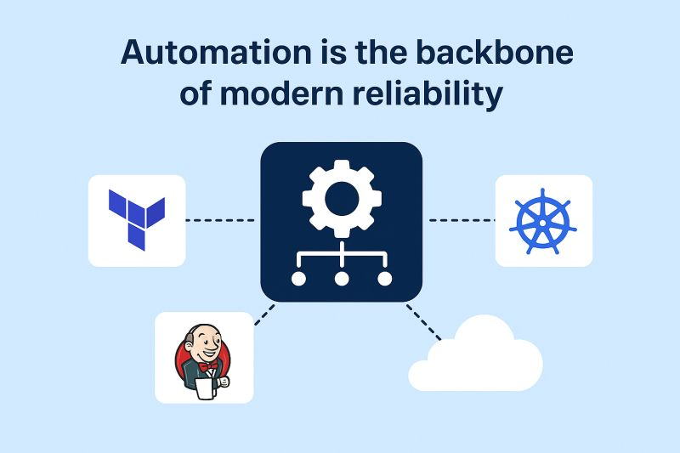

The Deployment Strategy I Trust the Most: Blue-Green  
  
In DevOps, how we release software can make all the difference between smooth updates and stressful rollbacks.  
  
There are several popular deployment strategies, each with its pros and trade-offs:  
  
--> Rolling Deployments: update servers gradually, one batch at a time.  
  
--> Canary Deployments: test new versions with a small % of users before full rollout.  
  
--> Recreate Deployments: stop the old version completely before bringing the new one live.  
  
--> Shadow Deployments: run the new version in parallel, invisible to users, to test real traffic.  
  
But the one I personally admire most is the:   
--> Blue-Green Deployment.  
  
Here’s why :  
  
It involves running two identical environments: Blue (the current live version) and Green (the new release).  
  
You deploy and test your new app in the Green environment without affecting users.  
Once you’re confident it’s stable, you simply switch traffic from Blue to Green , instantly making the new version live.  
  
No downtime.  
No panic rollbacks.  
Just smooth, confident delivery.  
  
If something goes wrong?  
Simply switch back to Blue. (RollBack) It’s that simple and safe.  
  
Blue-Green deployment might cost a bit more in infrastructure, but for teams that value stability, zero downtime, and user trust, it’s absolutely worth it.  
  
Question for you reader:  
Which deployment strategy do you use or trust the most in your DevOps workflow? and why do you prefer it?   
  
  
[**hashtag#DevOps**](https://www.linkedin.com/search/results/all/?keywords=%23devops&origin=HASH_TAG_FROM_FEED) [**hashtag#BlueGreenDeployment**](https://www.linkedin.com/search/results/all/?keywords=%23bluegreendeployment&origin=HASH_TAG_FROM_FEED) [**hashtag#SoftwareDelivery**](https://www.linkedin.com/search/results/all/?keywords=%23softwaredelivery&origin=HASH_TAG_FROM_FEED) [**hashtag#AWS**](https://www.linkedin.com/search/results/all/?keywords=%23aws&origin=HASH_TAG_FROM_FEED) [**hashtag#CICD**](https://www.linkedin.com/search/results/all/?keywords=%23cicd&origin=HASH_TAG_FROM_FEED) [**hashtag#CloudEngineering**](https://www.linkedin.com/search/results/all/?keywords=%23cloudengineering&origin=HASH_TAG_FROM_FEED) [**hashtag#Innovation**](https://www.linkedin.com/search/results/all/?keywords=%23innovation&origin=HASH_TAG_FROM_FEED) [**hashtag#TechLife**](https://www.linkedin.com/search/results/all/?keywords=%23techlife&origin=HASH_TAG_FROM_FEED) [**hashtag#ContinuousImprovement**](https://www.linkedin.com/search/results/all/?keywords=%23continuousimprovement&origin=HASH_TAG_FROM_FEED) [**hashtag#Reliability**](https://www.linkedin.com/search/results/all/?keywords=%23reliability&origin=HASH_TAG_FROM_FEED) [**hashtag#OnCall**](https://www.linkedin.com/search/results/all/?keywords=%23oncall&origin=HASH_TAG_FROM_FEED) [**hashtag#IncidentManagement**](https://www.linkedin.com/search/results/all/?keywords=%23incidentmanagement&origin=HASH_TAG_FROM_FEED) [**hashtag#DigitalTransformation**](https://www.linkedin.com/search/results/all/?keywords=%23digitaltransformation&origin=HASH_TAG_FROM_FEED)

From Alerts to Insights: The Power of Observability  
In modern systems, monitoring alone isn’t enough — observability is what truly drives reliability.  
While monitoring tells you what broke, observability helps you understand why.  
 By combining metrics, logs, and traces, teams can detect patterns, identify root causes faster, and even predict issues before they impact users.  
--> Metrics → Quantify performance  
--> Logs → Capture context  
--> Traces → Reveal dependencies  
When these three pillars come together, troubleshooting becomes smarter, automation becomes stronger, and uptime becomes predictable.  
--> Remember: The goal isn’t just fewer incidents — it’s faster learning from every incident.  
How are you enhancing observability in your environment?  
[**hashtag#SRE**](https://www.linkedin.com/search/results/all/?keywords=%23sre&origin=HASH_TAG_FROM_FEED) [**hashtag#DevOps**](https://www.linkedin.com/search/results/all/?keywords=%23devops&origin=HASH_TAG_FROM_FEED) [**hashtag#Observability**](https://www.linkedin.com/search/results/all/?keywords=%23observability&origin=HASH_TAG_FROM_FEED) [**hashtag#Monitoring**](https://www.linkedin.com/search/results/all/?keywords=%23monitoring&origin=HASH_TAG_FROM_FEED) [**hashtag#Logging**](https://www.linkedin.com/search/results/all/?keywords=%23logging&origin=HASH_TAG_FROM_FEED) [**hashtag#Tracing**](https://www.linkedin.com/search/results/all/?keywords=%23tracing&origin=HASH_TAG_FROM_FEED) [**hashtag#CloudEngineering**](https://www.linkedin.com/search/results/all/?keywords=%23cloudengineering&origin=HASH_TAG_FROM_FEED)

Dear DevOps Engineers, a gentle reminder to:  
- Learn Linux fundamentals before Shell scripting  
- Learn Shell scripting before Configuration Management  
- Learn Networking basics before Cloud Infrastructure  
- Learn Virtual Machines before Containers  
- Learn Git basics before GitOps  
- Learn Containers before Container Orchestration  
- Learn Single server deployment before Microservices  
- Learn Manual deployments before Automation  
- Learn Configuration files before Infrastructure as Code  
- Learn Application logs before Observability platforms  
- Learn Basic monitoring before Advanced telemetry  
- Learn Traditional security before Cloud security  
- Learn Local environments before Cloud environments  
- Learn System administration before Site Reliability Engineering  
- Learn Bash scripting before Python automation  
- Learn YAML basics before Kubernetes manifests  
- Learn TCP/IP before Service Mesh  
- Learn Load balancing before Auto-scaling  
  
It all starts with the core infrastructure & operations fundamentals.  
Have the patience to master the basics before diving into advanced tooling and automation.  
  
Strong foundational knowledge helps you understand WHY things work the way they do, not just HOW to use them.  
  
This enables you to troubleshoot effectively and adapt to new technologies as they emerge.  
  
What would you add to the list?

Hi Connections,  
  
I recently came across this interesting Kubernetes interview question and thought of sharing it here for everyone who’s preparing for DevOps or Cloud roles 🚀  
  
🌐 How Kube-Proxy Works with Kubernetes Services ⚙️  
  
In Kubernetes, Services and Kube-Proxy work together to manage traffic between Pods efficiently. Here’s a simple breakdown 👇  
  
1️⃣ Service Creation & Labels  
When a Kubernetes Service is created, labels are attached to Pods. These labels help Kubernetes identify which Pods belong to a specific Service.  
  
2️⃣ Selectors and Endpoints  
Kubernetes uses Selectors (defined in the Service manifest) to find the right Pods. Once matched, Kubernetes automatically creates Endpoints that connect the Service to those Pods.  
  
3️⃣ Kube-Proxy Updates IPTables 🔁  
The Kube-Proxy component runs on every node and continuously watches for Service and Endpoint changes. It updates the IPTables (or IPVS rules) to handle the routing.  
  
4️⃣ Request Routing 🌍  
When a request is sent to a Service’s ClusterIP, Kube-Proxy routes that request to one of the healthy Pod replicas behind that Service.  
  
✅ In summary:  
Kubernetes Services and Kube-Proxy work together — ensuring load balancing, efficient traffic routing, and smooth internal communication within the cluster.  
  
✨ Follow me for more interesting interview questions and technical insights! 🚀  
  
[**hashtag#aws**](https://www.linkedin.com/search/results/all/?keywords=%23aws&origin=HASH_TAG_FROM_FEED) [**hashtag#devops**](https://www.linkedin.com/search/results/all/?keywords=%23devops&origin=HASH_TAG_FROM_FEED) [**hashtag#Kubernetes**](https://www.linkedin.com/search/results/all/?keywords=%23kubernetes&origin=HASH_TAG_FROM_FEED) [**hashtag#cloud**](https://www.linkedin.com/search/results/all/?keywords=%23cloud&origin=HASH_TAG_FROM_FEED) [**hashtag#Kubernetesinterviewquestions**](https://www.linkedin.com/search/results/all/?keywords=%23kubernetesinterviewquestions&origin=HASH_TAG_FROM_FEED) [**hashtag#gcp**](https://www.linkedin.com/search/results/all/?keywords=%23gcp&origin=HASH_TAG_FROM_FEED) [**hashtag#azure**](https://www.linkedin.com/search/results/all/?keywords=%23azure&origin=HASH_TAG_FROM_FEED) [**hashtag#cloudinterviewquestions**](https://www.linkedin.com/search/results/all/?keywords=%23cloudinterviewquestions&origin=HASH_TAG_FROM_FEED)

Activate to view larger image,

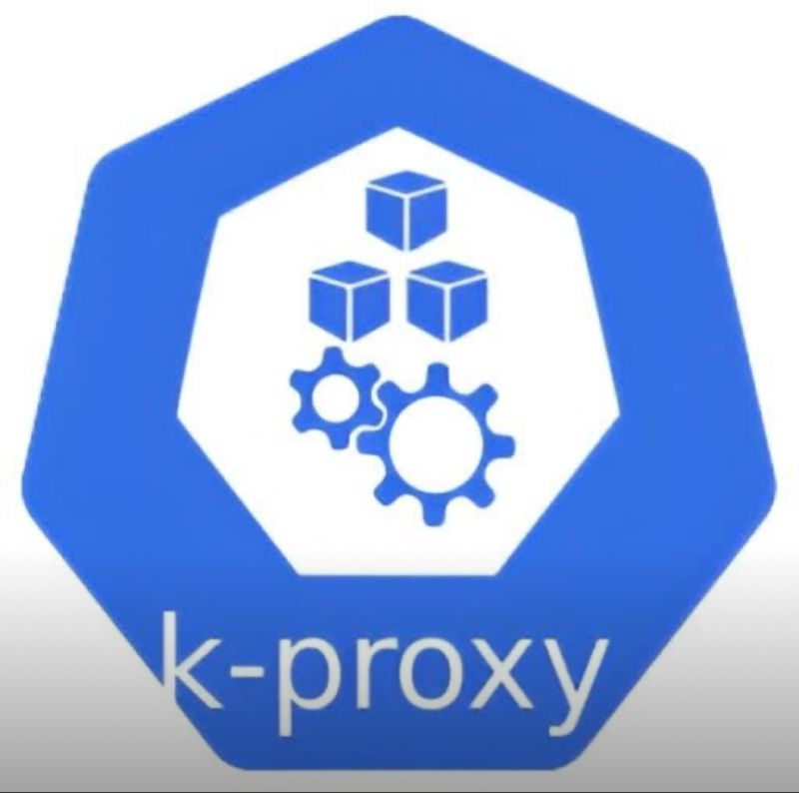

Devops Interview Question!!  
  
I noticed some commonly asked questions that might be helpful for those preparing and working hard to crack their next opportunity. 💪  
Here are a few important areas to focus on:  
 ✅ CI/CD concepts – Jenkins, GitLab, GitHub Actions  
 ✅ Infrastructure as Code – Terraform, AWS CloudFormation  
 ✅ AWS Services – EC2, S3, VPC, IAM, CloudWatch, Lambda  
 ✅ Docker & Kubernetes basics and deployment strategies  
 ✅ Handling secrets – AWS Secrets Manager, Parameter Store  
 ✅ Monitoring, troubleshooting, and cost optimization in AWS  
  
Let’s help each other grow — if you’re also preparing, feel free to comment or connect! 🚀  
[**hashtag#AWS**](https://www.linkedin.com/search/results/all/?keywords=%23aws&origin=HASH_TAG_FROM_FEED) [**hashtag#DevOps**](https://www.linkedin.com/search/results/all/?keywords=%23devops&origin=HASH_TAG_FROM_FEED) [**hashtag#Terraform**](https://www.linkedin.com/search/results/all/?keywords=%23terraform&origin=HASH_TAG_FROM_FEED) [**hashtag#Jenkins**](https://www.linkedin.com/search/results/all/?keywords=%23jenkins&origin=HASH_TAG_FROM_FEED) [**hashtag#Kubernetes**](https://www.linkedin.com/search/results/all/?keywords=%23kubernetes&origin=HASH_TAG_FROM_FEED) [**hashtag#CloudComputing**](https://www.linkedin.com/search/results/all/?keywords=%23cloudcomputing&origin=HASH_TAG_FROM_FEED) [**hashtag#CareerGrowth**](https://www.linkedin.com/search/results/all/?keywords=%23careergrowth&origin=HASH_TAG_FROM_FEED) [**hashtag#InterviewPreparation**](https://www.linkedin.com/search/results/all/?keywords=%23interviewpreparation&origin=HASH_TAG_FROM_FEED)

DevOps Engineer Interview Experience (Fresher) 💥   
I recently appeared for an interview for the role of DevOps Engineer, and it was a fantastic learning experience. The discussion covered a wide range of topics from AWS services, DevOps tools, Linux fundamentals, and real-world troubleshooting scenarios.  
Here are some of the key questions I faced:  
  
🔹 AWS & Cloud Questions  
1. Introduce yourself and explain your project.  
2. What is EBS (Elastic Block Store) and its use cases?  
3. What is a Snapshot and how is it different from a backup?  
4. What is an AMI (Amazon Machine Image)?  
5. What are different EC2 instance types and when to use them?  
6. Explain different S3 storage classes.  
7. How do you write an S3 bucket lifecycle policy?  
8. How do you secure an S3 bucket?  
9. What is a VPC (Virtual Private Cloud)?  
10. What is the difference between a Public Subnet and a Private Subnet?  
11. How do you make a subnet public or private?  
12. What is an Internet Gateway (IGW) and NAT Gateway?  
13. Which ports are used for HTTP and HTTPS?  
14. If you install Nginx, which configuration file do you modify?  
15. Are Security Groups stateful or stateless? Explain.  
16. How do you make an application Highly Available?  
17. Explain a 3-Tier Architecture. How would you set it up for a banking application?  
18. Can we attach an S3 bucket to an EC2 instance directly?  
19. What are some Linux commands you use daily?  
20. Explain different use cases of the grep command.  
21. Explain multiple options of the ls command.  
  
🔹DevOps & Tools Questions  
1. Explain the Docker container lifecycle.  
2. What is CI/CD and why is it important?  
3. Can you write a basic Jenkins pipeline script?  
4. What is Terraform and how does it work?  
5. How do you secure the Terraform state file (tf.state)?  
6. Explain important Terraform commands.  
7. What is the difference between terraform plan and terraform apply?  
8. What are some common issues you have faced while working with DevOps tools?  
9. Explain Prometheus architecture and its components  
10. If an application becomes unresponsive, how would you troubleshoot?  
11. What are your day-to-day responsibilities as a DevOps Engineer?  
  
✨ Takeaway:  
 The interview focused on hands-on implementation, scenario-based problem-solving, and practical knowledge rather than just theory. Every interview is an opportunity to learn, grow, and improve as a DevOps professional! 😉   
hashtag  
  
[**hashtag#DevOps**](https://www.linkedin.com/search/results/all/?keywords=%23devops&origin=HASH_TAG_FROM_FEED) hashtag  
[**hashtag#AWS**](https://www.linkedin.com/search/results/all/?keywords=%23aws&origin=HASH_TAG_FROM_FEED) hashtag  
[**hashtag#Docker**](https://www.linkedin.com/search/results/all/?keywords=%23docker&origin=HASH_TAG_FROM_FEED) hashtag  
[**hashtag#CI\_CD**](https://www.linkedin.com/search/results/all/?keywords=%23ci_cd&origin=HASH_TAG_FROM_FEED) hashtag  
[**hashtag#Jenkins**](https://www.linkedin.com/search/results/all/?keywords=%23jenkins&origin=HASH_TAG_FROM_FEED) hashtag  
[**hashtag#Terraform**](https://www.linkedin.com/search/results/all/?keywords=%23terraform&origin=HASH_TAG_FROM_FEED) hashtag  
[**hashtag#Prometheus**](https://www.linkedin.com/search/results/all/?keywords=%23prometheus&origin=HASH_TAG_FROM_FEED) hashtag  
[**hashtag#Linux**](https://www.linkedin.com/search/results/all/?keywords=%23linux&origin=HASH_TAG_FROM_FEED) hashtag  
[**hashtag#CloudComputing**](https://www.linkedin.com/search/results/all/?keywords=%23cloudcomputing&origin=HASH_TAG_FROM_FEED) hashtag  
[**hashtag#CloudEngineer**](https://www.linkedin.com/search/results/all/?keywords=%23cloudengineer&origin=HASH_TAG_FROM_FEED) hashtag  
[**hashtag#Monitoring**](https://www.linkedin.com/search/results/all/?keywords=%23monitoring&origin=HASH_TAG_FROM_FEED) hashtag  
[**hashtag#InterviewExperience**](https://www.linkedin.com/search/results/all/?keywords=%23interviewexperience&origin=HASH_TAG_FROM_FEED) hashtag  
[**hashtag#CareerGrowth**](https://www.linkedin.com/search/results/all/?keywords=%23careergrowth&origin=HASH_TAG_FROM_FEED) hashtag  
[**hashtag#TechLearning**](https://www.linkedin.com/search/results/all/?keywords=%23techlearning&origin=HASH_TAG_FROM_FEED) hashtag  
[**hashtag#3TierArchitecture**](https://www.linkedin.com/search/results/all/?keywords=%233tierarchitecture&origin=HASH_TAG_FROM_FEED) hashtag  
[**hashtag#S3**](https://www.linkedin.com/search/results/all/?keywords=%23s3&origin=HASH_TAG_FROM_FEED) hashtag  
[**hashtag#EBS**](https://www.linkedin.com/search/results/all/?keywords=%23ebs&origin=HASH_TAG_FROM_FEED) hashtag  
[**hashtag#VPC**](https://www.linkedin.com/search/results/all/?keywords=%23vpc&origin=HASH_TAG_FROM_FEED) hashtag  
[**hashtag#Networking**](https://www.linkedin.com/search/results/all/?keywords=%23networking&origin=HASH_TAG_FROM_FEED) hashtag  
[**hashtag#HighAvailability**](https://www.linkedin.com/search/results/all/?keywords=%23highavailability&origin=HASH_TAG_FROM_FEED) hashtag  
[**hashtag#devopsinterview**](https://www.linkedin.com/search/results/all/?keywords=%23devopsinterview&origin=HASH_TAG_FROM_FEED)   
hashtag  
  
[**hashtag#devopsinterviewquestions**](https://www.linkedin.com/search/results/all/?keywords=%23devopsinterviewquestions&origin=HASH_TAG_FROM_FEED)

Hi DevOps Engineers,  
  
I’ve realized that attending interviews is one of the best ways to gain real clarity about our knowledge and areas for improvement. Recently, I’ve been attending multiple interviews, and I’d like to share some of the questions I encountered.  
  
I hope these posts will be useful for you in your preparation. Stay tuned for more updates!  
  
  
 1. Tell me about yourself.  
 2. How did you provision a resource in Terraform?  
 3. What strategy will you follow in terraform?  
 4. Are you aware of the Folder structure of Terraform?  
 5. How did you ensure security on Jenkins and GitHub Actions?   
 6. What's your approach on Prometheus and Grafana?  
 7. What is Sonarqube?  
 8. What do you know about VPC Networking? Explain VPC Core components?  
 9. Difference between HTTP and HTTPS.  
10. Let say we have two websites - One starts with http and another website starts with https. Both websites are asking you to fill the form. If I click Submit, What difference will I see in http and https?   
11. What is TCP and UDP ?  
12. Where do I use TCP? Give More examples?  
13. Explain Layer 4 and Layer 7 load balancer? What's the difference?  
14. Explain Gateway load balancer.  
15. Where would I need an application load balancer and Network Load balancer?  
16. In which situation I would have http/https protocols?  
17. What do you know about sqs and sns ?  
18. Why do we need kubernetes? why not AWS Fargate ?  
19. Explain Job description? From your understanding What we are expecting from you?   
20. Tell me Route 53 and RDS.  
21. I want to Connect two VMs with private Ip and I just need to run the ping command from VM1 to VM2. What should I do ? Elaborate your answer. Do you think you need to add any security groups for this?  
  
  
Behavioral Questions :  
  
1. Suppose some seniors assign some work on azure and you start working on it. But Your team lead said, This is not right. you need to 'Reado' your work. How will you tackle this situation?   
2. You are learning or Studying some courses. You also need to do practical work on your job which is assigned to you. How will you manage both learning and practical work of yours? Explain.  
  
Follow for more questions !! Will update next set of questions Soon !!!  
  
[**hashtag#aws**](https://www.linkedin.com/search/results/all/?keywords=%23aws&origin=HASH_TAG_FROM_FEED) [**hashtag#devops**](https://www.linkedin.com/search/results/all/?keywords=%23devops&origin=HASH_TAG_FROM_FEED) [**hashtag#azure**](https://www.linkedin.com/search/results/all/?keywords=%23azure&origin=HASH_TAG_FROM_FEED) [**hashtag#gcp**](https://www.linkedin.com/search/results/all/?keywords=%23gcp&origin=HASH_TAG_FROM_FEED) [**hashtag#linux**](https://www.linkedin.com/search/results/all/?keywords=%23linux&origin=HASH_TAG_FROM_FEED) [**hashtag#networking**](https://www.linkedin.com/search/results/all/?keywords=%23networking&origin=HASH_TAG_FROM_FEED) [**hashtag#awsinterviewquestions**](https://www.linkedin.com/search/results/all/?keywords=%23awsinterviewquestions&origin=HASH_TAG_FROM_FEED) [**hashtag#devopsinterviewquestions**](https://www.linkedin.com/search/results/all/?keywords=%23devopsinterviewquestions&origin=HASH_TAG_FROM_FEED) [**hashtag#networkinginterviewquestions**](https://www.linkedin.com/search/results/all/?keywords=%23networkinginterviewquestions&origin=HASH_TAG_FROM_FEED) [**hashtag#syedabuthahir**](https://www.linkedin.com/search/results/all/?keywords=%23syedabuthahir&origin=HASH_TAG_FROM_FEED)

Must-Practice AWS Interview Questions for Aspiring DevOps Engineers!🚀  
  
If you're preparing for DevOps roles especially with 0–2 years of experience, this list is a goldmine for brushing up on core concepts across AWS, Linux, and Kubernetes.  
  
💡 These questions cover a wide range of topics, from cloud architecture and security to container orchestration and system administration.  
  
🧠 Interview Questions Snapshot:  
  
✅AWS & Cloud Concepts -  
1. What is AWS Lambda?  
2. Explain Auto Scaling Groups.  
3. What are the different storage classes in S3?  
4. How does S3 ensure data durability?  
5. IAM Role vs IAM User—what's the difference?  
6. What is a VPC and its key components?  
7. Public vs Private Subnet.  
8. How would you design a highly available web app in AWS?  
9. How would you migrate a large on-premises database to AWS?  
10. Why might EC2 instances fail to connect to the internet?  
11. Horizontal vs Vertical Scaling.  
12. How do you secure data at rest and in transit in AWS?  
13. What is AWS CloudFormation?  
14. Explain AWS Secrets Manager.  
15. How do you implement MFA in AWS?  
16. How does S3 encryption work?  
17. What is VPC Peering?  
  
✅Linux Fundamentals -   
1. What is Logical Volume Manager (LVM)?  
2. Explain the grep command.  
3. Key network commands in Linux.  
4. How do you manage system services?  
5. How to check disk usage?  
6. How do you extend storage in AWS when it's full?  
7. How to increase EC2 volume size from 8GB to 16GB?  
  
✅Kubernetes Essentials -  
1. What is a ReplicaSet?  
2. What is etcd in Kubernetes?  
3. How does Kubernetes handle networking?  
4. How do you monitor a Kubernetes cluster?  
5. What is a DaemonSet?  
6. DaemonSet vs StatefulSet.  
7. How do you troubleshoot a pod?  
  
📌 Save this post, share it with fellow learners, and follow me for more interview prep insights!  
[**hashtag#aws**](https://www.linkedin.com/search/results/all/?keywords=%23aws&origin=HASH_TAG_FROM_FEED) [**hashtag#devops**](https://www.linkedin.com/search/results/all/?keywords=%23devops&origin=HASH_TAG_FROM_FEED) [**hashtag#awsinterviewquestions**](https://www.linkedin.com/search/results/all/?keywords=%23awsinterviewquestions&origin=HASH_TAG_FROM_FEED) [**hashtag#devopsinterviewquestions**](https://www.linkedin.com/search/results/all/?keywords=%23devopsinterviewquestions&origin=HASH_TAG_FROM_FEED) [**hashtag#kubernetesinterviewquestions**](https://www.linkedin.com/search/results/all/?keywords=%23kubernetesinterviewquestions&origin=HASH_TAG_FROM_FEED) [**hashtag#linux**](https://www.linkedin.com/search/results/all/?keywords=%23linux&origin=HASH_TAG_FROM_FEED) [**hashtag#kubernetes**](https://www.linkedin.com/search/results/all/?keywords=%23kubernetes&origin=HASH_TAG_FROM_FEED) [**hashtag#linuxinterviewquestions**](https://www.linkedin.com/search/results/all/?keywords=%23linuxinterviewquestions&origin=HASH_TAG_FROM_FEED)

My DevOps Engineer Interview Experience (Fresher) 🚀  
I recently appeared for an interview for the role of DevOps Engineer, and it was a fantastic learning experience. The discussion covered a wide range of topics from AWS services, DevOps tools, Linux fundamentals, and real-world troubleshooting scenarios.  
Here are some of the key questions I faced:  
  
🔹 AWS & Cloud Questions  
1. Introduce yourself and explain your project.  
2. What is EBS (Elastic Block Store) and its use cases?  
3. What is a Snapshot and how is it different from a backup?  
4. What is an AMI (Amazon Machine Image)?  
5. What are different EC2 instance types and when to use them?  
6. Explain different S3 storage classes.  
7. How do you write an S3 bucket lifecycle policy?  
8. How do you secure an S3 bucket?  
9. What is a VPC (Virtual Private Cloud)?  
10. What is the difference between a Public Subnet and a Private Subnet?  
11. How do you make a subnet public or private?  
12. What is an Internet Gateway (IGW) and NAT Gateway?  
13. Which ports are used for HTTP and HTTPS?  
14. If you install Nginx, which configuration file do you modify?  
15. Are Security Groups stateful or stateless? Explain.  
16. How do you make an application Highly Available?  
17. Explain a 3-Tier Architecture. How would you set it up for a banking application?  
18. Can we attach an S3 bucket to an EC2 instance directly?  
19. What are some Linux commands you use daily?  
20. Explain different use cases of the grep command.  
21. Explain multiple options of the ls command.  
🔹 DevOps & Tools Questions  
1. Explain the Docker container lifecycle.  
2. What is CI/CD and why is it important?  
3. Can you write a basic Jenkins pipeline script?  
4. What is Terraform and how does it work?  
5. How do you secure the Terraform state file (tf.state)?  
6. Explain important Terraform commands.  
7. What is the difference between terraform plan and terraform apply?  
8. What are some common issues you have faced while working with DevOps tools?  
9. Explain Prometheus architecture and its components  
10. If an application becomes unresponsive, how would you troubleshoot?  
11. What are your day-to-day responsibilities as a DevOps Engineer?  
  
✨ Takeaway:  
 The interview focused on hands-on implementation, scenario-based problem-solving, and practical knowledge rather than just theory. Every interview is an opportunity to learn, grow, and improve as a DevOps professional!  
[**hashtag#DevOps**](https://www.linkedin.com/search/results/all/?keywords=%23devops&origin=HASH_TAG_FROM_FEED) [**hashtag#AWS**](https://www.linkedin.com/search/results/all/?keywords=%23aws&origin=HASH_TAG_FROM_FEED) [**hashtag#Docker**](https://www.linkedin.com/search/results/all/?keywords=%23docker&origin=HASH_TAG_FROM_FEED) [**hashtag#CI\_CD**](https://www.linkedin.com/search/results/all/?keywords=%23ci_cd&origin=HASH_TAG_FROM_FEED) [**hashtag#Jenkins**](https://www.linkedin.com/search/results/all/?keywords=%23jenkins&origin=HASH_TAG_FROM_FEED) [**hashtag#Terraform**](https://www.linkedin.com/search/results/all/?keywords=%23terraform&origin=HASH_TAG_FROM_FEED) [**hashtag#Prometheus**](https://www.linkedin.com/search/results/all/?keywords=%23prometheus&origin=HASH_TAG_FROM_FEED) [**hashtag#Linux**](https://www.linkedin.com/search/results/all/?keywords=%23linux&origin=HASH_TAG_FROM_FEED) [**hashtag#CloudComputing**](https://www.linkedin.com/search/results/all/?keywords=%23cloudcomputing&origin=HASH_TAG_FROM_FEED) [**hashtag#CloudEngineer**](https://www.linkedin.com/search/results/all/?keywords=%23cloudengineer&origin=HASH_TAG_FROM_FEED) [**hashtag#Monitoring**](https://www.linkedin.com/search/results/all/?keywords=%23monitoring&origin=HASH_TAG_FROM_FEED) [**hashtag#InterviewExperience**](https://www.linkedin.com/search/results/all/?keywords=%23interviewexperience&origin=HASH_TAG_FROM_FEED) [**hashtag#CareerGrowth**](https://www.linkedin.com/search/results/all/?keywords=%23careergrowth&origin=HASH_TAG_FROM_FEED) [**hashtag#TechLearning**](https://www.linkedin.com/search/results/all/?keywords=%23techlearning&origin=HASH_TAG_FROM_FEED) [**hashtag#3TierArchitecture**](https://www.linkedin.com/search/results/all/?keywords=%233tierarchitecture&origin=HASH_TAG_FROM_FEED) [**hashtag#S3**](https://www.linkedin.com/search/results/all/?keywords=%23s3&origin=HASH_TAG_FROM_FEED) [**hashtag#EBS**](https://www.linkedin.com/search/results/all/?keywords=%23ebs&origin=HASH_TAG_FROM_FEED) [**hashtag#VPC**](https://www.linkedin.com/search/results/all/?keywords=%23vpc&origin=HASH_TAG_FROM_FEED) [**hashtag#Networking**](https://www.linkedin.com/search/results/all/?keywords=%23networking&origin=HASH_TAG_FROM_FEED) [**hashtag#HighAvailability**](https://www.linkedin.com/search/results/all/?keywords=%23highavailability&origin=HASH_TAG_FROM_FEED) [**hashtag#devopsinterview**](https://www.linkedin.com/search/results/all/?keywords=%23devopsinterview&origin=HASH_TAG_FROM_FEED)   
[**hashtag#devopsinterviewquestions**](https://www.linkedin.com/search/results/all/?keywords=%23devopsinterviewquestions&origin=HASH_TAG_FROM_FEED)

Master Networking for DevOps Engineers! @  
Whether you're preparing for interviews or improving your real-world DevOps skills, this document covers all the key networking concepts you need - from fundamentals to advanced topics that every DevOps engineer should know.  
Perfect for those aiming to strengthen their networking foundation in C/CD, cloud environments, and containerized systems.  
- Check it out, learn something new, and don't forget to repost so others in the DevOps community can benefit too!  
Follow Sachin Singh for more helpful posts o  
[**hashtag#DevOps**](https://www.linkedin.com/search/results/all/?keywords=%23devops&origin=HASH_TAG_FROM_FEED) [**hashtag#Networking**](https://www.linkedin.com/search/results/all/?keywords=%23networking&origin=HASH_TAG_FROM_FEED) [**hashtag#CloudComputing**](https://www.linkedin.com/search/results/all/?keywords=%23cloudcomputing&origin=HASH_TAG_FROM_FEED) [**hashtag#AWS**](https://www.linkedin.com/search/results/all/?keywords=%23aws&origin=HASH_TAG_FROM_FEED)  
[**hashtag#Azure**](https://www.linkedin.com/search/results/all/?keywords=%23azure&origin=HASH_TAG_FROM_FEED) [**hashtag#Docker**](https://www.linkedin.com/search/results/all/?keywords=%23docker&origin=HASH_TAG_FROM_FEED) [**hashtag#Kubernetes**](https://www.linkedin.com/search/results/all/?keywords=%23kubernetes&origin=HASH_TAG_FROM_FEED) [**hashtag#CI\_CD**](https://www.linkedin.com/search/results/all/?keywords=%23ci_cd&origin=HASH_TAG_FROM_FEED) [**hashtag#Linux**](https://www.linkedin.com/search/results/all/?keywords=%23linux&origin=HASH_TAG_FROM_FEED) [**hashtag#NetworkingBasics**](https://www.linkedin.com/search/results/all/?keywords=%23networkingbasics&origin=HASH_TAG_FROM_FEED) [**hashtag#TechCommunity**](https://www.linkedin.com/search/results/all/?keywords=%23techcommunity&origin=HASH_TAG_FROM_FEED)  
[**hashtag#DevOpsEngineer**](https://www.linkedin.com/search/results/all/?keywords=%23devopsengineer&origin=HASH_TAG_FROM_FEED) [**hashtag#LearnDevOps**](https://www.linkedin.com/search/results/all/?keywords=%23learndevops&origin=HASH_TAG_FROM_FEED) [**hashtag#ITInfrastructure**](https://www.linkedin.com/search/results/all/?keywords=%23itinfrastructure&origin=HASH_TAG_FROM_FEED)  
Networking for DevOps Engineer  
11 pages

Your document has finished loading

% Ecommerce Application Deployment with Docker, Jenkins, Prometheus & Grafana  
\* Just completed another exciting DevOps project! © I deployed a full Ecommerce Application using Docker Compose, automated builds with Jenkins CI/CD, and implemented monitoring & visualization using Prometheus, Grafana, and cAdvisor.  
® Key Highlights:  
& Docker & Docker Compose - Containerized the entire application stack.  
• Jenkins Pipeline — Automated build and deployment process.  
I Prometheus & Grafana — Monitored app and system metrics with real-time dashboards.  
cAdvisor - Tracked container resource usage and  
performance.  
AWS EC2 - Hosted and managed the environment.  
¿ Service URLs (Localhost Setup)  
Ecommerce App → http://localhost:8081  
Jenkins → http://localhost:8080  
In Prometheus → http://localhost:9090  
~ Grafana → http://localhost:3000  
Node Exporter → http://localhost:9100  
cadvisor → http://localhost:8082  
Tools & Technologies:  
AWS | Docker | Jenkins | Prometheus | Grafana | cadvisor  
I Node Exporter | Linux  
[**hashtag#DevOps**](https://www.linkedin.com/search/results/all/?keywords=%23devops&origin=HASH_TAG_FROM_FEED) [**hashtag#AWS**](https://www.linkedin.com/search/results/all/?keywords=%23aws&origin=HASH_TAG_FROM_FEED) [**hashtag#Docker**](https://www.linkedin.com/search/results/all/?keywords=%23docker&origin=HASH_TAG_FROM_FEED) [**hashtag#Jenkins**](https://www.linkedin.com/search/results/all/?keywords=%23jenkins&origin=HASH_TAG_FROM_FEED) [**hashtag#Prometheus**](https://www.linkedin.com/search/results/all/?keywords=%23prometheus&origin=HASH_TAG_FROM_FEED) [**hashtag#Grafana**](https://www.linkedin.com/search/results/all/?keywords=%23grafana&origin=HASH_TAG_FROM_FEED) [**hashtag#Monitoring**](https://www.linkedin.com/search/results/all/?keywords=%23monitoring&origin=HASH_TAG_FROM_FEED) [**hashtag#CICD**](https://www.linkedin.com/search/results/all/?keywords=%23cicd&origin=HASH_TAG_FROM_FEED) [**hashtag#CloudComputing**](https://www.linkedin.com/search/results/all/?keywords=%23cloudcomputing&origin=HASH_TAG_FROM_FEED) [**hashtag#DevOpsProjects**](https://www.linkedin.com/search/results/all/?keywords=%23devopsprojects&origin=HASH_TAG_FROM_FEED) [**hashtag#Containers**](https://www.linkedin.com/search/results/all/?keywords=%23containers&origin=HASH_TAG_FROM_FEED) [**hashtag#Automation**](https://www.linkedin.com/search/results/all/?keywords=%23automation&origin=HASH_TAG_FROM_FEED)

Open to Work! 🌟  
 I’m actively seeking opportunities in Cloud & DevOps Engineering across the UAE.  
 Skilled in Azure, AWS, CI/CD pipelines, Docker, Kubernetes, Infrastructure as Code (Terraform), and Automation, I’m passionate about optimizing cloud environments and improving deployment efficiency.  
  
I’m eager to join a forward-thinking organization where I can contribute to Cloud Architecture, System Monitoring, and Continuous Integration/Deployment initiatives.  
  
📩 You can reach me at [**nusrathnufais32@gmail.com**](mailto:nusrathnufais32@gmail.com) or connect with me here on LinkedIn!  
  
[**hashtag#OpenToWork**](https://www.linkedin.com/search/results/all/?keywords=%23opentowork&origin=HASH_TAG_FROM_FEED) [**hashtag#CloudEngineer**](https://www.linkedin.com/search/results/all/?keywords=%23cloudengineer&origin=HASH_TAG_FROM_FEED) [**hashtag#DevOpsEngineer**](https://www.linkedin.com/search/results/all/?keywords=%23devopsengineer&origin=HASH_TAG_FROM_FEED) [**hashtag#Azure**](https://www.linkedin.com/search/results/all/?keywords=%23azure&origin=HASH_TAG_FROM_FEED) [**hashtag#AWS**](https://www.linkedin.com/search/results/all/?keywords=%23aws&origin=HASH_TAG_FROM_FEED) [**hashtag#Terraform**](https://www.linkedin.com/search/results/all/?keywords=%23terraform&origin=HASH_TAG_FROM_FEED) [**hashtag#Kubernetes**](https://www.linkedin.com/search/results/all/?keywords=%23kubernetes&origin=HASH_TAG_FROM_FEED) [**hashtag#CI\_CD**](https://www.linkedin.com/search/results/all/?keywords=%23ci_cd&origin=HASH_TAG_FROM_FEED) [**hashtag#Automation**](https://www.linkedin.com/search/results/all/?keywords=%23automation&origin=HASH_TAG_FROM_FEED) [**hashtag#CloudInfrastructure**](https://www.linkedin.com/search/results/all/?keywords=%23cloudinfrastructure&origin=HASH_TAG_FROM_FEED) [**hashtag#UAEJobs**](https://www.linkedin.com/search/results/all/?keywords=%23uaejobs&origin=HASH_TAG_FROM_FEED) [**hashtag#TechCareers**](https://www.linkedin.com/search/results/all/?keywords=%23techcareers&origin=HASH_TAG_FROM_FEED)  
[**hashtag#AWS**](https://www.linkedin.com/search/results/all/?keywords=%23aws&origin=HASH_TAG_FROM_FEED) hashtag  
[**hashtag#DevOps**](https://www.linkedin.com/search/results/all/?keywords=%23devops&origin=HASH_TAG_FROM_FEED) hashtag  
[**hashtag#Grafana**](https://www.linkedin.com/search/results/all/?keywords=%23grafana&origin=HASH_TAG_FROM_FEED) hashtag  
[**hashtag#Prometheus**](https://www.linkedin.com/search/results/all/?keywords=%23prometheus&origin=HASH_TAG_FROM_FEED) hashtag  
[**hashtag#CloudMonitoring**](https://www.linkedin.com/search/results/all/?keywords=%23cloudmonitoring&origin=HASH_TAG_FROM_FEED) hashtag  
[**hashtag#Observability**](https://www.linkedin.com/search/results/all/?keywords=%23observability&origin=HASH_TAG_FROM_FEED) hashtag  
[**hashtag#AWSCertified**](https://www.linkedin.com/search/results/all/?keywords=%23awscertified&origin=HASH_TAG_FROM_FEED) hashtag  
[**hashtag#MonitoringTools**](https://www.linkedin.com/search/results/all/?keywords=%23monitoringtools&origin=HASH_TAG_FROM_FEED) hashtag  
[**hashtag#SRE**](https://www.linkedin.com/search/results/all/?keywords=%23sre&origin=HASH_TAG_FROM_FEED) hashtag  
[**hashtag#Azure**](https://www.linkedin.com/search/results/all/?keywords=%23azure&origin=HASH_TAG_FROM_FEED)   
[**hashtag#CloudEngineer**](https://www.linkedin.com/search/results/all/?keywords=%23cloudengineer&origin=HASH_TAG_FROM_FEED)  
[**hashtag#DevOpsEngineer**](https://www.linkedin.com/search/results/all/?keywords=%23devopsengineer&origin=HASH_TAG_FROM_FEED)  
[**hashtag#SystemAdministrator**](https://www.linkedin.com/search/results/all/?keywords=%23systemadministrator&origin=HASH_TAG_FROM_FEED)  
[**hashtag#HiringCloud**](https://www.linkedin.com/search/results/all/?keywords=%23hiringcloud&origin=HASH_TAG_FROM_FEED)  
[**hashtag#HiringDevOps**](https://www.linkedin.com/search/results/all/?keywords=%23hiringdevops&origin=HASH_TAG_FROM_FEED)  
[**hashtag#HiringITSupport**](https://www.linkedin.com/search/results/all/?keywords=%23hiringitsupport&origin=HASH_TAG_FROM_FEED)  
[**hashtag#HiringSystemAdministartor**](https://www.linkedin.com/search/results/all/?keywords=%23hiringsystemadministartor&origin=HASH_TAG_FROM_FEED)  
[**hashtag#HiirngITSupport**](https://www.linkedin.com/search/results/all/?keywords=%23hiirngitsupport&origin=HASH_TAG_FROM_FEED)  
[**hashtag#HiringITAdmin**](https://www.linkedin.com/search/results/all/?keywords=%23hiringitadmin&origin=HASH_TAG_FROM_FEED)

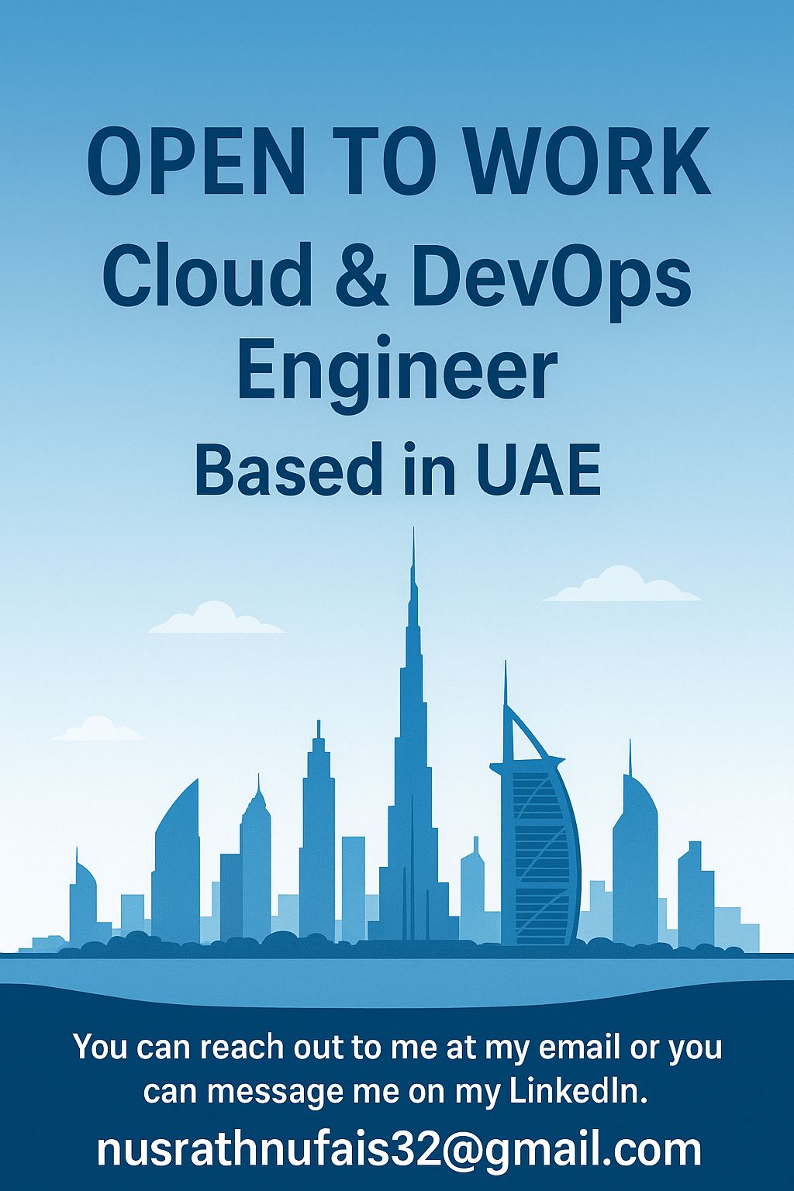

hi🚀 𝟔 𝐡𝐚𝐧𝐝𝐩𝐢𝐜𝐤𝐞𝐝 𝐂𝐥𝐨𝐮𝐝 𝐏𝐫𝐨𝐣𝐞𝐜𝐭𝐬 𝐲𝐨𝐮 𝐜𝐚𝐧 𝐛𝐮𝐢𝐥𝐝 𝐟𝐨𝐫 𝐟𝐫𝐞𝐞  
(includes video tutorials for AWS, GCP & Azure)  
  
\*\*AWS  
1. Deploy a Containerized Web App on AWS ECS with CI/CD (Beginner)  
↳ Learn how to build, dockerize, and deploy a web app on AWS ECS Fargate with CI/CD pipelines.  
↳ Master Docker, ECR, ECS tasks, and GitHub Actions.  
Full video walkthrough: [**https://lnkd.in/d4pMS2vq**](https://lnkd.in/d4pMS2vq)  
  
2. Deploy AWS EKS Cluster with Terraform (Intermediate)  
↳ Provision a fully managed Kubernetes cluster on AWS with Terraform.  
↳ Understand EKS networking, node groups, and integrate Helm charts for workloads.  
Full video walkthrough: [**https://lnkd.in/d3yJnX\_4**](https://lnkd.in/d3yJnX_4)  
  
\*\* Azure  
3. End-to-End Project with Terraform using Azure DevOps ( Intermediate)  
↳ Build enterprise-grade Azure infrastructure with Terraform and automate deployments using Azure DevOps pipelines.  
↳ Learn real-world patterns: resource groups, VNets, AKS clusters, and more.  
Full video walkthrough: [**https://lnkd.in/dDCit4ve**](https://lnkd.in/dDCit4ve)  
  
4. Realtime DevOps Project using Azure DevOps and GitOps (Beginner to Advanced)  
↳ Explore GitOps practices with Azure DevOps, automating infrastructure and application deployments.  
↳ Implement CI/CD flows and promote changes across environments seamlessly.  
Full Video Walkthrough: [**https://lnkd.in/dxFh\_xum**](https://lnkd.in/dxFh_xum)  
Reference GitHub repository: [**https://lnkd.in/dAfz9Yma**](https://lnkd.in/dAfz9Yma)  
  
\*\*Google Cloud  
5. CI/CD Pipeline with Cloud Build and Cloud Deploy for GKE Apps (Beginner)  
↳ Automate container builds with Cloud Build and deploy to GKE clusters using Cloud Deploy.  
↳ Integrate Google Cloud tools for efficient release management.  
Full video walkthrough: [**https://lnkd.in/d4vWCRct**](https://lnkd.in/d4vWCRct)  
  
6. Google Cloud DevOps Project: CI/CD Pipeline using GitHub Actions and Terraform (Intermediate)  
↳ Provision GCP infrastructure with Terraform, and implement GitHub Actions for end-to-end deployment automation.  
↳ Ideal for DevOps engineers looking to master Google Cloud workflows.  
Full video walkthrough: [**https://lnkd.in/dCMPVM\_E**](https://lnkd.in/dCMPVM_E)  
  
Few suggestions here who's starting new:  
- Be consistent and focus on mastering one cloud provider before moving to others.  
- Use free credits from AWS, Azure, or GCP to build these projects in a real cloud environment.  
- Running projects for 2–4 hours should cost under $5 — just remember to delete your resources afterward.  
- Document everything in a GitHub repo and add the link to your resume to show your hands-on skills.  
  
♻️ Found this helpful? Feel free to repost & share with your network.  
  
🔔 Follow DevCloud Partners Partners

**Basics: Must-Know Linux Concepts**  
What is Linux and what are its key features?  
Explain the Linux file system hierarchy.  
What are the five basic components of Linux OS?  
List commonly used shells (e.g., BASH, csh, ksh, zsh, fish)  
What is a process? How do you find a process by name or PID?  
Describe file permissions and the use of chmod.  
How do you check disk space and memory usage? (df -h, free -m)  
What is the difference between Linux and Unix?  
How do you create, move, rename, and remove files/directories? (touch, mv, rm, cp)  
Explain the root account and its privileges.  
  
➤ Intermediate: Real-World Administration and Troubleshooting  
  
How do you manage users and groups? (useradd, usermod, groupadd)  
What is the purpose of /etc/passwd and /etc/shadow?  
How do you find and kill a hanging process? (ps, top, kill, killall)  
Differentiate between a hard link and a soft link.  
How do you schedule tasks in Linux? (cron, at)  
Explain zombie and orphan processes.  
How do you troubleshoot a service that fails to start? (Use systemctl, check logs with journalctl, inspect /var/log/)  
  
➤ Advanced: Deep-Dive & Scenario-Based Questions  
  
How would you debug a slow system or process?  
Walk through steps to recover a non-booting Linux system (use Live CD, check /etc/fstab, inspect GRUB, run fsck)  
What is LVM, and how do you manage volumes with lvcreate, lvextend, or lvresize?  
Describe steps to handle disk usage at 100% (find large files, use du, log rotation)  
How does kernel space differ from user space? Can you edit the kernel? What is a kernel module?  
What are kernel parameters, and how do you change them?  
Explain the difference between TCP and UDP sockets in Linux networking.  
  
➤ Problem-solving questions:   
  
“A user faces slow login; walk through troubleshooting steps.”  
Tasks like writing scripts for log rotation or automating backup.  
Questions on scaling, tuning performance, kernel configuration, and network troubleshooting.  
Deep familiarity with commands, logs, and best practices is essential.  
Tips for Cracking Linux Interviews  
Practice in a live Linux environment daily.  
Focus on both explanation and practical demonstration.  
Review log files and typical troubleshooting commands.  
  
[**hashtag#DevOps**](https://www.linkedin.com/search/results/all/?keywords=%23devops&origin=HASH_TAG_FROM_FEED) [**hashtag#Linux**](https://www.linkedin.com/search/results/all/?keywords=%23linux&origin=HASH_TAG_FROM_FEED) [**hashtag#Networking**](https://www.linkedin.com/search/results/all/?keywords=%23networking&origin=HASH_TAG_FROM_FEED) [**hashtag#PortNumbers**](https://www.linkedin.com/search/results/all/?keywords=%23portnumbers&origin=HASH_TAG_FROM_FEED) [**hashtag#DevOpsEngineer**](https://www.linkedin.com/search/results/all/?keywords=%23devopsengineer&origin=HASH_TAG_FROM_FEED) [**hashtag#SysAdmin**](https://www.linkedin.com/search/results/all/?keywords=%23sysadmin&origin=HASH_TAG_FROM_FEED) [**hashtag#CloudComputing**](https://www.linkedin.com/search/results/all/?keywords=%23cloudcomputing&origin=HASH_TAG_FROM_FEED) [**hashtag#TechnicalInterview**](https://www.linkedin.com/search/results/all/?keywords=%23technicalinterview&origin=HASH_TAG_FROM_FEED) [**hashtag#ITKnowledge**](https://www.linkedin.com/search/results/all/?keywords=%23itknowledge&origin=HASH_TAG_FROM_FEED) [**hashtag#Troubleshooting**](https://www.linkedin.com/search/results/all/?keywords=%23troubleshooting&origin=HASH_TAG_FROM_FEED) [**hashtag#CyberSecurity**](https://www.linkedin.com/search/results/all/?keywords=%23cybersecurity&origin=HASH_TAG_FROM_FEED) [**hashtag#NetworkingBasics**](https://www.linkedin.com/search/results/all/?keywords=%23networkingbasics&origin=HASH_TAG_FROM_FEED)

Essential Port Numbers Every DevOps Engineer Should Know ✅  
  
Whether you're [**hashtag#troubleshooting**](https://www.linkedin.com/search/results/all/?keywords=%23troubleshooting&origin=HASH_TAG_FROM_FEED), configuring firewalls, or setting up services — knowing the right port numbers is a must for every DevOps engineer. From SSH (22) to HTTPS (443), these ports keep the internet and our infrastructure running smoothly! 🌱  
  
This list is a quick reference guide to the most commonly used ports in DevOps, Networking, and System Administration. Perfect for interviews, daily tasks, and improving your foundational knowledge.  
  
🔁 Found it useful? Repost it and help others in the DevOps community stay sharp!  
  
Follow Nusrath Nufais for more helpful posts 🩷   
  
[**hashtag#DevOps**](https://www.linkedin.com/search/results/all/?keywords=%23devops&origin=HASH_TAG_FROM_FEED) [**hashtag#Linux**](https://www.linkedin.com/search/results/all/?keywords=%23linux&origin=HASH_TAG_FROM_FEED) [**hashtag#Networking**](https://www.linkedin.com/search/results/all/?keywords=%23networking&origin=HASH_TAG_FROM_FEED) [**hashtag#PortNumbers**](https://www.linkedin.com/search/results/all/?keywords=%23portnumbers&origin=HASH_TAG_FROM_FEED) [**hashtag#DevOpsEngineer**](https://www.linkedin.com/search/results/all/?keywords=%23devopsengineer&origin=HASH_TAG_FROM_FEED) [**hashtag#SysAdmin**](https://www.linkedin.com/search/results/all/?keywords=%23sysadmin&origin=HASH_TAG_FROM_FEED) [**hashtag#CloudComputing**](https://www.linkedin.com/search/results/all/?keywords=%23cloudcomputing&origin=HASH_TAG_FROM_FEED) [**hashtag#TechnicalInterview**](https://www.linkedin.com/search/results/all/?keywords=%23technicalinterview&origin=HASH_TAG_FROM_FEED) [**hashtag#ITKnowledge**](https://www.linkedin.com/search/results/all/?keywords=%23itknowledge&origin=HASH_TAG_FROM_FEED) [**hashtag#Troubleshooting**](https://www.linkedin.com/search/results/all/?keywords=%23troubleshooting&origin=HASH_TAG_FROM_FEED) [**hashtag#CyberSecurity**](https://www.linkedin.com/search/results/all/?keywords=%23cybersecurity&origin=HASH_TAG_FROM_FEED) [**hashtag#NetworkingBasics**](https://www.linkedin.com/search/results/all/?keywords=%23networkingbasics&origin=HASH_TAG_FROM_FEED)

I wish I had these Terraform resources when I started learning Terraform   
These blogs will help you learn Terraform fast and in a structured way.  
  
Getting started with Terraform   
[**https://lnkd.in/gPataM9d**](https://lnkd.in/gPataM9d)   
  
Terraform Variables and Locals   
[**https://lnkd.in/gym8Rfb8**](https://lnkd.in/gym8Rfb8)   
  
Terraform Workspaces and Remote State aform-workspaces-and-remote-state  
[**https://lnkd.in/grXaVMde**](https://lnkd.in/grXaVMde)   
  
 Terraform Resources and Data Sources [**https://lnkd.in/gr4G9dhD**](https://lnkd.in/gr4G9dhD)   
  
 Terraform loops with Count and For\_Each   
[**https://lnkd.in/gqj3zWgs**](https://lnkd.in/gqj3zWgs)  
  
Terraform If/Else conditional statement [**https://lnkd.in/gDRrGqT8**](https://lnkd.in/gDRrGqT8)   
  
Terraform Dynamic blocks [**https://lnkd.in/g9hBB8E3**](https://lnkd.in/g9hBB8E3)   
  
Terraform Functions [**https://lnkd.in/gat82K3R**](https://lnkd.in/gat82K3R)   
  
Terraform Modules [**https://lnkd.in/gZGYFUYZ**](https://lnkd.in/gZGYFUYZ)   
  
Terraform Best Practices  
[**https://lnkd.in/g36Bcrfk**](https://lnkd.in/g36Bcrfk)  
  
20 Most Asked Scenario-Based Advanced Terraform Questions With Answers  
[**https://lnkd.in/gK\_tDvqW**](https://lnkd.in/gK_tDvqW)  
  
  
[**hashtag#DevOps**](https://www.linkedin.com/search/results/all/?keywords=%23devops&origin=HASH_TAG_FROM_FEED) [**hashtag#DevOpsEngineer**](https://www.linkedin.com/search/results/all/?keywords=%23devopsengineer&origin=HASH_TAG_FROM_FEED) [**hashtag#CloudFormation**](https://www.linkedin.com/search/results/all/?keywords=%23cloudformation&origin=HASH_TAG_FROM_FEED) [**hashtag#InfrastructureProvisioning**](https://www.linkedin.com/search/results/all/?keywords=%23infrastructureprovisioning&origin=HASH_TAG_FROM_FEED) [**hashtag#IAC**](https://www.linkedin.com/search/results/all/?keywords=%23iac&origin=HASH_TAG_FROM_FEED) [**hashtag#Terraform**](https://www.linkedin.com/search/results/all/?keywords=%23terraform&origin=HASH_TAG_FROM_FEED)

**[](https://www.linkedin.com/in/akhilesh-mishra-0ab886124/)**

**[Akhilesh Mishra](https://www.linkedin.com/in/akhilesh-mishra-0ab886124/)**

Senior DevOps Engineer | Write To Inspire | 43k Linkedin | 12k Twitter | 11K Medium | Mentor | Educator | Tech Writer | Help people get into DevOps

**20-Week Real-World Project based AWS DevOps Bootcamp**

* **Fee: ₹40,000 INR ($450)**
* **Total Classes: 40**
* **Duration: 2.5 Hours**
* [**Payment Plan Available**](https://livingdevops.com/contact)
* **Starting On: 2025-11-22**
* **Classes on: Saturday-Sunday**
* **Timings: 6.00 PM IST - 8.30 PM IST**
* **Language: English**

**Complete Hands-on Bootcamp with Advanced Real-World Projects, real production context, implementations, and live troubleshooting.**

* **Topic covered:** Cloud, DevOps, AIops, DevSecOps, SRE
* **Format**: Live sessions, 150 min duration.
* **Tools used:** AWS, Terraform, Docker, Linux, Kubernetes, ArgoCD, Helm, Github Actions, Python, Prometheus, Grafana, Loki, Postgres, Ansible, and other modern DevOps tools
* **Target Audience:** Those who want to learn how a DevOps engineer builds things in the real world
* **Prerequisite**: Basic understanding of Linux, AWS
* All classes will be live classes, and they will also be recorded
* The recording will be shared along with notes, assignments, resources, and other relevant materials. Lifetime access to recordings.
* Group Chat on WhatsApp and Discord for all communications, discussions, and troubleshooting during bootcamp

**Module 1: Foundation Skills – Linux, Shell Scripting, AWS & Docker (Classes 1-5)**

**Class 1: Linux and Shell Scripting Fundamentals**

* Linux command-line essentials, file permissions, process management, and system monitoring
* Variables, loops, conditionals, functions in bash scripting, and input/output redirection
* Project: Create comprehensive system information script

**Class 2: Advanced Shell Scripting for DevOps Automation**

* Log Monitor Script: Real-time log monitoring with email alerts for HTTP 500 errors
* System Monitor Script: Automated metrics collection with report generation and Container Monitor Script for performance monitoring Project: Create automated backup and disk cleanup scripts

**Class 3: AWS Fundamentals**

* AWS account setup, security best practices, IAM fundamentals, and core services (EC2, VPC, Security Groups, Load Balancers)
* AWS CLI configuration, basic automation, and cost management basics
* Project: Deploy personal portfolio website with proper AWS architecture

**Class 4: Docker Fundamentals and Best Practices**

* Docker architecture, multi-stage builds, Docker Compose for multi-container applications
* Container networking, volume management, security, and image optimization techniques
* Project: Containerize full-stack application with proper optimization

**Class 5: Advanced Container Monitoring Project**

* Real-time container monitoring with visual dashboard and interactive charts for performance visualization
* Alert system with AWS SES email notifications and stress testing for different load scenarios
* Project: Extend monitoring system with custom metrics and notifications

**Module 2: AWS ECS, Infrastructure as Code & CI/CD (Classes 6-13)**

**Class 6: Two-Tier App Deployment on ECS (Console)**

* ECS fundamentals: clusters, services, task definitions, and Application Load Balancer configuration
* Container service discovery, logging, health checks, and basic CloudWatch monitoring
* Project: Deploy database-backed web application on ECS

**Class 7: Terraform Fundamentals**

* Terraform basics: providers, resources, state management, and writing modular configurations
* Variable management, workspace concepts, and planning infrastructure changes safely
* Project: Convert manual AWS setup to Terraform code

**Class 8: ECS Infrastructure with Terraform**

* Converting manual ECS deployment to Infrastructure as Code with HTTPS and SSL certificates
* Multi-environment setup with Terraform modules and state management strategies
* Project: Create development and production environments

**Class 9: Git and GitHub Actions Fundamentals**

* Git workflows, branching strategies, and GitHub Actions: workflows, jobs, steps
* Secrets management, environment variables, and basic CI/CD pipeline creation
* Project: Create multi-stage pipeline with automated testing

**Class 10: Automated Build and Deploy for ECS with GitHub Actions**

* Container image building, versioning strategies, and automated testing integration
* ECS deployment automation with GitHub Actions and environment-specific workflows
* Project: Implement blue-green deployment strategy

**Class 11: ECS Load Testing, Auto Scaling, and Monitoring**

* Application and container auto-scaling configuration with load testing strategies
* CloudWatch logging, custom dashboards, and alert management automation
* Project: Create comprehensive monitoring and alerting setup

**Class 12: Three-Tier Application with Advanced Terraform**

* Advanced Terraform: modules, data sources, multi-environment strategies (dev, staging, prod)
* Database tier with RDS, networking, security best practices, and CloudFront CDN integration
* Project: Implement disaster recovery and backup strategies

**Class 13: OIDC with AWS and GitHub for Keyless Authentication**

* OpenID Connect (OIDC) setup between GitHub and AWS with IAM roles and trust relationships
* Keyless authentication for Terraform and application deployments with security best practices
* Project: Implement fine-grained permissions and security policies

**Module 3: Python for DevOps, Lambda & FinOps (Classes 14-20)**

**Class 14: Python for DevOps Automation**

* Python essentials for DevOps: boto3, requests, automation libraries, and AWS SDK integration
* Error handling, logging, testing best practices, and creating reusable Python modules
* Project: Build automated AWS resource provisioning tool

**Class 15: AWS Lambda and Serverless Architecture**

* Lambda fundamentals: functions, triggers, execution models, and event-driven architecture patterns
* Lambda layers for code reusability and integration with SQS, SNS, S3 for event processing
* Project: Create serverless data processing pipeline

**Class 16: Advanced Lambda Projects with Terraform**

* DRY Terraform configurations for multi-Lambda setups and deployment automation with CI/CD
* VPC integration, security groups, networking, and monitoring serverless applications
* Project: Build multi-service serverless architecture

**Class 17: Event-Driven Architecture and Lambda Orchestration**

* Step Functions for Lambda orchestration and EventBridge for event routing and processing
* Dead letter queues, error handling strategies, performance optimization, and cost management
* Project: Create complex business workflow automation

**Class 18: FinOps Fundamentals and Cost Management**

* FinOps principles, cloud cost management strategies, AWS Cost Explorer, budgets, and billing alerts
* Resource tagging strategies, cost allocation, and building cost dashboards and reports
* Project: Create comprehensive cost monitoring and optimization plan

**Class 19: RDS Migration for Cost Savings – Part 1**

* RDS cost analysis, optimization strategies, and Python scripts for database migration automation
* Data validation, integrity checking, migration planning, and rollback strategies
* Project: Build automated migration testing framework

**Class 20: RDS Migration for Cost Savings – Part 2**

* ECS job for large-scale database migration and Lambda triggers for migration workflow automation
* Monitoring and alerting during migration process with post-migration validation and cleanup
* Project: Implement zero-downtime migration strategy

**Module 4: Kubernetes and Container Orchestration (Classes 21-32)**

**Class 21: Kubernetes Fundamentals**

* Kubernetes architecture, core concepts, pods, services, deployments, ConfigMaps
* kubectl commands, cluster management, and local development with Minikube
* Project: Deploy multi-tier application on Kubernetes

**Class 22: Advanced Kubernetes Concepts**

* StatefulSets, DaemonSets, Jobs, persistent volumes, and storage classes
* Network policies, security contexts, resource limits, and quality of service
* Project: Implement stateful application with proper storage

**Class 23: Kubernetes Monitoring with Prometheus, Grafana, and Loki**

* Prometheus setup, service discovery, Grafana dashboards, and visualization
* Loki for centralized log aggregation and Alert manager configuration
* Project: Create custom metrics and alerting rules

**Class 24: GitOps with ArgoCD**

* ArgoCD installation, configuration, and application deployment through GitOps
* Sync policies, automated deployments, and managing configuration through Git Project: Implement progressive delivery strategies

**Class 25: Terraform for EKS – Infrastructure Setup**

* EKS cluster creation with managed node groups and VPC networking configuration
* IAM roles, security configuration, cluster autoscaling, and cost optimization
* Project: Multi-AZ EKS setup with disaster recovery

**Class 26: EKS Advanced Configuration and Security**

* Self-managed node groups, Fargate profiles, and Pod Identity implementation
* SSL/TLS management with cert-manager, ACM, network security, and encryption
* Project: Implement zero-trust network policies

**Class 27: Microservices Architecture on EKS – Part 1**

* Microservices design principles, patterns, service discovery, and communication
* API gateway, load balancing, and database per service pattern
* Project: Implement circuit breaker and retry patterns

**Class 28: Microservices Architecture on EKS – Part 2**

* Advanced service mesh with Istio and distributed tracing and observability
* Config management, secret handling, and inter-service authentication
* Project: Implement canary deployments and feature flags

**Class 29: Helm and Kustomize for Kubernetes**

* Helm charts for complex applications and Kustomize for environment-specific configurations
* Chart templating, value management, and application versioning strategies
* Project: Create reusable Helm charts library

**Class 30: Kubernetes Security and Pod Identity**

* Pod Security Standards, admission controllers, and Workload Identity management
* Image scanning, vulnerability management, and runtime security monitoring
* Project: Implement comprehensive security scanning pipeline

**Class 31: Multi-Environment Kubernetes Strategy**

* Environment isolation, namespace strategies, resource quotas, and limit ranges
* Environment promotion workflows and cluster federation management Project: Implement GitOps across multiple environments

**Class 32: Advanced GitHub Actions for Kubernetes**

* Matrix builds for multiple microservices and reusable workflows with composite actions
* Security scanning integration (SAST, DAST, SCA) and compliance workflows
* Project: Build enterprise-grade CI/CD pipeline

**Module 5: SRE Practices and Operational Excellence (Classes 33-34)**

**Class 33: SRE Fundamentals and Incident Response**

* Site Reliability Engineering principles, incident response procedures, and on-call management
* SLI, SLO, error budget management, and incident command system
* Project: Build comprehensive incident response framework

**Class 34: Postmortems and Agile Practices**

* Postmortem culture, blameless analysis, root cause analysis, and sprint planning
* Retrospectives, design reviews, and project management for DevOps teams
* Project: Implement postmortem analysis and agile framework

**Module 6: DevSecOps and Security (Classes 35-37)**

**Class 35: DevSecOps Fundamentals and Security Scanning**

* Security shift-left principles and SAST, DAST, SCA integration in CI/CD
* Container image vulnerability scanning and infrastructure security scanning
* Project: Create comprehensive security scanning pipeline

**Class 36: Advanced Security: Secrets Management and Compliance**

* HashiCorp Vault integration and AWS Secrets Manager integration
* Compliance automation (SOC2, PCI DSS, HIPAA) and security policy as code Project: Implement end-to-end secrets rotation automation

**Class 37: Security Monitoring and Incident Response**

* SIEM integration, log analysis, intrusion detection, and automated response
* Security alerting, incident management, and forensics implementation
* Project: Build automated security incident response system

**Module 7: AIops and Intelligent Automation (Classes 38-40)**

**Class 38: AI Tools for DevOps Engineers**

* Effective use of ChatGPT, GitHub Copilot, Claude for DevOps tasks and prompt engineering
* AI-assisted code generation, debugging, documentation, and infrastructure design
* Project: Create AI-generated documentation and automation scripts

**Class 39: Intelligent Monitoring and Infrastructure Optimization**

* Machine learning for anomaly detection and intelligent alerting systems
* AI for resource usage prediction, automated scaling decisions, and cost optimization
* Project: Implement ML-based monitoring and optimization system

**Class 40: Advanced AIops Integration and Self-Healing Infrastructure**

* Self-healing infrastructure with AI decision making and intelligent deployment strategies
* AI-powered performance analysis and advanced ChatOps with incident management
* Project: Build comprehensive AIops platform demonstration

**Course Completion and Certification**

Upon completion of all 40 classes and associated projects, students will receive:

* Advanced DevOps Practitioner Certificate with AIops specialization
* Portfolio of 15+ real-world projects including microservices and AIops implementations
* GitHub repository showcasing all implemented solutions
* Reference architecture diagrams and best practices documentation
* Interview preparation and job placement assistance

*This curriculum follows a logical, incremental learning path from Linux fundamentals to advanced AIops, ensuring each concept builds upon previous knowledge*

**Reach out for Queries, Part payment requests**

* Email:livingdevops@gmail.com
* WhatsApp: +91 9259681620

**₹40,000**

[**Enroll**](https://rzp.io/rzp/livingdevops20weekbootcamp)

**Wall of Love**

 Cloud DevOps Project: End-to-End CI/CD  
Pipeline on AWS  
This project showcases a complete DevOps pipeline deployed on authentic AWS infrastructure. It integrates Infrastructure as Code, containerization, CI/CD automation, GitOps deployment, and configuration management—designed for scalability, security, and reproducibility.  
  
🧱 Infrastructure as Code with Terraform  
• Provisioned AWS resources: VPC, Subnets, Internet Gateway, Route Tables, EC2 Instances.  
• Remote backend locking using S3 and DynamoDB.  
• Modularized Terraform codebase with dynamic outputs for Jenkins and Kubernetes nodes.  
  
⚙️ Jenkins CI/CD Pipeline  
• Automated Jenkins installation and configuration via Ansible.  
• Pipeline stages:  
• Code Checkout from GitHub  
• Static Code Analysis  
• Build & Unit Testing  
• Docker Image Creation  
• Image Scanning (Trivy)  
• Push to DockerHub  
• Trigger ArgoCD for GitOps deployment  
  
📦 Docker Containerization  
• Containerized both NodeJS and Django applications.  
• Built secure, reproducible images using multi-stage Dockerfiles.  
• Published images to DockerHub with automated cleanup of dangling layers.  
  
☸️ Kubernetes Cluster on EC2  
• Manually provisioned multi-node cluster (1 master, 2 workers) using kubeadm.  
• Configured kubectl for cluster management.  
• Deployed Jenkins agents for distributed builds.  
  
🔁 GitOps Deployment with ArgoCD  
• Installed ArgoCD in the Kubernetes cluster.  
• Synced application manifests from GitHub:  
• Deployment, Service, Ingress, ConfigMap, Secret  
• Enabled auto-sync, health checks, and rollback capabilities.  
• Visualized rollout status and history via ArgoCD UI.  
  
🧪 Configuration Management with Ansible  
• Automated provisioning and configuration of:  
• Jenkins master and agents  
• Docker installation and daemon setup  
• Kubernetes installation (kubeadm, kubelet, kubectl)  
• System updates, firewall rules, and SSH hardening  
• Used dynamic inventory and role-based playbooks for modularity.  
• Ensured idempotent execution and audit-friendly logs.  
  
  
[**hashtag#DevOps**](https://www.linkedin.com/search/results/all/?keywords=%23devops&origin=HASH_TAG_FROM_FEED) [**hashtag#CloudComputing**](https://www.linkedin.com/search/results/all/?keywords=%23cloudcomputing&origin=HASH_TAG_FROM_FEED) [**hashtag#AWS**](https://www.linkedin.com/search/results/all/?keywords=%23aws&origin=HASH_TAG_FROM_FEED) [**hashtag#InfrastructureAsCode**](https://www.linkedin.com/search/results/all/?keywords=%23infrastructureascode&origin=HASH_TAG_FROM_FEED) [**hashtag#CI\_CD**](https://www.linkedin.com/search/results/all/?keywords=%23ci_cd&origin=HASH_TAG_FROM_FEED) [**hashtag#GitOps**](https://www.linkedin.com/search/results/all/?keywords=%23gitops&origin=HASH_TAG_FROM_FEED) [**hashtag#Kubernetes**](https://www.linkedin.com/search/results/all/?keywords=%23kubernetes&origin=HASH_TAG_FROM_FEED) [**hashtag#Docker**](https://www.linkedin.com/search/results/all/?keywords=%23docker&origin=HASH_TAG_FROM_FEED) [**hashtag#Terraform**](https://www.linkedin.com/search/results/all/?keywords=%23terraform&origin=HASH_TAG_FROM_FEED) [**hashtag#Jenkins**](https://www.linkedin.com/search/results/all/?keywords=%23jenkins&origin=HASH_TAG_FROM_FEED) [**hashtag#ArgoCD**](https://www.linkedin.com/search/results/all/?keywords=%23argocd&origin=HASH_TAG_FROM_FEED) [**hashtag#Ansible**](https://www.linkedin.com/search/results/all/?keywords=%23ansible&origin=HASH_TAG_FROM_FEED)

Activate to view larger image,

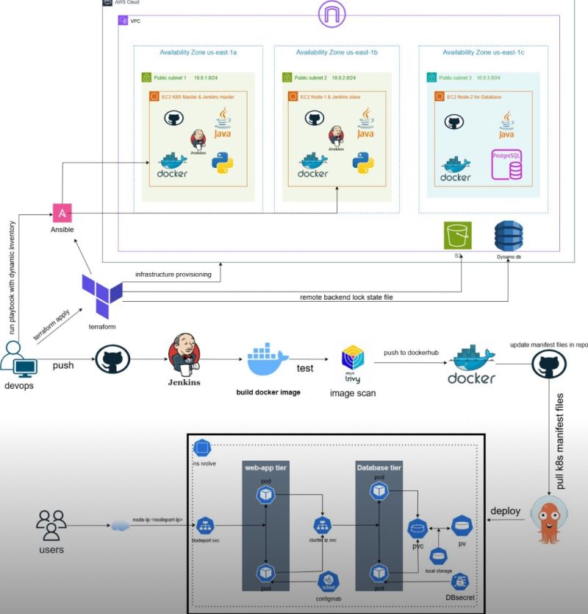

[Living Devops – Let's Do Devops](https://livingdevops.com/)

Most people think observability is just "install Prometheus and Grafana," but production setups look completely different.  
  
We had four microservices running and needed to solve two problems.   
- Logs tell you what happened in your application. - Metrics tell you how it's performing.   
- Different data, different tools, different pipelines.  
  
For logs on Fargate workloads, we used AWS add-ons like OpenTelemetry that automatically pull logs from pods to CloudWatch. Pretty straightforward.  
  
Stateful applications needed a different approach. We ran Fluentd as a sidecar container sharing a volume with the main app. The app writes logs to the volume, Fluentd reads and forwards them. Simple pattern that works everywhere.  
  
Now here's the production part.   
- CloudWatch is fine for basic logging, but when you're dealing with massive data volumes, you need something faster.   
- Our flow looked like this: CloudWatch to a formatter Lambda, then Kinesis Firehose with a 20-minute buffer, streaming into OpenSearch for high-speed queries.   
- Everything also backs up to S3. We kept 7 days in OpenSearch, 30 days in CloudWatch, and months in S3.  
  
OpenSearch costs more, but it's built for querying petabytes of data fast. That matters when you need real-time log analysis.  
  
- For metrics, we used the Prometheus scraping application endpoints every 30 seconds.   
- Developers expose these endpoints using Prometheus SDKs in their code.   
- Then Grafana pulls from Prometheus, CloudWatch, wherever your data lives, and visualizes everything in one place.  
  
- We imported pre-built dashboards from http://  
[**grafana.com**](http://grafana.com/) using just an ID. Got professional EKS monitoring instantly.   
- Then, built custom panels for application-specific metrics.  
- Multiple data sources, one dashboard.  
  
The whole setup took us through what actually runs in production. Not tutorials, not hello world examples.   
The architecture companies use when things need to scale and stay reliable.  
.  
.  
.  
👉 If you want to build this kind of infrastructure yourself instead of just reading about it, my real-time project-based DevOps bootcamp walks through the complete implementation.   
  
Because hands-on experience is what actually prepares you for production environments.  
[**https://lnkd.in/gqkdH38B**](https://lnkd.in/gqkdH38B)  
  
For the Discount and Payment plan, reach out to me

Activate to view larger image,

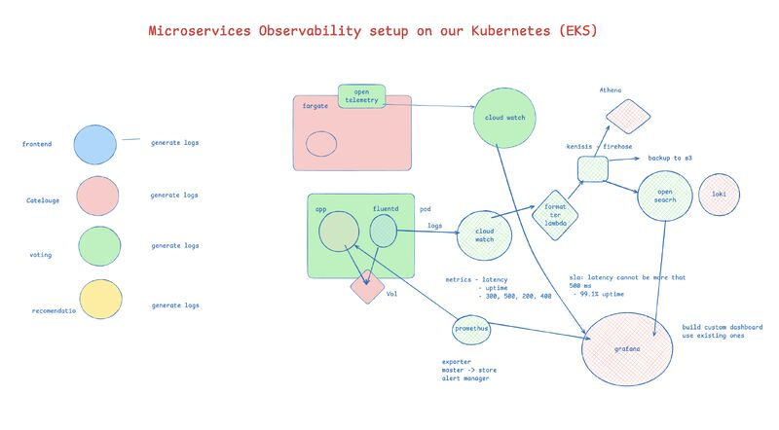

AWS has 200+ services. Most DevOps engineers use these 11 daily and touch maybe 5-10 others occasionally.  
  
Networking:  
VPC - your private cloud network  
ALB - traffic distribution across servers   
Route53 - DNS and domain management  
  
Compute:  
EC2 - virtual servers  
ECS - Docker container orchestration  
EKS - managed Kubernetes  
Lambda - serverless functions  
  
Storage & Data:  
S3 - object storage that scales infinitely  
RDS - managed databases  
  
Operations:  
CloudWatch - monitoring, logs, alerts  
IAM - access control and permissions  
  
Focus on understanding how these 11 services work together rather than collecting service knowledge like Pokemon cards.  
  
Which of these 11 services do you use most in your daily workflow?

The days of “we’ll teach you Kubernetes on the job” are over. Companies want Devops engineers who think in systems, not just tools.  
  
Job descriptions used to list Docker, Jenkins, and AWS as requirements.   
  
Now they want you to design the entire infrastructure from scratch.  
  
The interview questions evolved from what is daemon set, GitOps to:   
- How would you architect zero-downtime deployments for a banking application?  
- Walk me through your approach to auto-scaling across multiple regions during Black Friday traffic.  
- Tell me about implementing chaos engineering in a production environment with strict SLA requirements.  
  
They want to know how you’d design infrastructure that scales from 100 to 100,000 users without breaking.  
  
They expect you to:  
- Understand blast radius and failure modes, not just deployment scripts  
- Design observability strategies, not just setting up monitoring  
- Build self-healing systems, not just reactive automation  
- Think about security architecture, not just compliance checklists  
  
  
  
You can’t fake production experience, but you can:  
- Build complex personal projects that mirror real-world challenges  
- Study post-mortems from major outages  
- Contribute to infrastructure open source projects  
- Document your architectural decision-making process  
  
And this is where my Advanced, real world projects based Devops Bootcamp help you with.   
This is not “Another influencer selling course”, but a real learning experience you will find anywhere.  
  
Check it out: [**https://lnkd.in/gqkdH38B**](https://lnkd.in/gqkdH38B)

You've watched every 'DevOps Zero to Hero' video out there. You've completed multiple Udemy courses. Yet somehow, those interview rejections keep coming.

Watching someone deploy a simple app to AWS or set up a basic Jenkins pipeline isn't enough.

Real DevOps is messy. It's:

- That 2 AM production issue where your EKS cluster is throwing mysterious errors

- Figuring out why your Terraform state is locked after a failed deployment

- Debugging why your microservices can't communicate despite following all the 'tutorial steps'

- Dealing with configuration conflicts that no YouTube video ever mentioned

You see, those polished tutorials? They're scripted. Everything works perfectly. But real DevOps work is about handling things when they DON'T work perfectly.

Want to actually land that job? Start building:

- Set up a multi-environment infrastructure from scratch

- Break things. Fix things. Break them again

- Create complex CI/CD pipelines with real testing and security checks

- Deal with SSL certificates, networking issues, and permission problems

- Build projects that make you question your life choices

Because in interviews, they don't want to hear about what you watched.

They want to hear about what you broke, what you fixed, and what you learned the hard way.

Stop watching. Start building. Start breaking things.

That's where the real learning happens.

.

.

.

Want to learn Devops with advanced, real world projects, production level context and implementations, live troubleshooting?

Join my 20 week Devops bootcamp:

<https://lnkd.in/gqkdH38B>

Production Kubernetes cluster is down. Your manager is asking for updates every 5 minutes.

Here’s your step-by-step troubleshooting playbook:

Step 1: Get your bearings

Check where you are: kubectl config current-context

See all contexts: kubectl config get-contexts

Switch if needed: kubectl config use-context name

List namespaces: kubectl get ns

Step 2: See the big picture

Node health: kubectl get nodes

All pods: kubectl get pods -A

Recent events: kubectl get events –sort-by=.metadata.creationTimestamp -A

This tells you if it’s a cluster-wide issue or isolated problem.

Step 3: Focus on the failing pod

Get details: kubectl describe pod podname -n namespace

Check logs: kubectl logs podname -n namespace

Get inside: kubectl exec -it podname -n namespace – /bin/sh

Step 4: Check health probes

Look for probe failures in the describe output

Test probe endpoint: kubectl exec -it podname -n namespace – curl localhost:port/health

Step 5: Check deployments and rollouts

Rollout status: kubectl rollout status deployment/name -n namespace

View history: kubectl rollout history deployment/name -n namespace

Rollback: kubectl rollout undo deployment/name -n namespace

Step 6: Verify networking

List services: kubectl get svc -n namespace

Check endpoints: kubectl get endpoints -n namespace

Test DNS: kubectl exec -it podname – nslookup servicename

Step 7: Quick fixes that work

Restart deployment: kubectl rollout restart deployment/name -n namespace

Delete problematic pod: kubectl delete pod podname -n namespace

The key is following the steps in order, not jumping around randomly.

.

.

Subscribe to my weekly Devops Newsletter where I share real world Devops related content.

https://lnkd.in/gaca-kQS

Activate to view larger image,

graphical user interface, text, application

Activate to view larger image,

likeinsightfullove

166

2 comments

26 reposts

Like

Comment

Repost

Send

Feed post number 51

View Akhilesh Mishra’s graphic link

Akhilesh MishraAkhilesh Mishra

• FollowingPremium • Following

Senior DevOps Engineer | Write To Inspire | 43k Linkedin | 12k Twitter | 11K Medium | Mentor | Educator | Tech Writer | Help people get into DevOpsSenior DevOps Engineer | Write To Inspire | 43k Linkedin | 12k Twitter | 11K Medium | Mentor | Educator | Tech Writer | Help people get into DevOps

Book an appointment

1w • Edited • 1 week ago • Edited • Visible to anyone on or off LinkedIn

Production Kubernetes cluster is down. Your manager is asking for updates every 5 minutes.

Here’s your step-by-step troubleshooting playbook:

Step 1: Get your bearings

Check where you are: kubectl config current-context

See all contexts: kubectl config get-contexts

Switch if needed: kubectl config use-context name

List namespaces: kubectl get ns

Step 2: See the big picture

Node health: kubectl get nodes

All pods: kubectl get pods -A

Recent events: kubectl get events –sort-by=.metadata.creationTimestamp -A

This tells you if it’s a cluster-wide issue or isolated problem.

Step 3: Focus on the failing pod

Get details: kubectl describe pod podname -n namespace

Check logs: kubectl logs podname -n namespace

Get inside: kubectl exec -it podname -n namespace – /bin/sh

Step 4: Check health probes

Look for probe failures in the describe output

Test probe endpoint: kubectl exec -it podname -n namespace – curl localhost:port/health

Step 5: Check deployments and rollouts

Rollout status: kubectl rollout status deployment/name -n namespace

View history: kubectl rollout history deployment/name -n namespace

Rollback: kubectl rollout undo deployment/name -n namespace

Step 6: Verify networking

List services: kubectl get svc -n namespace

Check endpoints: kubectl get endpoints -n namespace

Test DNS: kubectl exec -it podname – nslookup servicename

Step 7: Quick fixes that work

Restart deployment: kubectl rollout restart deployment/name -n namespace

Delete problematic pod: kubectl delete pod podname -n namespace

The key is following the steps in order, not jumping around randomly.

.

.

Subscribe to my weekly Devops Newsletter where I share real world Devops related content.

https://lnkd.in/gaca-kQS

…more

Activate to view larger image,

graphical user interface, text, application

Your Terraform code looked clean 3 months ago. Now it’s a 3,000-line file that nobody dares to touch.  
  
I’ve been there.  
  
You start simple. A VPC. A few EC2 instances. Some RDS databases.  
  
Then you add more. And more. Before you know it, everything’s a mess.  
  
One massive file. Copy-pasted code for every environment. Hardcoded values everywhere. No security scans. Modules that try to do everything.  
  
Here’s what actually breaks Terraform projects:  
  
1. Putting everything in one file  
When your [**main.tf**](http://main.tf/) is 3,000 lines, finding anything takes forever. Split it. [**networking.tf**](http://networking.tf/), [**compute.tf**](http://compute.tf/), [**database.tf**](http://database.tf/). Keep [**main.tf**](http://main.tf/) under 100 lines.  
  
2. Duplicating code for each environment  
You have three folders: dev, staging, prod. Same code, different values. One codebase with tfvars files is the answer.  
  
3. Hardcoding instance types and AMIs  
Hardcoded values kill flexibility. Use variables. Add validation. Catch mistakes early.  
  
4. Copy-pasting the same blocks everywhere  
If you’re copying code, you need a module. Build it once, use it everywhere.  
  
5. Never scanning for security issues  
Run Checkov or Terrascan in your pipeline. Catch misconfigurations before they hit production.  
  
6. Building modules that do everything  
VPC + EKS + RDS + S3 in one module? Nobody can use it. Make focused modules that do one thing well.  
  
7. Not explaining your decisions  
Six months later, nobody knows why you chose those settings. Document the why, not the what.  
  
I made all these mistakes. Spent nights debugging state corruption. Watched production break because of bad configuration.  
  
You don’t need to go through that.  
  
Fix these issues now. Your team will thank you. Your future self will thank you.  
  
Start with the basics. Split your files. Use variables. Build small modules. Run security scans.  
  
That’s it.  
.  
.  
.  
  
Subscribe to my weekly Devops Newsletter where I share real world Devops related content.  
 [**https://lnkd.in/gaca-kQS**](https://lnkd.in/gaca-kQS)

I checked 50 DevOps job postings last week.  
43 of them said "Python preferred."  
Not required. Preferred.  
  
That's the keyword that changes everything.  
Because most people skip it, they think, "Oh, it's just preferred, not required."  
  
But here's what hiring managers actually mean:  
We'll pick the candidate who knows Python over the one who doesn't. Every single time.  
  
I've been there. I've seen it happen.  
Two equally good candidates. One knows Python. One doesn't.  
  
The one who knows Python gets the offer.  
Because Python means you can actually build stuff.  
  
You're not just running commands someone else wrote. You're writing automation that saves hours of work. You're building tools the whole team uses.  
  
You're solving problems, not just following runbooks.  
  
Look, everyone knows Docker.   
Everyone knows Kubernetes.  
But show me someone who can write an elegant automation that solves a business problem. That's rare.  
  
That's what gets you hired.  
.  
.  
.  
I'm conducting an Advanced Python for DevOps Bootcamp ( Starting on Nov 1st):  
Check it out: [**https://lnkd.in/gXKeZkT4**](https://lnkd.in/gXKeZkT4)  
Use pythonfordevops20 discount code to get 20% off. Valid for 24 hours only.

Top 10 Kubernetes Pod Concepts That Confuse Beginners  
  
1. Pods vs Containers  
A pod is the smallest deployment unit that can house one or more containers, not a single container itself.  
  
2. Pod Lifecycle and Persistence  
Pods are designed to be temporary and ephemeral - they can be easily created, destroyed, and replaced unlike virtual machines.  
  
3. Pod Communication  
Each pod gets its own IP address for cluster communication, while containers within the same pod communicate using localhost.  
  
4. Pod Scaling  
Kubernetes scales applications by adjusting the number of pod replicas (horizontal scaling), not by adding more containers within a pod.  
  
5. Resource Requests and Limits  
You specify how much CPU/memory each container needs (requests) and the maximum it can use (limits) to prevent evictions.  
  
6. Pods vs Deployments  
A pod is a single instance of an application, while a deployment manages multiple pods and handles replication and scaling.  
  
7. Pod Affinity and Anti-Affinity  
Pod affinity keeps related pods together on the same nodes, while anti-affinity separates them for better distribution.  
  
8. Pod Networking Model  
Each pod gets its own IP address allowing direct communication, while Services act as load balancers for consistent access.  
  
9. Persistent Storage in Pods  
While pods are temporary, Kubernetes supports persistent storage through Persistent Volumes that outlive pod lifecycles.  
  
10. Multi-Container Pod Communication  
Containers within the same pod share IP address, port space, and storage volumes, making data sharing seamless.  
  
Understanding these concepts will help you manage containerized applications more effectively and avoid common Kubernetes pitfalls.

Some things in DevOps are so obvious:  
- Docker contains everything   
- Kubernetes makes simple things complicated  
  
- Github Action makes your life easier until it doesn’t.  
- ArgoCD argues with your deployments constantly  
  
- Prometheus promises to alert you about everything  
- Grafana shows you pretty graphs of your pain  
  
- Nginx engines never fail you  
- And coffee does make things easier.  
  
What would you add to this?

Most people think DevOps means "I know AWS, Kubernetes and Docker" then wonder why they can't land a job or excel in their role.  
  
Here's the reality check you need  
  
Excelling at DevOps is not:  
  
❌ Memorizing kubectl commands from Stack Overflow   
❌ Having AWS certifications but never touching production   
❌ Calling yourself "Senior" after 6 months with Jenkins   
❌ Being the person everyone pings at 3AM for outages   
❌ Building complex systems that only you understand  
  
👉 Companies don't need human documentation or personal heroes.   
  
They need systems that work without you.  
  
Real DevOps excellence is about:  
✅ Building monitoring so good you sleep peacefully   
✅ Writing runbooks that junior devs can actually follow   
✅ Creating CI/CD that developers trust and love using   
✅ Designing infrastructure that scales without your intervention   
✅ Making deployments so boring they become routine  
  
👉 The best DevOps engineers are the ones whose systems run so smoothly, people forget they exist.  
  
Excellence isn't about:  
✅ Knowing every tool that exists   
✅ Being the smartest person in the room   
✅ Working harder than everyone else  
  
👉 It's about making everyone else's job easier while you focus on what actually matters.  
  
Remember: Great DevOps engineers build themselves out of emergencies, not into them.

==

DevOps in plain English:

✅ Cloud:  
• AWS/GCP/Azure → cloud platforms  
• Terraform → infrastructure as code  
  
✅ Scripting:  
• Bash → automation scripts  
• Python → complex automation  
  
✅ Containers:  
• Docker → application packaging  
• Kubernetes → container orchestration  
  
✅ CI/CD:  
• Jenkins → build automation  
• GitHub Actions → integrated pipelines  
• ArgoCD → CD tools for kubernetes   
  
✅ Monitoring:  
• Prometheus → metrics collection  
• Grafana → data visualization  
  
✅ Version Control:  
• Git → code versioning  
• GitHub → code collaboration  
  
✅ Devsecops:  
• checkov → Terraform scans  
• trivy → docker image scanning  
• sonarcube → code scanning   
  
That’s 80% of what you’ll touch daily.

There are two ways to expose your microservices on AWS EKS with SSL. Some prefer ALB while others go with NLB  
  
Most teams pick one without understanding the trade-offs. Here's what you need to know:  
  
1. Application Load Balancer + AWS Certificate Manager  
  
The load balancer sits outside your cluster and handles everything at the HTTP layer. You get SSL termination at the ALB, path-based routing, and automatic certificate renewal through ACM.  
  
Install the AWS Load Balancer Controller in your cluster. Create an Ingress resource with ACM certificate annotations. The controller creates the ALB automatically.  
  
Traffic flow: User → ALB (SSL termination) → Pods (HTTP)  
  
Benefits: Fully managed by AWS. Zero certificate maintenance. Simple setup.  
  
Drawbacks: Locked into AWS. HTTP/HTTPS only.  
  
2. Network Load Balancer + cert-manager  
  
The load balancer operates at the TCP layer and just forwards packets. SSL termination happens inside your cluster at the NGINX Ingress Controller.  
  
Install cert-manager and NGINX Ingress Controller. Create an Ingress with cert-manager annotations. It automatically requests certificates from Let's Encrypt.  
  
Traffic flow: User → NLB (TCP forwarding) → NGINX (SSL termination) → Pods (HTTP)  
  
Benefits: Cloud-agnostic. Works with any protocol. Lower cost at scale. End-to-end encryption.  
  
Drawbacks: More components to manage. You handle certificate renewals (automated, but still your responsibility).  
  
Both approaches work in production. Both scale.   
  
The right choice depends on your constraints and priorities.

Activate to view larger image,

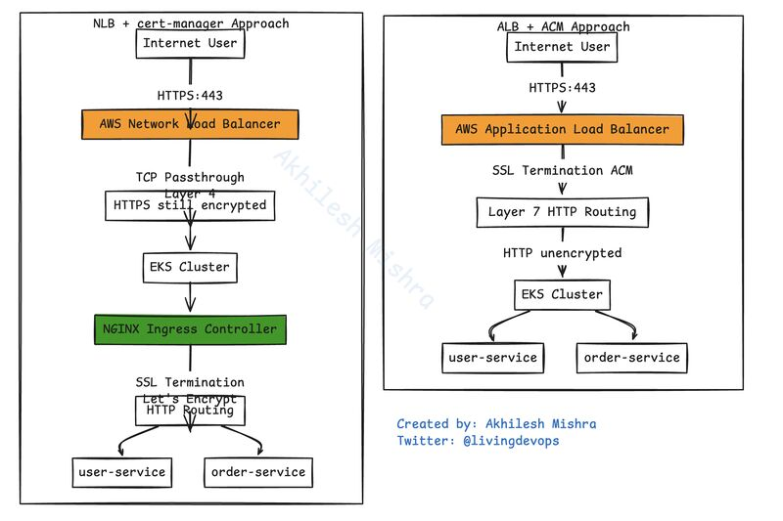

If you’re planning to get into DevOps in 2026, then stop learning like it’s 2020.  
  
👉 Choose GitHub Actions over Jenkins.  
Jenkins feels like maintaining legacy code. GitHub Actions integrates with your repos, has built-in security scanning, and every company is moving to it.  
  
👉 Choose Terraform over cloud-specific IaC  
AWS CloudFormation locks you into AWS. Azure ARM locks you into Azure. Terraform works everywhere. Learn one tool, manage any cloud.  
  
👉 Choose Loki + Grafana over Datadog.  
Datadog will eat your budget. Loki gives you powerful log aggregation without the enterprise price tag. Plus, Grafana visualizations are industry standard now.  
  
👉 Choose Kubernetes over Docker Swarm.  
Swarm is dead. Kubernetes won. Every job posting mentions K8s. Learn what companies actually use in production.  
  
👉 Choose Prometheus over Nagios.  
Nagios is what legacy systems still run. Prometheus is what modern infrastructure uses. Better query language, native Kubernetes integration, and actually scales.  
  
👉 Leave Ansible in the dumpster, you don’t need it.  
  
👉 Choose Python over Go for DevOps  
Yes, Go is faster. But Python is fast enough for 99% of DevOps work, and you can actually write it without fighting the language.  
  
👉 You also need to learn basic system design basics, detailed architecture and disaster recovery practices.  
  
Learn what matters. Ignore the rest.​​​​​​​​​​​​​​​​  
  
✅Spend time on Medium, Reddit, and daily dev to stay up-to-date with the latest tools, trends, and implementations.

These Linux commands helped me most in last 13 years of IT career  
  
Daily Heroes:  
• ps aux | grep {process} - Find that sneaky process  
• lsof -i :{port} - Who's hogging that port?  
• df -h - The classic "we're out of space" checker  
• netstat -tulpn - Network connection detective  
• kubectl get pods | grep -i error - K8s trouble finder  
  
Log Warriors:  
• tail -f /var/log/\* - Real-time log watcher  
• journalctl -fu service-name - SystemD log stalker  
• grep -r "error" . - The error hunter  
• zcat access.log.gz | grep "500" - Compressed log ninja  
• less +F - The better tail command  
  
Container Whisperers:  
• docker ps --format '{{.Names}} {{.Status}}' - Clean status check  
• docker stats --no-stream - Quick resource check  
• crictl logs {container} - Raw container stories  
• docker exec -it - The container backdoor  
• podman top - Process peek inside containers  
  
System Detectives:  
• htop - System resource storyteller  
• iostat -xz 1 - Disk performance poet  
• free -h - Memory mystery solver  
• vmstat 1 - System vital signs  
• dmesg -T | tail - Kernel's recent gossip  
  
Network Ninjas:  
• curl -v - HTTP conversation debugger  
• dig +short - Quick DNS lookup  
• ss -tunlp - Socket statistics simplified  
• iptables -L - Firewall rule reader  
• traceroute - Path finder  
  
File Jugglers:  
• find . -name "\*.yaml" -type f - YAML hunter  
• rsync -avz - Better file copier  
• tar -xvf - The unzipper (yes, we all google this)  
• ln -s - Symlink wizard  
• chmod +x - Make it executable  
  
Performance Profilers:  
• strace -p {pid} - System call spy  
• tcpdump -i any - Network packet sniffer  
• sar -n DEV 1 - Network stats watch  
• uptime - Load average at a glance  
• top -c - Classic process viewer  
  
Git Essentials:  
• git log --oneline - History simplified  
• git reset --hard HEAD^ - The "oops" eraser  
• git stash - The work hider  
• git diff --cached - What's staged?  
• git blame - The "who did this?" resolver  
  
Quick Fixes:  
• sudo !! - Run last command with sudo  
• ctrl+r - Command history search  
• history | grep - Command time machine  
• alias - Command shortcut maker  
• watch - Command repeater

AI won’t take your DevOps job. But a DevOps engineer using AI will.  
  
If your daily work is copy-pasting Terraform from GitHub, following tutorials without understanding why, and setting up alerts that only scream after everything’s already on fire, then  
You’re in trouble.  
  
That’s not DevOps. That’s following instructions. And AI is really good at following instructions.  
  
Meanwhile, smart engineers are using AI differently.  
  
- They let AI write boilerplate while they focus on system design.  
- They let AI generate test cases while they focus on breaking things properly.  
- They let AI handle documentation while they make architectural decisions.  
  
Here’s what companies actually pay for:  
  
- Someone who can debug a production incident at 3 AM when monitoring shows nothing useful.  
  
- Someone who can design systems that survive failures without taking everything down.  
  
- Someone who can make trade-offs between cost, performance, and reliability based on real business context.  
  
  
AI can generate a Kubernetes manifest, but AI can’t decide if Kubernetes is even the right choice for your problem.  
  
AI can write Terraform code, but AI can’t design infrastructure that balances your team’s skills, budget constraints, and business needs.  
  
  
The real question isn’t “Will AI replace DevOps?”  
It’s “Are you building skills AI can’t replicate?”  
  
Stop competing with AI on repetitive tasks, and start using AI to amplify what only humans can do: judgment, context, and experience.  
  
Level up or get left behind.

Early in my DevOps career, I deleted a 5GB log file from a production server that was running out of space.

I ran df -h expecting to see the disk usage drop. It didn’t.

Still showed 100% full.

No errors, no warnings. Just the same disk usage as before I deleted anything.

That’s when I learned that deleting a file doesn’t always free up space immediately.

In Linux, what we think of as a “file” is actually two separate things: the filename (which is just a pointer) and the inode (which contains the actual data and metadata). When you delete a filename, you’re only removing the pointer. The inode and its data remain on disk as long as any process still has the file open.

In my case, the web server was still writing to that log file. Even though I had deleted the filename, the server process kept its file handle open. The inode stayed alive, invisible to normal file listings but still consuming disk space.

The space was only freed when I restarted the web server, which closed all its file handles.

This is why you need different commands to see the full picture:

# Check filesystem usage

- df -h

# Check actual directory sizes

- du -sh /var/log/\*

# Find deleted files still open by processes

- lsof +L1

The du command shows you what’s actually using space in directories, while df shows filesystem-level usage.

When they don’t match, you often have deleted files still held open by running processes.

This is also why proper log rotation doesn’t just delete files. Tools like logrotate rename files and send signals to processes so they can close and reopen their file handles cleanly.

Three key takeaways:

1. Filenames are just pointers to inodes

1. Deletion only happens when no processes reference the inode

1. Always check both df and du when troubleshooting disk space

It’s a small detail, but understanding it can save you from confusing production incidents.

[What is HTTPS? | Cloudflare](https://www.cloudflare.com/en-gb/learning/ssl/what-is-https/)

[How does the Internet work? | Cloudflare](https://www.cloudflare.com/en-gb/learning/network-layer/how-does-the-internet-work/)

[Course: DevOps for beginners: Docker, K8s, Cloud, CI/CD & 4 Projects | Udemy Business](https://tcsglobal.udemy.com/course/devops-for-beginners-docker-k8s-cloud-cicd-4-projects/learn/lecture/49337979#overview)

Kubernetes CI/CD — The Future of Modern Deployments!  
Ever wondered what makes Kubernetes-based CI/CD pipelines so powerful compared to traditional setups?  
  
Here’s a clear visual that shows the transformation  
  
Conventional Pipeline:  
  
Code committed to Git  
Build using tools like JUnit and SonarQube  
Artifacts stored in Artifactory  
Manual deployment to staging → QA → production  
  
Kubernetes Pipeline:  
  
Code committed → Dockerized build  
Push image to Container Registry (DockerHub/GitHub)  
Automated rollout using Kubernetes manifests  
Smart deployment strategies: Blue-Green & Canary  
Seamless flow across Staging, QA, and Prod Clusters  
Continuous monitoring, self-healing, and scaling   
  
Key Takeaway:  
  
Kubernetes brings automation, scalability, and resilience to CI/CD by reducing manual effort and accelerating delivery. With containerization and Infrastructure as Code, deployments become faster, repeatable, and cloud-native.  
  
Whether you're a DevOps Engineer, SRE, or Cloud Architect. Mastering Kubernetes pipelines is the next step in cloud automation excellence.  
  
  
What’s your go-to CI/CD stack for Kubernetes?  
  
[**hashtag#Kubernetes**](https://www.linkedin.com/search/results/all/?keywords=%23kubernetes&origin=HASH_TAG_FROM_FEED) [**hashtag#CICD**](https://www.linkedin.com/search/results/all/?keywords=%23cicd&origin=HASH_TAG_FROM_FEED) [**hashtag#DevOps**](https://www.linkedin.com/search/results/all/?keywords=%23devops&origin=HASH_TAG_FROM_FEED) [**hashtag#CloudComputing**](https://www.linkedin.com/search/results/all/?keywords=%23cloudcomputing&origin=HASH_TAG_FROM_FEED) [**hashtag#Containerization**](https://www.linkedin.com/search/results/all/?keywords=%23containerization&origin=HASH_TAG_FROM_FEED) [**hashtag#Docker**](https://www.linkedin.com/search/results/all/?keywords=%23docker&origin=HASH_TAG_FROM_FEED) [**hashtag#Helm**](https://www.linkedin.com/search/results/all/?keywords=%23helm&origin=HASH_TAG_FROM_FEED) [**hashtag#Terraform**](https://www.linkedin.com/search/results/all/?keywords=%23terraform&origin=HASH_TAG_FROM_FEED) [**hashtag#Jenkins**](https://www.linkedin.com/search/results/all/?keywords=%23jenkins&origin=HASH_TAG_FROM_FEED) [**hashtag#GitOps**](https://www.linkedin.com/search/results/all/?keywords=%23gitops&origin=HASH_TAG_FROM_FEED) [**hashtag#ArgoCD**](https://www.linkedin.com/search/results/all/?keywords=%23argocd&origin=HASH_TAG_FROM_FEED) [**hashtag#SonarQube**](https://www.linkedin.com/search/results/all/?keywords=%23sonarqube&origin=HASH_TAG_FROM_FEED) [**hashtag#JUnit**](https://www.linkedin.com/search/results/all/?keywords=%23junit&origin=HASH_TAG_FROM_FEED) [**hashtag#BlueGreenDeployment**](https://www.linkedin.com/search/results/all/?keywords=%23bluegreendeployment&origin=HASH_TAG_FROM_FEED) [**hashtag#CanaryDeployment**](https://www.linkedin.com/search/results/all/?keywords=%23canarydeployment&origin=HASH_TAG_FROM_FEED) [**hashtag#CloudNative**](https://www.linkedin.com/search/results/all/?keywords=%23cloudnative&origin=HASH_TAG_FROM_FEED) [**hashtag#SRE**](https://www.linkedin.com/search/results/all/?keywords=%23sre&origin=HASH_TAG_FROM_FEED) [**hashtag#InfrastructureAsCode**](https://www.linkedin.com/search/results/all/?keywords=%23infrastructureascode&origin=HASH_TAG_FROM_FEED) [**hashtag#Automation**](https://www.linkedin.com/search/results/all/?keywords=%23automation&origin=HASH_TAG_FROM_FEED) [**hashtag#AWS**](https://www.linkedin.com/search/results/all/?keywords=%23aws&origin=HASH_TAG_FROM_FEED) [**hashtag#Azure**](https://www.linkedin.com/search/results/all/?keywords=%23azure&origin=HASH_TAG_FROM_FEED) [**hashtag#GCP**](https://www.linkedin.com/search/results/all/?keywords=%23gcp&origin=HASH_TAG_FROM_FEED) [**hashtag#CloudEngineer**](https://www.linkedin.com/search/results/all/?keywords=%23cloudengineer&origin=HASH_TAG_FROM_FEED) [**hashtag#PlatformEngineering**](https://www.linkedin.com/search/results/all/?keywords=%23platformengineering&origin=HASH_TAG_FROM_FEED) [**hashtag#TechCommunity**](https://www.linkedin.com/search/results/all/?keywords=%23techcommunity&origin=HASH_TAG_FROM_FEED) [**hashtag#Innovation**](https://www.linkedin.com/search/results/all/?keywords=%23innovation&origin=HASH_TAG_FROM_FEED) [**hashtag#DevSecOps**](https://www.linkedin.com/search/results/all/?keywords=%23devsecops&origin=HASH_TAG_FROM_FEED) [**hashtag#C2C**](https://www.linkedin.com/search/results/all/?keywords=%23c2c&origin=HASH_TAG_FROM_FEED) [**hashtag#CloudEngineering**](https://www.linkedin.com/search/results/all/?keywords=%23cloudengineering&origin=HASH_TAG_FROM_FEED) [**hashtag#USAJOBS**](https://www.linkedin.com/search/results/all/?keywords=%23usajobs&origin=HASH_TAG_FROM_FEED) [**hashtag#TechJobs**](https://www.linkedin.com/search/results/all/?keywords=%23techjobs&origin=HASH_TAG_FROM_FEED)



From Code to Cloud — The DevOps Way  
  
Ever wondered how your code moves from a Git commit to a live running application on AWS?  
  
This simple visual breaks it down beautifully. Here’s the flow most high-performing DevOps teams use:  
1) GitHub → Stores code & triggers builds when new commits are pushed.  
2) Jenkins → Detects changes & kicks off the CI/CD pipeline automatically.  
3) Docker → Packages apps into portable containers for consistent deployments.  
4) Terraform (IaC) → Provisions AWS EC2 instances & network infra in code.  
5) Ansible → Automates configuration & deployment of containers to EC2.  
6) AWS EC2 → Runs the final app to be scalable, secure, production-ready.  
  
Key Takeaway:  
The magic of DevOps isn’t in the tools it’s in the automation, consistency, and collaboration that make delivery faster and more reliable.  
--> Automate early.  
--> Test continuously.  
--> Deploy confidently.  
  
If you’re building or scaling cloud infrastructure, this is the roadmap worth mastering.  
  
[**hashtag#DevOps**](https://www.linkedin.com/search/results/all/?keywords=%23devops&origin=HASH_TAG_FROM_FEED) [**hashtag#CloudComputing**](https://www.linkedin.com/search/results/all/?keywords=%23cloudcomputing&origin=HASH_TAG_FROM_FEED) [**hashtag#AWS**](https://www.linkedin.com/search/results/all/?keywords=%23aws&origin=HASH_TAG_FROM_FEED) [**hashtag#Terraform**](https://www.linkedin.com/search/results/all/?keywords=%23terraform&origin=HASH_TAG_FROM_FEED) [**hashtag#Ansible**](https://www.linkedin.com/search/results/all/?keywords=%23ansible&origin=HASH_TAG_FROM_FEED) [**hashtag#Docker**](https://www.linkedin.com/search/results/all/?keywords=%23docker&origin=HASH_TAG_FROM_FEED) [**hashtag#GitHub**](https://www.linkedin.com/search/results/all/?keywords=%23github&origin=HASH_TAG_FROM_FEED) [**hashtag#Jenkins**](https://www.linkedin.com/search/results/all/?keywords=%23jenkins&origin=HASH_TAG_FROM_FEED) [**hashtag#CICD**](https://www.linkedin.com/search/results/all/?keywords=%23cicd&origin=HASH_TAG_FROM_FEED) [**hashtag#InfrastructureAsCode**](https://www.linkedin.com/search/results/all/?keywords=%23infrastructureascode&origin=HASH_TAG_FROM_FEED) [**hashtag#Automation**](https://www.linkedin.com/search/results/all/?keywords=%23automation&origin=HASH_TAG_FROM_FEED) [**hashtag#CloudEngineer**](https://www.linkedin.com/search/results/all/?keywords=%23cloudengineer&origin=HASH_TAG_FROM_FEED) [**hashtag#SRE**](https://www.linkedin.com/search/results/all/?keywords=%23sre&origin=HASH_TAG_FROM_FEED) [**hashtag#PlatformEngineering**](https://www.linkedin.com/search/results/all/?keywords=%23platformengineering&origin=HASH_TAG_FROM_FEED) [**hashtag#CloudNative**](https://www.linkedin.com/search/results/all/?keywords=%23cloudnative&origin=HASH_TAG_FROM_FEED) [**hashtag#DevSecOps**](https://www.linkedin.com/search/results/all/?keywords=%23devsecops&origin=HASH_TAG_FROM_FEED) [**hashtag#CareerInTech**](https://www.linkedin.com/search/results/all/?keywords=%23careerintech&origin=HASH_TAG_FROM_FEED) [**hashtag#TechCommunity**](https://www.linkedin.com/search/results/all/?keywords=%23techcommunity&origin=HASH_TAG_FROM_FEED) [**hashtag#Innovation**](https://www.linkedin.com/search/results/all/?keywords=%23innovation&origin=HASH_TAG_FROM_FEED) [**hashtag#EngineeringExcellence**](https://www.linkedin.com/search/results/all/?keywords=%23engineeringexcellence&origin=HASH_TAG_FROM_FEED) [**hashtag#C2C**](https://www.linkedin.com/search/results/all/?keywords=%23c2c&origin=HASH_TAG_FROM_FEED) [**hashtag#SRE**](https://www.linkedin.com/search/results/all/?keywords=%23sre&origin=HASH_TAG_FROM_FEED) [**hashtag#CloudEngineering**](https://www.linkedin.com/search/results/all/?keywords=%23cloudengineering&origin=HASH_TAG_FROM_FEED) [**hashtag#APM**](https://www.linkedin.com/search/results/all/?keywords=%23apm&origin=HASH_TAG_FROM_FEED) [**hashtag#Containerization**](https://www.linkedin.com/search/results/all/?keywords=%23containerization&origin=HASH_TAG_FROM_FEED) [**hashtag#Integration**](https://www.linkedin.com/search/results/all/?keywords=%23integration&origin=HASH_TAG_FROM_FEED) [**hashtag#JOBS**](https://www.linkedin.com/search/results/all/?keywords=%23jobs&origin=HASH_TAG_FROM_FEED) [**hashtag#US**](https://www.linkedin.com/search/results/all/?keywords=%23us&origin=HASH_TAG_FROM_FEED)

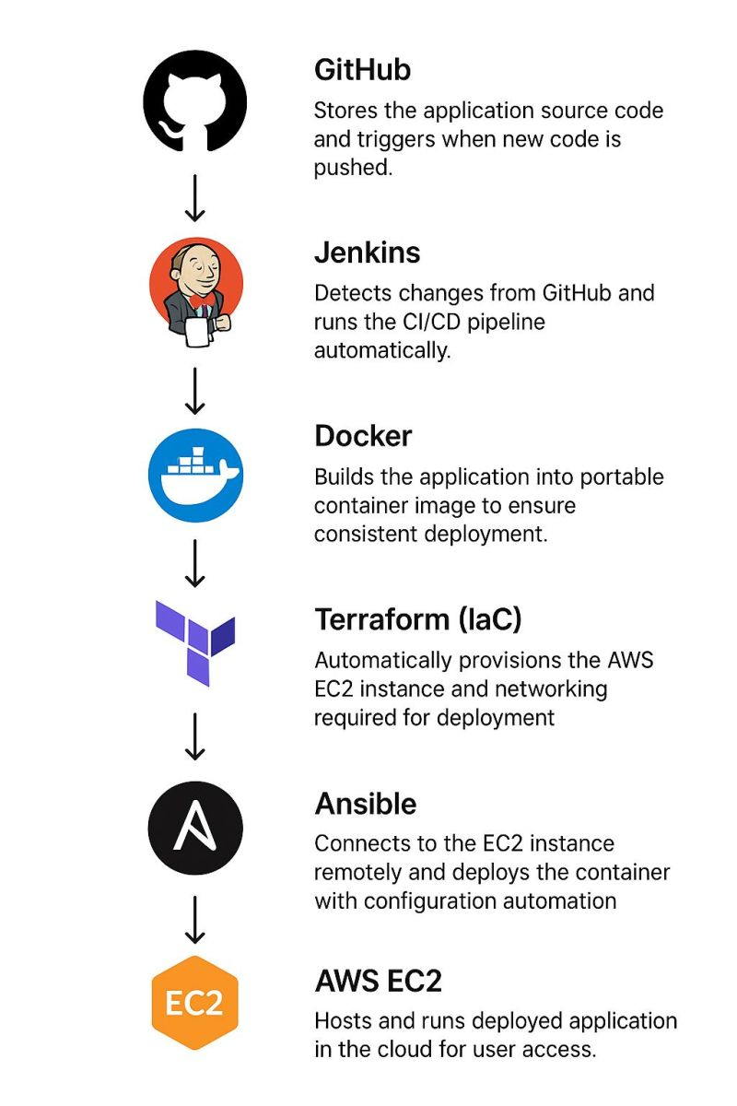

“One misconfigured subnet almost brought down our AKS pipeline.”  
"While deploying an AKS cluster using Azure DevOps pipelines, everything looked fine until our workloads couldn’t pull secrets or route outbound traffic. The cluster was up. Nodes were healthy. But pods failed silently. Why? Misconfigured VNet subnet delegation."  
  
Here’s what we learned and implemented:  
1. Validated subnet delegation and NSG rules using automated PowerShell checks  
2. Created reusable Terraform + ARM templates for consistent AKS + VNet pairing  
3. Integrated checks into Azure DevOps pipelines as pre-deployment stages  
4. Hardened network policies and restricted pod communication via Calico  
5. Instrumented Network Watcher + Log Analytics for traffic flow tracing  
Result:  
1. Faster detection of network misconfigs  
2. Zero downtime in staging and lower MTTR in prod  
3. Repeatable, secure AKS deployment patterns at scale  
In cloud-native environments, networking is half the battle and it often hides beneath “successful” deployments.  
  
Are you validating your infra and networking logic before AKS even spins up?  
  
[**hashtag#AzureCloud**](https://www.linkedin.com/search/results/all/?keywords=%23azurecloud&origin=HASH_TAG_FROM_FEED) [**hashtag#AKS**](https://www.linkedin.com/search/results/all/?keywords=%23aks&origin=HASH_TAG_FROM_FEED) [**hashtag#VNet**](https://www.linkedin.com/search/results/all/?keywords=%23vnet&origin=HASH_TAG_FROM_FEED) [**hashtag#Subnet**](https://www.linkedin.com/search/results/all/?keywords=%23subnet&origin=HASH_TAG_FROM_FEED) [**hashtag#AzureDevOps**](https://www.linkedin.com/search/results/all/?keywords=%23azuredevops&origin=HASH_TAG_FROM_FEED) [**hashtag#Pipelines**](https://www.linkedin.com/search/results/all/?keywords=%23pipelines&origin=HASH_TAG_FROM_FEED) [**hashtag#PowerShell**](https://www.linkedin.com/search/results/all/?keywords=%23powershell&origin=HASH_TAG_FROM_FEED) [**hashtag#InfrastructureAsCode**](https://www.linkedin.com/search/results/all/?keywords=%23infrastructureascode&origin=HASH_TAG_FROM_FEED) [**hashtag#Networking**](https://www.linkedin.com/search/results/all/?keywords=%23networking&origin=HASH_TAG_FROM_FEED) [**hashtag#DevOps**](https://www.linkedin.com/search/results/all/?keywords=%23devops&origin=HASH_TAG_FROM_FEED)   
[**hashtag#CloudEngineering**](https://www.linkedin.com/search/results/all/?keywords=%23cloudengineering&origin=HASH_TAG_FROM_FEED) [**hashtag#SRE**](https://www.linkedin.com/search/results/all/?keywords=%23sre&origin=HASH_TAG_FROM_FEED) [**hashtag#MTTR**](https://www.linkedin.com/search/results/all/?keywords=%23mttr&origin=HASH_TAG_FROM_FEED) [**hashtag#Observability**](https://www.linkedin.com/search/results/all/?keywords=%23observability&origin=HASH_TAG_FROM_FEED) [**hashtag#IaC**](https://www.linkedin.com/search/results/all/?keywords=%23iac&origin=HASH_TAG_FROM_FEED) [**hashtag#ProductionReady**](https://www.linkedin.com/search/results/all/?keywords=%23productionready&origin=HASH_TAG_FROM_FEED) [**hashtag#TechnicalRecruiter**](https://www.linkedin.com/search/results/all/?keywords=%23technicalrecruiter&origin=HASH_TAG_FROM_FEED) [**hashtag#SeniorTalentAcquisitionSpecialist**](https://www.linkedin.com/search/results/all/?keywords=%23seniortalentacquisitionspecialist&origin=HASH_TAG_FROM_FEED)   
[**hashtag#GlobalTechRecruiter**](https://www.linkedin.com/search/results/all/?keywords=%23globaltechrecruiter&origin=HASH_TAG_FROM_FEED) [**hashtag#SeniorTechnicalRecruiter**](https://www.linkedin.com/search/results/all/?keywords=%23seniortechnicalrecruiter&origin=HASH_TAG_FROM_FEED) [**hashtag#TalentAcquisition**](https://www.linkedin.com/search/results/all/?keywords=%23talentacquisition&origin=HASH_TAG_FROM_FEED) [**hashtag#RecruitingManager**](https://www.linkedin.com/search/results/all/?keywords=%23recruitingmanager&origin=HASH_TAG_FROM_FEED) [**hashtag#USOpportunities**](https://www.linkedin.com/search/results/all/?keywords=%23usopportunities&origin=HASH_TAG_FROM_FEED)  
[**hashtag#BenchSales**](https://www.linkedin.com/search/results/all/?keywords=%23benchsales&origin=HASH_TAG_FROM_FEED) [**hashtag#Recruiter**](https://www.linkedin.com/search/results/all/?keywords=%23recruiter&origin=HASH_TAG_FROM_FEED) [**hashtag#ITJobs**](https://www.linkedin.com/search/results/all/?keywords=%23itjobs&origin=HASH_TAG_FROM_FEED) [**hashtag#USA**](https://www.linkedin.com/search/results/all/?keywords=%23usa&origin=HASH_TAG_FROM_FEED)   
[**hashtag#USAITJobs**](https://www.linkedin.com/search/results/all/?keywords=%23usaitjobs&origin=HASH_TAG_FROM_FEED) [**hashtag#Vendors**](https://www.linkedin.com/search/results/all/?keywords=%23vendors&origin=HASH_TAG_FROM_FEED) [**hashtag#Virginia**](https://www.linkedin.com/search/results/all/?keywords=%23virginia&origin=HASH_TAG_FROM_FEED) [**hashtag#Cincinnati**](https://www.linkedin.com/search/results/all/?keywords=%23cincinnati&origin=HASH_TAG_FROM_FEED) [**hashtag#California**](https://www.linkedin.com/search/results/all/?keywords=%23california&origin=HASH_TAG_FROM_FEED) [**hashtag#C2C**](https://www.linkedin.com/search/results/all/?keywords=%23c2c&origin=HASH_TAG_FROM_FEED) [**hashtag#CorpToCorp**](https://www.linkedin.com/search/results/all/?keywords=%23corptocorp&origin=HASH_TAG_FROM_FEED)

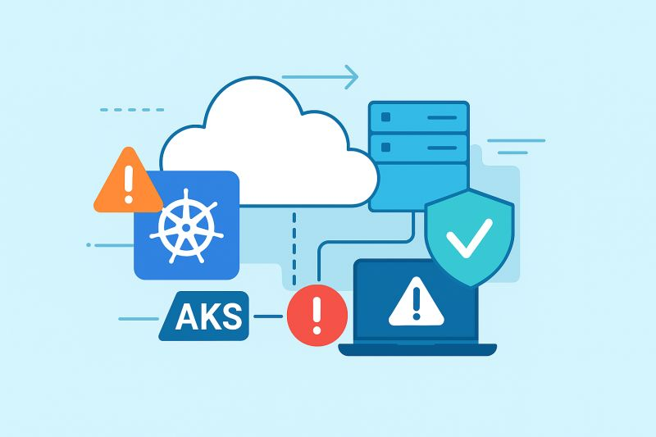

DNS Is Not Magic… But It’s Usually The Problem  
If you've ever been troubleshooting slow microservices in Kubernetes, you already know this one:  
  
It’s always the DNS. And even when it's not DNS it still somehow ends up being DNS.  
Recently, we were investigating latency issues in one of our services were there are no errors, no CPU spikes and the Pods were healthy but the app was super slow so decided to dig with logs, metrics, and packet traces we found the root cause in CoreDNS.  
  
Enabling Autopath reduced DNS resolution time, Simple change, Massive impact.   
  
Takeaway:  
Before blaming the app, the network, or Kubernetes itself.  
  
--> Always check DNS first.  
It saves time. It saves frustration. And it saves you from those 2-hour war room calls.  
  
  
[**hashtag#DNS**](https://www.linkedin.com/search/results/all/?keywords=%23dns&origin=HASH_TAG_FROM_FEED) [**hashtag#Kubernetes**](https://www.linkedin.com/search/results/all/?keywords=%23kubernetes&origin=HASH_TAG_FROM_FEED) [**hashtag#CoreDNS**](https://www.linkedin.com/search/results/all/?keywords=%23coredns&origin=HASH_TAG_FROM_FEED) [**hashtag#DevOps**](https://www.linkedin.com/search/results/all/?keywords=%23devops&origin=HASH_TAG_FROM_FEED) [**hashtag#SRE**](https://www.linkedin.com/search/results/all/?keywords=%23sre&origin=HASH_TAG_FROM_FEED) [**hashtag#PlatformEngineering**](https://www.linkedin.com/search/results/all/?keywords=%23platformengineering&origin=HASH_TAG_FROM_FEED) [**hashtag#CloudEngineering**](https://www.linkedin.com/search/results/all/?keywords=%23cloudengineering&origin=HASH_TAG_FROM_FEED) [**hashtag#Networking**](https://www.linkedin.com/search/results/all/?keywords=%23networking&origin=HASH_TAG_FROM_FEED) [**hashtag#Microservices**](https://www.linkedin.com/search/results/all/?keywords=%23microservices&origin=HASH_TAG_FROM_FEED) [**hashtag#K8s**](https://www.linkedin.com/search/results/all/?keywords=%23k8s&origin=HASH_TAG_FROM_FEED) [**hashtag#KubeLife**](https://www.linkedin.com/search/results/all/?keywords=%23kubelife&origin=HASH_TAG_FROM_FEED) [**hashtag#Troubleshooting**](https://www.linkedin.com/search/results/all/?keywords=%23troubleshooting&origin=HASH_TAG_FROM_FEED) [**hashtag#Debugging**](https://www.linkedin.com/search/results/all/?keywords=%23debugging&origin=HASH_TAG_FROM_FEED) [**hashtag#Observability**](https://www.linkedin.com/search/results/all/?keywords=%23observability&origin=HASH_TAG_FROM_FEED) [**hashtag#PerformanceTuning**](https://www.linkedin.com/search/results/all/?keywords=%23performancetuning&origin=HASH_TAG_FROM_FEED) [**hashtag#IncidentResponse**](https://www.linkedin.com/search/results/all/?keywords=%23incidentresponse&origin=HASH_TAG_FROM_FEED) [**hashtag#CloudNative**](https://www.linkedin.com/search/results/all/?keywords=%23cloudnative&origin=HASH_TAG_FROM_FEED) [**hashtag#InfraLife**](https://www.linkedin.com/search/results/all/?keywords=%23infralife&origin=HASH_TAG_FROM_FEED) [**hashtag#TechTips**](https://www.linkedin.com/search/results/all/?keywords=%23techtips&origin=HASH_TAG_FROM_FEED) [**hashtag#Latency**](https://www.linkedin.com/search/results/all/?keywords=%23latency&origin=HASH_TAG_FROM_FEED) [**hashtag#EngineerLife**](https://www.linkedin.com/search/results/all/?keywords=%23engineerlife&origin=HASH_TAG_FROM_FEED) [**hashtag#ItIsAlwaysDNS**](https://www.linkedin.com/search/results/all/?keywords=%23itisalwaysdns&origin=HASH_TAG_FROM_FEED) [**hashtag#DevCommunity**](https://www.linkedin.com/search/results/all/?keywords=%23devcommunity&origin=HASH_TAG_FROM_FEED) [**hashtag#LearningInPublic**](https://www.linkedin.com/search/results/all/?keywords=%23learninginpublic&origin=HASH_TAG_FROM_FEED) [**hashtag#C2C**](https://www.linkedin.com/search/results/all/?keywords=%23c2c&origin=HASH_TAG_FROM_FEED)

Activate to view larger image,

SRE isn’t about achieving 100% uptime.  
  
It’s about knowing when not to.  
  
I think this is one of the most misunderstood parts of the SRE role. People assume reliability means zero downtime. But in real-world systems, perfect reliability = infinite cost. So instead, we use SLOs and Error Budgets.  
Here’s how it works:  
Instead of aiming for 100% uptime, we define what’s good enough (ex: 99.9%).  
  
That remaining 0.1% becomes the error budget.  
We can “spend” that budget on:  
 • Deploying new features  
 • Running experiments  
 • System improvements  
If we exceed the error budget → we slow down and stabilize.  
 If we have budget left → we can release faster.  
This is why SRE is not just “Ops with scripts.”  
 It’s engineering + reliability + business alignment.  
  
  
Reliability is a product decision, not just a technical one.  
If you're an SRE, DevOps, or Cloud Engineer:  
 Your goal is not to stop failure.  
 Your goal is to balance reliability with innovation.  
That’s where the real impact is.  
  
[**hashtag#SRE**](https://www.linkedin.com/search/results/all/?keywords=%23sre&origin=HASH_TAG_FROM_FEED) [**hashtag#DevOps**](https://www.linkedin.com/search/results/all/?keywords=%23devops&origin=HASH_TAG_FROM_FEED) [**hashtag#CloudEngineering**](https://www.linkedin.com/search/results/all/?keywords=%23cloudengineering&origin=HASH_TAG_FROM_FEED) [**hashtag#Reliability**](https://www.linkedin.com/search/results/all/?keywords=%23reliability&origin=HASH_TAG_FROM_FEED) [**hashtag#SLOs**](https://www.linkedin.com/search/results/all/?keywords=%23slos&origin=HASH_TAG_FROM_FEED) [**hashtag#ErrorBudgets**](https://www.linkedin.com/search/results/all/?keywords=%23errorbudgets&origin=HASH_TAG_FROM_FEED) [**hashtag#TechLeadership**](https://www.linkedin.com/search/results/all/?keywords=%23techleadership&origin=HASH_TAG_FROM_FEED) [**hashtag#Observability**](https://www.linkedin.com/search/results/all/?keywords=%23observability&origin=HASH_TAG_FROM_FEED) [**hashtag#SoftwareEngineering**](https://www.linkedin.com/search/results/all/?keywords=%23softwareengineering&origin=HASH_TAG_FROM_FEED) [**hashtag#SiteReliabilityEngineering**](https://www.linkedin.com/search/results/all/?keywords=%23sitereliabilityengineering&origin=HASH_TAG_FROM_FEED) [**hashtag#PlatformEngineering**](https://www.linkedin.com/search/results/all/?keywords=%23platformengineering&origin=HASH_TAG_FROM_FEED) [**hashtag#C2C**](https://www.linkedin.com/search/results/all/?keywords=%23c2c&origin=HASH_TAG_FROM_FEED) [**hashtag#Reliability**](https://www.linkedin.com/search/results/all/?keywords=%23reliability&origin=HASH_TAG_FROM_FEED) [**hashtag#Uptime**](https://www.linkedin.com/search/results/all/?keywords=%23uptime&origin=HASH_TAG_FROM_FEED) [**hashtag#AWS**](https://www.linkedin.com/search/results/all/?keywords=%23aws&origin=HASH_TAG_FROM_FEED) [**hashtag#GCP**](https://www.linkedin.com/search/results/all/?keywords=%23gcp&origin=HASH_TAG_FROM_FEED) [**hashtag#Azure**](https://www.linkedin.com/search/results/all/?keywords=%23azure&origin=HASH_TAG_FROM_FEED)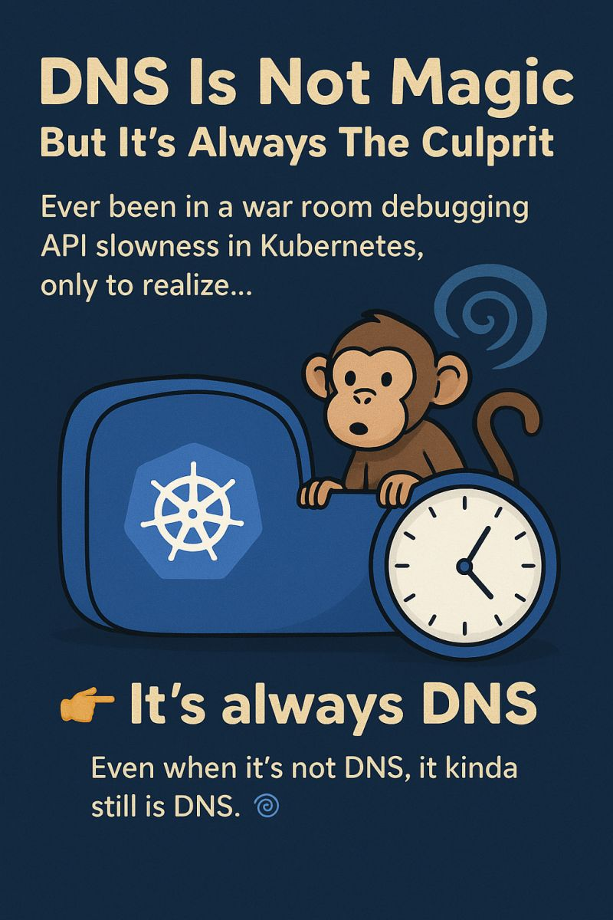

Optimizing Traffic with Cloud Load Balancing: My Experience  
  
As a DevOps/SRE Engineer, ensuring high availability, scalability, and performance for applications is a top priority. Cloud Load Balancing has been a game-changer in distributing traffic efficiently across services. Here’s how I’ve leveraged it in real-world scenarios:  
  
Traffic Distribution & High Availability  
--> Used AWS Elastic Load Balancer (ELB) and Azure Load Balancer to distribute requests across multiple backend instances, preventing bottlenecks.  
 --> Configured Google Cloud Load Balancing (GCLB) to route traffic based on latency, geography, and backend health checks for optimal performance.  
  
Example: Implemented Layer 7 load balancing in a microservices environment, routing API requests to different backend services dynamically, reducing latency by 40%.  
  
  
Auto Scaling & Failover Strategies  
--> Integrated Application Load Balancers (ALB) with Auto Scaling Groups to handle traffic spikes without manual intervention.  
 --> Configured multi-region failover to ensure zero downtime by automatically rerouting traffic during outages.  
  
Example: Set up Global Load Balancing with GeoDNS, allowing seamless failover between regions, ensuring 99.99% uptime for critical applications.  
  
Security & Optimization  
--> Secured traffic with TLS termination at the load balancer, improving backend performance.  
 --> Implemented WAF (Web Application Firewall) for filtering malicious requests.  
  
Example: Enabled SSL offloading at the load balancer level, reducing backend CPU usage by 30%, improving response times.  
  
Key Takeaway: Cloud Load Balancing is essential for reliability, performance, and security in modern cloud architectures. Optimizing traffic flow, ensuring failover, and implementing security best practices have helped me deliver scalable, resilient systems.  
How have you used load balancers in your architecture? Let’s discuss! 🚀  
  
  
  
[**hashtag#CloudLoadBalancing**](https://www.linkedin.com/search/results/all/?keywords=%23cloudloadbalancing&origin=HASH_TAG_FROM_FEED) [**hashtag#SRE**](https://www.linkedin.com/search/results/all/?keywords=%23sre&origin=HASH_TAG_FROM_FEED) [**hashtag#DevOps**](https://www.linkedin.com/search/results/all/?keywords=%23devops&origin=HASH_TAG_FROM_FEED) [**hashtag#AWS**](https://www.linkedin.com/search/results/all/?keywords=%23aws&origin=HASH_TAG_FROM_FEED) [**hashtag#Azure**](https://www.linkedin.com/search/results/all/?keywords=%23azure&origin=HASH_TAG_FROM_FEED) [**hashtag#GCP**](https://www.linkedin.com/search/results/all/?keywords=%23gcp&origin=HASH_TAG_FROM_FEED) [**hashtag#Scalability**](https://www.linkedin.com/search/results/all/?keywords=%23scalability&origin=HASH_TAG_FROM_FEED)   
[**hashtag#HighAvailability**](https://www.linkedin.com/search/results/all/?keywords=%23highavailability&origin=HASH_TAG_FROM_FEED) [**hashtag#TrafficOptimization**](https://www.linkedin.com/search/results/all/?keywords=%23trafficoptimization&origin=HASH_TAG_FROM_FEED) [**hashtag#CloudEngineering**](https://www.linkedin.com/search/results/all/?keywords=%23cloudengineering&origin=HASH_TAG_FROM_FEED) [**hashtag#C2C**](https://www.linkedin.com/search/results/all/?keywords=%23c2c&origin=HASH_TAG_FROM_FEED) [**hashtag#ALB**](https://www.linkedin.com/search/results/all/?keywords=%23alb&origin=HASH_TAG_FROM_FEED) [**hashtag#WAF**](https://www.linkedin.com/search/results/all/?keywords=%23waf&origin=HASH_TAG_FROM_FEED)

Activate to view larger image,



Want to Build a Career in Cloud, DevOps or SRE .But Don’t Know Where to Start?  
  
You’re not alone. Most people jump straight into Kubernetes, Terraform, or AWS certifications… and end up feeling overwhelmed.  
  
The truth is the cloud has layers. And when you learn in the wrong order, everything feels confusing.  
  
That’s why this visual is powerful:  
It lays out the exact progression path to master Cloud roles:  
1. Linux — Terminal, File system, Shell scripting  
2. Networking — DNS, TLS, HTTP/S, Ports, Load Balancing  
3. Cloud Platforms — AWS / Azure / GCP core services  
4. Security — IAM, Encryption, Zero Trust fundamentals  
5. Containers & Orchestration — Docker → Kubernetes → Service Mesh  
6. Infrastructure as Code — Terraform, Ansible, CloudFormation  
7. Observability — Metrics, Logging, Tracing (Grafana, Prometheus, ELK)  
8. CI/CD & GitOps — Jenkins, GitHub Actions, ArgoCD, Flux.  
  
If you’re serious about Cloud / DevOps / Site Reliability Engineering:  
Focus on understanding the each layer not just the tools. Because tools change but foundations don’t.  
  
  
[**hashtag#cloudcomputing**](https://www.linkedin.com/search/results/all/?keywords=%23cloudcomputing&origin=HASH_TAG_FROM_FEED) [**hashtag#devops**](https://www.linkedin.com/search/results/all/?keywords=%23devops&origin=HASH_TAG_FROM_FEED) [**hashtag#sre**](https://www.linkedin.com/search/results/all/?keywords=%23sre&origin=HASH_TAG_FROM_FEED) [**hashtag#aws**](https://www.linkedin.com/search/results/all/?keywords=%23aws&origin=HASH_TAG_FROM_FEED) [**hashtag#azure**](https://www.linkedin.com/search/results/all/?keywords=%23azure&origin=HASH_TAG_FROM_FEED) [**hashtag#gcp**](https://www.linkedin.com/search/results/all/?keywords=%23gcp&origin=HASH_TAG_FROM_FEED) [**hashtag#kubernetes**](https://www.linkedin.com/search/results/all/?keywords=%23kubernetes&origin=HASH_TAG_FROM_FEED) [**hashtag#learning**](https://www.linkedin.com/search/results/all/?keywords=%23learning&origin=HASH_TAG_FROM_FEED) [**hashtag#career**](https://www.linkedin.com/search/results/all/?keywords=%23career&origin=HASH_TAG_FROM_FEED) [**hashtag#techjobs**](https://www.linkedin.com/search/results/all/?keywords=%23techjobs&origin=HASH_TAG_FROM_FEED) [**hashtag#cloudarchitecture**](https://www.linkedin.com/search/results/all/?keywords=%23cloudarchitecture&origin=HASH_TAG_FROM_FEED) [**hashtag#infrastructureascode**](https://www.linkedin.com/search/results/all/?keywords=%23infrastructureascode&origin=HASH_TAG_FROM_FEED) [**hashtag#observability**](https://www.linkedin.com/search/results/all/?keywords=%23observability&origin=HASH_TAG_FROM_FEED) [**hashtag#cicd**](https://www.linkedin.com/search/results/all/?keywords=%23cicd&origin=HASH_TAG_FROM_FEED)

Activate to view larger image,



[(18) Activity | Anand N S S Dovala | LinkedIn](https://www.linkedin.com/in/anand-dovala459/recent-activity/all/)

Mastering AWS VPC Peering in simplified visual guide   
  
If you’ve ever managed complex AWS architectures, you know how tricky VPC Peering can get especially when connecting across accounts and regions.  
  
I created this visual to break down four common VPC Peering scenarios in a single snapshot:  
 1. Same Account, Same Region  
 2. Different Accounts, Same Region  
 3. Same Account, Different Regions  
 4. Different Accounts, Different Regions  
  
Each use case includes limitations like:  
 --> Non-overlapping CIDRs  
 --> MTU limits (1500 vs 9001 bytes)  
 --> Security group restrictions  
  
Key takeaway:  
VPC Peering is simple in setup but tricky in scaling. When your interconnectivity grows and consider Transit Gateway or PrivateLink for better manageability and cost optimization.  
  
Whether you’re an SRE, Cloud Architect, or DevOps Engineer, mastering these fundamentals helps you design secure, scalable multi-account architectures in AWS.  
  
If you found this useful:  
 --> Reshare with your network.  
 --> Follow me for more Cloud Architecture visuals & SRE insights.  
  
  
[**hashtag#AWS**](https://www.linkedin.com/search/results/all/?keywords=%23aws&origin=HASH_TAG_FROM_FEED) [**hashtag#CloudComputing**](https://www.linkedin.com/search/results/all/?keywords=%23cloudcomputing&origin=HASH_TAG_FROM_FEED) [**hashtag#VPC**](https://www.linkedin.com/search/results/all/?keywords=%23vpc&origin=HASH_TAG_FROM_FEED) [**hashtag#DevOps**](https://www.linkedin.com/search/results/all/?keywords=%23devops&origin=HASH_TAG_FROM_FEED) [**hashtag#SRE**](https://www.linkedin.com/search/results/all/?keywords=%23sre&origin=HASH_TAG_FROM_FEED) [**hashtag#Networking**](https://www.linkedin.com/search/results/all/?keywords=%23networking&origin=HASH_TAG_FROM_FEED) [**hashtag#CloudArchitecture**](https://www.linkedin.com/search/results/all/?keywords=%23cloudarchitecture&origin=HASH_TAG_FROM_FEED) [**hashtag#TransitGateway**](https://www.linkedin.com/search/results/all/?keywords=%23transitgateway&origin=HASH_TAG_FROM_FEED) [**hashtag#PrivateLink**](https://www.linkedin.com/search/results/all/?keywords=%23privatelink&origin=HASH_TAG_FROM_FEED) [**hashtag#AWSCommunity**](https://www.linkedin.com/search/results/all/?keywords=%23awscommunity&origin=HASH_TAG_FROM_FEED) [**hashtag#C2C**](https://www.linkedin.com/search/results/all/?keywords=%23c2c&origin=HASH_TAG_FROM_FEED)

Activate to view larger image,

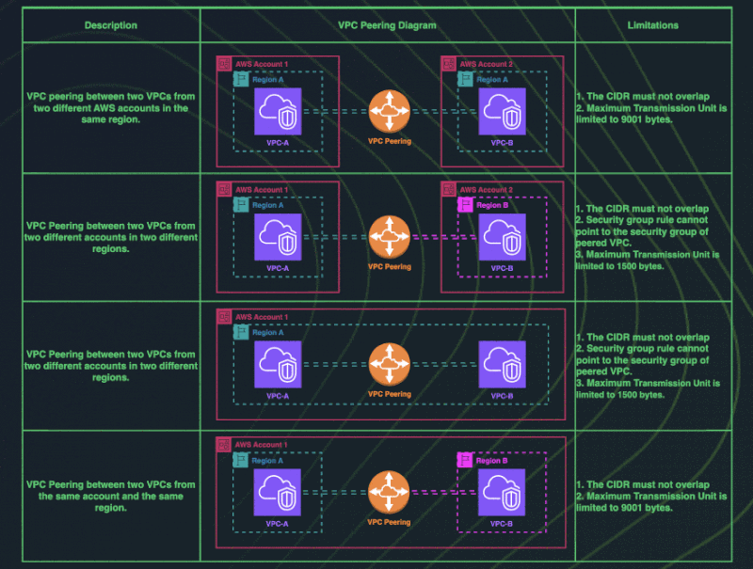

Making Sense of Logs in Kubernetes: What Actually Works?   
If you've ever worked with Kubernetes, you know one thing for sure that containers are short-lived, and so are their logs.  
 A pod crashes or scales down, and boom your logs are gone. So how do we make sure we don’t miss critical information?  
Here’s what’s helped me (and might help you too):  
--> Use Fluent Bit or Fluentd as a DaemonSet to collect logs from all nodes  
--> Ship logs to a central system like Grafana Loki, Elasticsearch, or Datadog  
--> Keep logs structured (JSON format is your friend)  
--> Add useful tags to pod name, namespace, labels to make searching easier  
--> Be smart with log retention so you're not burning storage unnecessarily  
Kubernetes isn’t just about keeping apps running — it’s about seeing what’s happening under the hood.  
 And good logging? It’s a lifesaver when things go sideways.  
🔁 How are you handling logs in your Kubernetes setup? Got a favorite tool or setup? Drop your thoughts below — always looking to learn from others!  
  
  
[**hashtag#Kubernetes**](https://www.linkedin.com/search/results/all/?keywords=%23kubernetes&origin=HASH_TAG_FROM_FEED) [**hashtag#DevOps**](https://www.linkedin.com/search/results/all/?keywords=%23devops&origin=HASH_TAG_FROM_FEED)   
  
[**hashtag#SRE**](https://www.linkedin.com/search/results/all/?keywords=%23sre&origin=HASH_TAG_FROM_FEED) [**hashtag#Logging**](https://www.linkedin.com/search/results/all/?keywords=%23logging&origin=HASH_TAG_FROM_FEED) [**hashtag#Observability**](https://www.linkedin.com/search/results/all/?keywords=%23observability&origin=HASH_TAG_FROM_FEED) [**hashtag#Fluentd**](https://www.linkedin.com/search/results/all/?keywords=%23fluentd&origin=HASH_TAG_FROM_FEED)   
  
[**hashtag#FluentBit**](https://www.linkedin.com/search/results/all/?keywords=%23fluentbit&origin=HASH_TAG_FROM_FEED) [**hashtag#Grafana**](https://www.linkedin.com/search/results/all/?keywords=%23grafana&origin=HASH_TAG_FROM_FEED) [**hashtag#ElasticSearch**](https://www.linkedin.com/search/results/all/?keywords=%23elasticsearch&origin=HASH_TAG_FROM_FEED)  
  
[**hashtag#CloudNative**](https://www.linkedin.com/search/results/all/?keywords=%23cloudnative&origin=HASH_TAG_FROM_FEED) [**hashtag#Containers**](https://www.linkedin.com/search/results/all/?keywords=%23containers&origin=HASH_TAG_FROM_FEED) [**hashtag#C2C**](https://www.linkedin.com/search/results/all/?keywords=%23c2c&origin=HASH_TAG_FROM_FEED)

In observability, data means nothing until it tells a story.  
  
That’s where Dynatrace dashboards truly shine.  
  
-->Over the past few months, I’ve been building and refining dashboards that do more than just show metrics but also they reveal patterns, predict incidents, and empower teams to act faster.  
  
Here’s what I’ve learned :-  
1) Start with a purpose, not a metric. Every dashboard should answer a business or operational question but not just display numbers.  
2) Correlate across layers. Combine infrastructure, application, and user experience data. Seeing the whole journey changes everything.  
3) Use custom metrics wisely. Too many KPIs = confusion. Focus on signals that truly impact SLIs and SLOs.  
4) Leverage Dynatrace’s Davis AI. Automated anomaly detection + root cause insights save hours of manual triage.  
5) Visuals should drive action. If a graph doesn’t guide a decision, it’s just decoration.  
  
Dashboards aren’t about aesthetics but they’re about observability intelligence.  
  
When designed well, they become your single source of truth for uptime, reliability, and performance.   
  
--> Curious about what’s the one metric you never miss adding to your dashboard?  
  
 Let’s share some ideas below.  
  
  
[**hashtag#Dynatrace**](https://www.linkedin.com/search/results/all/?keywords=%23dynatrace&origin=HASH_TAG_FROM_FEED) [**hashtag#Observability**](https://www.linkedin.com/search/results/all/?keywords=%23observability&origin=HASH_TAG_FROM_FEED) [**hashtag#Monitoring**](https://www.linkedin.com/search/results/all/?keywords=%23monitoring&origin=HASH_TAG_FROM_FEED) [**hashtag#Dashboard**](https://www.linkedin.com/search/results/all/?keywords=%23dashboard&origin=HASH_TAG_FROM_FEED) [**hashtag#SiteReliabilityEngineering**](https://www.linkedin.com/search/results/all/?keywords=%23sitereliabilityengineering&origin=HASH_TAG_FROM_FEED) [**hashtag#DevOps**](https://www.linkedin.com/search/results/all/?keywords=%23devops&origin=HASH_TAG_FROM_FEED) [**hashtag#Automation**](https://www.linkedin.com/search/results/all/?keywords=%23automation&origin=HASH_TAG_FROM_FEED) [**hashtag#PerformanceEngineering**](https://www.linkedin.com/search/results/all/?keywords=%23performanceengineering&origin=HASH_TAG_FROM_FEED) [**hashtag#CloudMonitoring**](https://www.linkedin.com/search/results/all/?keywords=%23cloudmonitoring&origin=HASH_TAG_FROM_FEED) [**hashtag#APM**](https://www.linkedin.com/search/results/all/?keywords=%23apm&origin=HASH_TAG_FROM_FEED) [**hashtag#SRE**](https://www.linkedin.com/search/results/all/?keywords=%23sre&origin=HASH_TAG_FROM_FEED) [**hashtag#CloudComputing**](https://www.linkedin.com/search/results/all/?keywords=%23cloudcomputing&origin=HASH_TAG_FROM_FEED) [**hashtag#Kubernetes**](https://www.linkedin.com/search/results/all/?keywords=%23kubernetes&origin=HASH_TAG_FROM_FEED) [**hashtag#AWS**](https://www.linkedin.com/search/results/all/?keywords=%23aws&origin=HASH_TAG_FROM_FEED) [**hashtag#Azure**](https://www.linkedin.com/search/results/all/?keywords=%23azure&origin=HASH_TAG_FROM_FEED) [**hashtag#GoogleCloud**](https://www.linkedin.com/search/results/all/?keywords=%23googlecloud&origin=HASH_TAG_FROM_FEED) [**hashtag#DevOpsCommunity**](https://www.linkedin.com/search/results/all/?keywords=%23devopscommunity&origin=HASH_TAG_FROM_FEED) [**hashtag#MonitoringTools**](https://www.linkedin.com/search/results/all/?keywords=%23monitoringtools&origin=HASH_TAG_FROM_FEED) [**hashtag#IncidentManagement**](https://www.linkedin.com/search/results/all/?keywords=%23incidentmanagement&origin=HASH_TAG_FROM_FEED) [**hashtag#Metrics**](https://www.linkedin.com/search/results/all/?keywords=%23metrics&origin=HASH_TAG_FROM_FEED) [**hashtag#DataAnalytics**](https://www.linkedin.com/search/results/all/?keywords=%23dataanalytics&origin=HASH_TAG_FROM_FEED) [**hashtag#DigitalExperience**](https://www.linkedin.com/search/results/all/?keywords=%23digitalexperience&origin=HASH_TAG_FROM_FEED) [**hashtag#AIops**](https://www.linkedin.com/search/results/all/?keywords=%23aiops&origin=HASH_TAG_FROM_FEED) [**hashtag#Innovation**](https://www.linkedin.com/search/results/all/?keywords=%23innovation&origin=HASH_TAG_FROM_FEED) [**hashtag#EngineeringCulture**](https://www.linkedin.com/search/results/all/?keywords=%23engineeringculture&origin=HASH_TAG_FROM_FEED) [**hashtag#PerformanceOptimization**](https://www.linkedin.com/search/results/all/?keywords=%23performanceoptimization&origin=HASH_TAG_FROM_FEED) [**hashtag#ReliabilityEngineering**](https://www.linkedin.com/search/results/all/?keywords=%23reliabilityengineering&origin=HASH_TAG_FROM_FEED) [**hashtag#Telemetry**](https://www.linkedin.com/search/results/all/?keywords=%23telemetry&origin=HASH_TAG_FROM_FEED) [**hashtag#FullStackObservability**](https://www.linkedin.com/search/results/all/?keywords=%23fullstackobservability&origin=HASH_TAG_FROM_FEED)

Activate to view larger image,

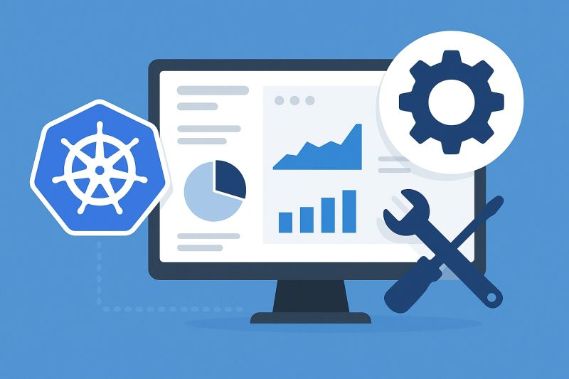

🧠 Real World DevOps Design  
  
Canary Deployments. VPC Endpoints. WAF. OIDC.  
  
These aren’t just buzzwords. They are what separate cloud setups that work from cloud setups that last. Here’s why each one matters when designing production grade systems 👇  
  
  
Canary Deployments — release safely, not recklessly  
Never ship 100% of traffic to a new version at once. Use CodeDeploy with ALB listeners to shift 10% of traffic first, monitor health, then roll forward or back automatically. One bad deploy can take down an entire service. Canary releases protect uptime, user trust, and your team’s sleep schedule.  
  
OIDC — secure your CI/CD pipelines  
Hard coded AWS keys in GitHub are a security risk waiting to happen. With OpenID Connect, GitHub Actions assumes temporary IAM roles via STS. No static credentials, no rotation headaches, just short lived least privilege access the way AWS intended.  
  
VPC Endpoints — cut costs, stay private  
Private subnets can’t talk to AWS APIs by default. Instead of paying for NAT Gateways, create VPC Endpoints to route traffic inside AWS’s private network. You eliminate outbound data costs, remove public exposure, and improve latency while saving money for your company.  
  
WAF — protect the edge before the app  
Most attacks never reach your code. They hit your perimeter. AWS WAF blocks SQL injection, XSS, and bot traffic before it touches your containers. Pair it with ACM managed TLS to enforce HTTPS and harden every layer of your stack.  
  
Security first.  
Reliability next.  
Cost efficiency always.  
  
All of this comes together in a production grade ECS Fargate deployment, managed end to end with Terraform, GitHub Actions (OIDC), and CodeDeploy (Canary) — automated, reproducible, and secure.  
  
Repo Link: [**https://lnkd.in/ew5Pnbt4**](https://lnkd.in/ew5Pnbt4)

Activate to view larger image,



* CI/CD Pipeline with Jenkins, Docker, and Kubernetes  
    
  This diagram illustrates a CI/CD workflow where code is pushed to GitHub, triggering Jenkins CI jobs for dependency checks, code analysis, and Docker image creation. The CD pipeline deploys the image using ArgoCD to Kubernetes, with monitoring via Prometheus and Grafana, and notifications via email  
    
  [**hashtag#DevOps**](https://www.linkedin.com/search/results/all/?keywords=%23devops&origin=HASH_TAG_FROM_FEED) [**hashtag#SRE**](https://www.linkedin.com/search/results/all/?keywords=%23sre&origin=HASH_TAG_FROM_FEED) [**hashtag#SiteReliabilityEngineering**](https://www.linkedin.com/search/results/all/?keywords=%23sitereliabilityengineering&origin=HASH_TAG_FROM_FEED) [**hashtag#CloudComputing**](https://www.linkedin.com/search/results/all/?keywords=%23cloudcomputing&origin=HASH_TAG_FROM_FEED) [**hashtag#CloudNative**](https://www.linkedin.com/search/results/all/?keywords=%23cloudnative&origin=HASH_TAG_FROM_FEED) [**hashtag#AWS**](https://www.linkedin.com/search/results/all/?keywords=%23aws&origin=HASH_TAG_FROM_FEED) [**hashtag#Azure**](https://www.linkedin.com/search/results/all/?keywords=%23azure&origin=HASH_TAG_FROM_FEED) [**hashtag#GoogleCloud**](https://www.linkedin.com/search/results/all/?keywords=%23googlecloud&origin=HASH_TAG_FROM_FEED) [**hashtag#Kubernetes**](https://www.linkedin.com/search/results/all/?keywords=%23kubernetes&origin=HASH_TAG_FROM_FEED) [**hashtag#Docker**](https://www.linkedin.com/search/results/all/?keywords=%23docker&origin=HASH_TAG_FROM_FEED) [**hashtag#EKS**](https://www.linkedin.com/search/results/all/?keywords=%23eks&origin=HASH_TAG_FROM_FEED) [**hashtag#InfrastructureAsCode**](https://www.linkedin.com/search/results/all/?keywords=%23infrastructureascode&origin=HASH_TAG_FROM_FEED) [**hashtag#Terraform**](https://www.linkedin.com/search/results/all/?keywords=%23terraform&origin=HASH_TAG_FROM_FEED) [**hashtag#Ansible**](https://www.linkedin.com/search/results/all/?keywords=%23ansible&origin=HASH_TAG_FROM_FEED) [**hashtag#CI\_CD**](https://www.linkedin.com/search/results/all/?keywords=%23ci_cd&origin=HASH_TAG_FROM_FEED) [**hashtag#Automation**](https://www.linkedin.com/search/results/all/?keywords=%23automation&origin=HASH_TAG_FROM_FEED) [**hashtag#ResilienceEngineering**](https://www.linkedin.com/search/results/all/?keywords=%23resilienceengineering&origin=HASH_TAG_FROM_FEED) [**hashtag#HighAvailability**](https://www.linkedin.com/search/results/all/?keywords=%23highavailability&origin=HASH_TAG_FROM_FEED) [**hashtag#Scalability**](https://www.linkedin.com/search/results/all/?keywords=%23scalability&origin=HASH_TAG_FROM_FEED) [**hashtag#PerformanceEngineering**](https://www.linkedin.com/search/results/all/?keywords=%23performanceengineering&origin=HASH_TAG_FROM_FEED) [**hashtag#SystemDesign**](https://www.linkedin.com/search/results/all/?keywords=%23systemdesign&origin=HASH_TAG_FROM_FEED) [**hashtag#EngineeringCulture**](https://www.linkedin.com/search/results/all/?keywords=%23engineeringculture&origin=HASH_TAG_FROM_FEED) [**hashtag#TechLeadership**](https://www.linkedin.com/search/results/all/?keywords=%23techleadership&origin=HASH_TAG_FROM_FEED) [**hashtag#DevOpsCommunity**](https://www.linkedin.com/search/results/all/?keywords=%23devopscommunity&origin=HASH_TAG_FROM_FEED) [**hashtag#CloudEngineering**](https://www.linkedin.com/search/results/all/?keywords=%23cloudengineering&origin=HASH_TAG_FROM_FEED) [**hashtag#Innovation**](https://www.linkedin.com/search/results/all/?keywords=%23innovation&origin=HASH_TAG_FROM_FEED) [**hashtag#TechLife**](https://www.linkedin.com/search/results/all/?keywords=%23techlife&origin=HASH_TAG_FROM_FEED) [**hashtag#ContinuousImprovement**](https://www.linkedin.com/search/results/all/?keywords=%23continuousimprovement&origin=HASH_TAG_FROM_FEED) [**hashtag#Reliability**](https://www.linkedin.com/search/results/all/?keywords=%23reliability&origin=HASH_TAG_FROM_FEED) [**hashtag#OnCall**](https://www.linkedin.com/search/results/all/?keywords=%23oncall&origin=HASH_TAG_FROM_FEED) [**hashtag#IncidentManagement**](https://www.linkedin.com/search/results/all/?keywords=%23incidentmanagement&origin=HASH_TAG_FROM_FEED) [**hashtag#DigitalTransformation**](https://www.linkedin.com/search/results/all/?keywords=%23digitaltransformation&origin=HASH_TAG_FROM_FEED) [**hashtag#c2c**](https://www.linkedin.com/search/results/all/?keywords=%23c2c&origin=HASH_TAG_FROM_FEED)

Activate to view larger image,



Activate to view larger image,

* + 136
    - 4 comments
    - 6 reposts

Like

Comment

Repost

Send

* Feed post number 13

**[](https://www.linkedin.com/in/anand-dovala459?miniProfileUrn=urn%3Ali%3Afsd_profile%3AACoAACkKlyEB5o_HZ1o5Qx2597BWCaMxJ0wh1EI" \t "_self)**

[**Anand N S S DovalaAnand N S S Dovala**   • 2ndVerified • 2ndDevOps | SRE | Cloud Infrastructure Expert | CI/CD Automation | Jenkins, Ansible | AWS, GCP & Azure | Kubernetes, Docker, Terraform | Linux, Dynatrace, Datadog, ELK, Splunk | SonarQube | Open Telemetry | JiraDevOps | SRE | Cloud Infrastructure Expert | CI/CD Automation | Jenkins, Ansible | AWS, GCP & Azure | Kubernetes, Docker, Terraform | Linux, Dynatrace, Datadog, ELK, Splunk | SonarQube | Open Telemetry | Jira](https://www.linkedin.com/in/anand-dovala459?miniProfileUrn=urn%3Ali%3Afsd_profile%3AACoAACkKlyEB5o_HZ1o5Qx2597BWCaMxJ0wh1EI)2w • 2 weeks ago • Visible to anyone on or off LinkedIn

Follow

Incident Response Isn’t Just a Process but It’s a Mindset.  
  
When systems break, panic helps no one but clarity and precision do.  
  
Here are a few powerful commands I rely on in high-severity incidents:  
  
--> Linux Deep-Dive Commands  
dstat -tcdnm → real-time CPU, disk, network metrics  
iotop → pinpoint I/O bottlenecks instantly  
strace -p <pid> → trace system calls for a hung process  
lsof -i :<port> → find which process owns a port  
journalctl -xe → analyze critical system logs post-crash  
  
--> Python for Rapid Diagnostics  
psutil → capture live CPU, memory, and process metrics  
subprocess → automate log collection & network checks  
socket → test service availability in seconds  
boto3 → interact with AWS services during recovery automation  
  
Pro tip: Automate your incident checks so that your future self at 3 AM will thank you.  
  
Every SRE knows that it’s not about how fast you react, but how fast you diagnose, automate, and recover.  
  
Incident Response Isn’t Just a Process but It’s a Mindset.  
  
When systems break, panic helps no one but clarity and precision do.  
  
Here are a few powerful commands I rely on in high-severity incidents:  
  
--> Linux Deep-Dive Commands  
dstat -tcdnm → real-time CPU, disk, network metrics  
iotop → pinpoint I/O bottlenecks instantly  
strace -p <pid> → trace system calls for a hung process  
lsof -i :<port> → find which process owns a port  
journalctl -xe → analyze critical system logs post-crash  
  
--> Python for Rapid Diagnostics  
psutil → capture live CPU, memory, and process metrics  
subprocess → automate log collection & network checks  
socket → test service availability in seconds  
boto3 → interact with AWS services during recovery automation  
  
Pro tip: Automate your incident checks so that your future self at 3 AM will thank you.  
  
Every SRE knows that it’s not about how fast you react, but how fast you diagnose, automate, and recover.  
  
--> What’s your go-to command when production misbehaves?  
  
[**hashtag#SRE**](https://www.linkedin.com/search/results/all/?keywords=%23sre&origin=HASH_TAG_FROM_FEED) [**hashtag#DevOps**](https://www.linkedin.com/search/results/all/?keywords=%23devops&origin=HASH_TAG_FROM_FEED) [**hashtag#IncidentResponse**](https://www.linkedin.com/search/results/all/?keywords=%23incidentresponse&origin=HASH_TAG_FROM_FEED) [**hashtag#Troubleshooting**](https://www.linkedin.com/search/results/all/?keywords=%23troubleshooting&origin=HASH_TAG_FROM_FEED) [**hashtag#Linux**](https://www.linkedin.com/search/results/all/?keywords=%23linux&origin=HASH_TAG_FROM_FEED) [**hashtag#Python**](https://www.linkedin.com/search/results/all/?keywords=%23python&origin=HASH_TAG_FROM_FEED) [**hashtag#Automation**](https://www.linkedin.com/search/results/all/?keywords=%23automation&origin=HASH_TAG_FROM_FEED) [**hashtag#CloudOps**](https://www.linkedin.com/search/results/all/?keywords=%23cloudops&origin=HASH_TAG_FROM_FEED) [**hashtag#ReliabilityEngineering**](https://www.linkedin.com/search/results/all/?keywords=%23reliabilityengineering&origin=HASH_TAG_FROM_FEED) [**hashtag#SiteReliabilityEngineering**](https://www.linkedin.com/search/results/all/?keywords=%23sitereliabilityengineering&origin=HASH_TAG_FROM_FEED) [**hashtag#SysAdmin**](https://www.linkedin.com/search/results/all/?keywords=%23sysadmin&origin=HASH_TAG_FROM_FEED) [**hashtag#Monitoring**](https://www.linkedin.com/search/results/all/?keywords=%23monitoring&origin=HASH_TAG_FROM_FEED) [**hashtag#Observability**](https://www.linkedin.com/search/results/all/?keywords=%23observability&origin=HASH_TAG_FROM_FEED) [**hashtag#CloudEngineering**](https://www.linkedin.com/search/results/all/?keywords=%23cloudengineering&origin=HASH_TAG_FROM_FEED) [**hashtag#Infrastructure**](https://www.linkedin.com/search/results/all/?keywords=%23infrastructure&origin=HASH_TAG_FROM_FEED) [**hashtag#ProductionSupport**](https://www.linkedin.com/search/results/all/?keywords=%23productionsupport&origin=HASH_TAG_FROM_FEED) [**hashtag#OnCall**](https://www.linkedin.com/search/results/all/?keywords=%23oncall&origin=HASH_TAG_FROM_FEED) [**hashtag#CommandLine**](https://www.linkedin.com/search/results/all/?keywords=%23commandline&origin=HASH_TAG_FROM_FEED) [**hashtag#ShellScripting**](https://www.linkedin.com/search/results/all/?keywords=%23shellscripting&origin=HASH_TAG_FROM_FEED) [**hashtag#PythonScripts**](https://www.linkedin.com/search/results/all/?keywords=%23pythonscripts&origin=HASH_TAG_FROM_FEED) [**hashtag#TechCommunity**](https://www.linkedin.com/search/results/all/?keywords=%23techcommunity&origin=HASH_TAG_FROM_FEED) [**hashtag#CloudComputing**](https://www.linkedin.com/search/results/all/?keywords=%23cloudcomputing&origin=HASH_TAG_FROM_FEED) [**hashtag#AWS**](https://www.linkedin.com/search/results/all/?keywords=%23aws&origin=HASH_TAG_FROM_FEED) [**hashtag#Azure**](https://www.linkedin.com/search/results/all/?keywords=%23azure&origin=HASH_TAG_FROM_FEED) [**hashtag#GCP**](https://www.linkedin.com/search/results/all/?keywords=%23gcp&origin=HASH_TAG_FROM_FEED) [**hashtag#ITOperations**](https://www.linkedin.com/search/results/all/?keywords=%23itoperations&origin=HASH_TAG_FROM_FEED) [**hashtag#DevSecOps**](https://www.linkedin.com/search/results/all/?keywords=%23devsecops&origin=HASH_TAG_FROM_FEED) [**hashtag#CI\_CD**](https://www.linkedin.com/search/results/all/?keywords=%23ci_cd&origin=HASH_TAG_FROM_FEED) [**hashtag#PerformanceEngineering**](https://www.linkedin.com/search/results/all/?keywords=%23performanceengineering&origin=HASH_TAG_FROM_FEED) [**hashtag#DataOps**](https://www.linkedin.com/search/results/all/?keywords=%23dataops&origin=HASH_TAG_FROM_FEED) [**hashtag#TechLeadership**](https://www.linkedin.com/search/results/all/?keywords=%23techleadership&origin=HASH_TAG_FROM_FEED)Activate to view larger image,

Empowering Observability with OpenTelemetry and Dynatrace.  
  
Observability is key in managing modern, distributed applications. By integrating OpenTelemetry with Dynatrace, you can ingest telemetry data seamlessly, gain AI-powered insights, and drive proactive issue detection.  
  
Step-by-Step Guide:  
- Configure Dynatrace & OpenTelemetry Collector  
- Instrument your applications  
- Leverage advanced features like automatic instrumentation, security monitoring, and multi-cloud visibility  
  
Why it matters: Standardized telemetry and AI insights empower you to monitor microservices, legacy apps, and custom business metrics, providing full-stack observability.  
  
Dynatrace is a Software Intelligence Platform used for distributed tracking, performance monitoring and system insights.  
  
[**hashtag#Observability**](https://www.linkedin.com/search/results/all/?keywords=%23observability&origin=HASH_TAG_FROM_FEED) [**hashtag#OpenTelemetry**](https://www.linkedin.com/search/results/all/?keywords=%23opentelemetry&origin=HASH_TAG_FROM_FEED) [**hashtag#Dynatrace**](https://www.linkedin.com/search/results/all/?keywords=%23dynatrace&origin=HASH_TAG_FROM_FEED) [**hashtag#AI**](https://www.linkedin.com/search/results/all/?keywords=%23ai&origin=HASH_TAG_FROM_FEED) [**hashtag#Cloud**](https://www.linkedin.com/search/results/all/?keywords=%23cloud&origin=HASH_TAG_FROM_FEED) [**hashtag#Telemetry**](https://www.linkedin.com/search/results/all/?keywords=%23telemetry&origin=HASH_TAG_FROM_FEED) [**hashtag#Performance**](https://www.linkedin.com/search/results/all/?keywords=%23performance&origin=HASH_TAG_FROM_FEED) [**hashtag#CloudEngineering**](https://www.linkedin.com/search/results/all/?keywords=%23cloudengineering&origin=HASH_TAG_FROM_FEED) [**hashtag#Innovation**](https://www.linkedin.com/search/results/all/?keywords=%23innovation&origin=HASH_TAG_FROM_FEED) [**hashtag#TechLife**](https://www.linkedin.com/search/results/all/?keywords=%23techlife&origin=HASH_TAG_FROM_FEED) [**hashtag#ContinuousImprovement**](https://www.linkedin.com/search/results/all/?keywords=%23continuousimprovement&origin=HASH_TAG_FROM_FEED) [**hashtag#Reliability**](https://www.linkedin.com/search/results/all/?keywords=%23reliability&origin=HASH_TAG_FROM_FEED) [**hashtag#OnCall**](https://www.linkedin.com/search/results/all/?keywords=%23oncall&origin=HASH_TAG_FROM_FEED) [**hashtag#IncidentManagement**](https://www.linkedin.com/search/results/all/?keywords=%23incidentmanagement&origin=HASH_TAG_FROM_FEED) [**hashtag#DigitalTransformation**](https://www.linkedin.com/search/results/all/?keywords=%23digitaltransformation&origin=HASH_TAG_FROM_FEED) [**hashtag#SiteReliabilityEngineer**](https://www.linkedin.com/search/results/all/?keywords=%23sitereliabilityengineer&origin=HASH_TAG_FROM_FEED) [**hashtag#DevOps**](https://www.linkedin.com/search/results/all/?keywords=%23devops&origin=HASH_TAG_FROM_FEED) [**hashtag#C2C**](https://www.linkedin.com/search/results/all/?keywords=%23c2c&origin=HASH_TAG_FROM_FEED) [**hashtag#SoftwareIntelligence**](https://www.linkedin.com/search/results/all/?keywords=%23softwareintelligence&origin=HASH_TAG_FROM_FEED) [**hashtag#jobs**](https://www.linkedin.com/search/results/all/?keywords=%23jobs&origin=HASH_TAG_FROM_FEED) [**hashtag#usjobs**](https://www.linkedin.com/search/results/all/?keywords=%23usjobs&origin=HASH_TAG_FROM_FEED)

Activate to view larger image,

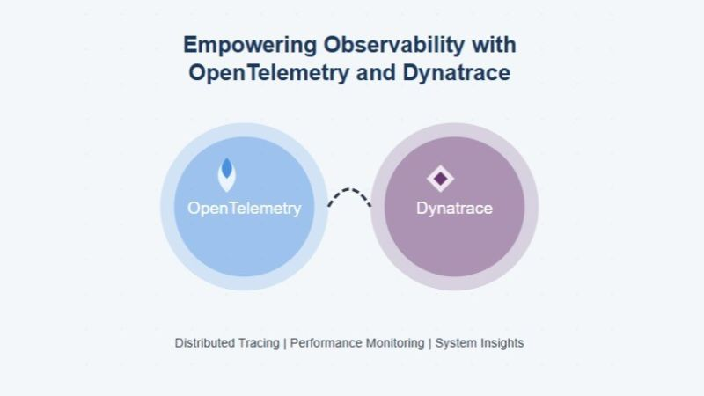

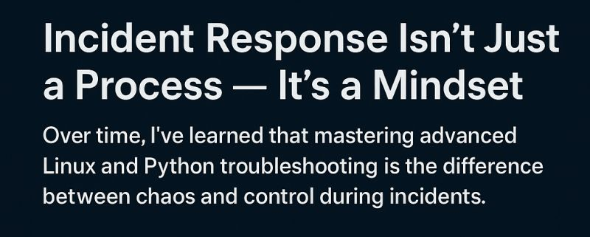

Is VPC Really That Important for a DevOps Engineer? Spoiler: Absolutely.   
  
  
If you're a DevOps Engineer, you've likely touched every layer of cloud infrastructure from CI/CD to containers. But one thing that's often underappreciated (until it breaks)? Virtual Private Cloud (VPC).  
  
Why VPC Matters in DevOps Workflows:  
  
--> Security First: A properly configured VPC ensures your workloads are isolated, secure, and not exposed to the public internet unless you want them to be.  
  
--> Service Communication: Whether you're spinning up a Kubernetes cluster, deploying a Lambda function, or running an RDS instance where your services live inside a VPC.  
  
--> Custom Networking: You need subnets, route tables, NAT gateways, and security groups to make sure your CI/CD runners, bastion hosts, and databases talk only to who they should.  
  
--> Observability & Control: Want to inspect traffic or troubleshoot DNS failures? You'll need to understand VPC flow logs, DNS resolution, and peering.  
  
--> My Experience:  
 In one case, a CI/CD pipeline deployment was failing intermittently. After hours of debugging builds and containers, the issue? A misconfigured VPC route table was silently dropping outbound traffic. A simple fix, but a deep lesson: DevOps isn’t just about automation but also it’s about infrastructure awareness.  
  
--> If you're serious about cloud-native DevOps, VPCs aren’t optional they’re foundational.  
  
Do you actively manage VPCs in your pipelines or leave it to the infra team? Let’s discuss!   
  
[**hashtag#DevOps**](https://www.linkedin.com/search/results/all/?keywords=%23devops&origin=HASH_TAG_FROM_FEED) [**hashtag#SRE**](https://www.linkedin.com/search/results/all/?keywords=%23sre&origin=HASH_TAG_FROM_FEED) [**hashtag#CloudNetworking**](https://www.linkedin.com/search/results/all/?keywords=%23cloudnetworking&origin=HASH_TAG_FROM_FEED)   
[**hashtag#VPC**](https://www.linkedin.com/search/results/all/?keywords=%23vpc&origin=HASH_TAG_FROM_FEED) [**hashtag#AWS**](https://www.linkedin.com/search/results/all/?keywords=%23aws&origin=HASH_TAG_FROM_FEED) [**hashtag#GCP**](https://www.linkedin.com/search/results/all/?keywords=%23gcp&origin=HASH_TAG_FROM_FEED) [**hashtag#CICD**](https://www.linkedin.com/search/results/all/?keywords=%23cicd&origin=HASH_TAG_FROM_FEED) [**hashtag#SiteReliabilityEngineering**](https://www.linkedin.com/search/results/all/?keywords=%23sitereliabilityengineering&origin=HASH_TAG_FROM_FEED) [**hashtag#CloudNative**](https://www.linkedin.com/search/results/all/?keywords=%23cloudnative&origin=HASH_TAG_FROM_FEED) [**hashtag#VPC**](https://www.linkedin.com/search/results/all/?keywords=%23vpc&origin=HASH_TAG_FROM_FEED) [**hashtag#DNS**](https://www.linkedin.com/search/results/all/?keywords=%23dns&origin=HASH_TAG_FROM_FEED) [**hashtag#Kubernetes**](https://www.linkedin.com/search/results/all/?keywords=%23kubernetes&origin=HASH_TAG_FROM_FEED) [**hashtag#RDS**](https://www.linkedin.com/search/results/all/?keywords=%23rds&origin=HASH_TAG_FROM_FEED) [**hashtag#Security**](https://www.linkedin.com/search/results/all/?keywords=%23security&origin=HASH_TAG_FROM_FEED) [**hashtag#IAM**](https://www.linkedin.com/search/results/all/?keywords=%23iam&origin=HASH_TAG_FROM_FEED) [**hashtag#Lamda**](https://www.linkedin.com/search/results/all/?keywords=%23lamda&origin=HASH_TAG_FROM_FEED)  
[**hashtag#Azure**](https://www.linkedin.com/search/results/all/?keywords=%23azure&origin=HASH_TAG_FROM_FEED) [**hashtag#InfrastructureAsCode**](https://www.linkedin.com/search/results/all/?keywords=%23infrastructureascode&origin=HASH_TAG_FROM_FEED) [**hashtag#CloudSecurity**](https://www.linkedin.com/search/results/all/?keywords=%23cloudsecurity&origin=HASH_TAG_FROM_FEED) [**hashtag#CloudComputing**](https://www.linkedin.com/search/results/all/?keywords=%23cloudcomputing&origin=HASH_TAG_FROM_FEED)  
[**hashtag#NetworkingMatters**](https://www.linkedin.com/search/results/all/?keywords=%23networkingmatters&origin=HASH_TAG_FROM_FEED) [**hashtag#C2C**](https://www.linkedin.com/search/results/all/?keywords=%23c2c&origin=HASH_TAG_FROM_FEED) [**hashtag#Jobs**](https://www.linkedin.com/search/results/all/?keywords=%23jobs&origin=HASH_TAG_FROM_FEED) [**hashtag#ConfigrationManagement**](https://www.linkedin.com/search/results/all/?keywords=%23configrationmanagement&origin=HASH_TAG_FROM_FEED)  
[**hashtag#CloudEngineering**](https://www.linkedin.com/search/results/all/?keywords=%23cloudengineering&origin=HASH_TAG_FROM_FEED) [**hashtag#Innovation**](https://www.linkedin.com/search/results/all/?keywords=%23innovation&origin=HASH_TAG_FROM_FEED) [**hashtag#TechLife**](https://www.linkedin.com/search/results/all/?keywords=%23techlife&origin=HASH_TAG_FROM_FEED) [**hashtag#ContinuousImprovement**](https://www.linkedin.com/search/results/all/?keywords=%23continuousimprovement&origin=HASH_TAG_FROM_FEED) [**hashtag#Reliability**](https://www.linkedin.com/search/results/all/?keywords=%23reliability&origin=HASH_TAG_FROM_FEED) [**hashtag#OnCall**](https://www.linkedin.com/search/results/all/?keywords=%23oncall&origin=HASH_TAG_FROM_FEED) [**hashtag#IncidentManagement**](https://www.linkedin.com/search/results/all/?keywords=%23incidentmanagement&origin=HASH_TAG_FROM_FEED) [**hashtag#DigitalTransformation**](https://www.linkedin.com/search/results/all/?keywords=%23digitaltransformation&origin=HASH_TAG_FROM_FEED)

* 1
* Confluent Kafka on Kubernetes: My Experience with Building Scalable Event Streaming.  
    
  Running Apache Kafka is powerful but managing it at scale, securely, and reliably in Kubernetes? That’s where Confluent Kafka shines. In my DevOps/SRE role, deploying Confluent Platform on Kubernetes allowed me to unlock high-throughput, resilient event streaming while aligning with modern, cloud-native practices.  
    
  -->Why Confluent Kafka + Kubernetes?  
  Operator-based Automation: With the Confluent Operator, I could automate deployment, scaling, and upgrades of Kafka clusters natively within Kubernetes.  
  Production-grade Observability: Integrated Prometheus and Grafana dashboards provided deep visibility into broker health, throughput, partition lag, and ZooKeeper status.  
  Security at Scale: TLS encryption, SASL authentication, and RBAC policies were baked into the Kubernetes configurations using secrets and config maps.  
  Declarative Configs: Infrastructure-as-Code via Helm and Kustomize made the management of Kafka topics, connectors, and brokers predictable and version-controlled.  
    
  -->Real-World Experience  
  In one project, we needed to ingest and process millions of events from IoT devices. We deployed Confluent Kafka on GKE (Google Kubernetes Engine) using the Confluent Helm charts, scaled Kafka brokers based on consumer lag, and implemented Kafka Connect and ksqlDB for real-time transformations.  
    
  During a surge in events, autoscaling kicked in to handle the increased load by using Horizontal Pod Autoscalers (HPA) tied to custom metrics like Kafka queue depth and consumer lag.  
  We even integrated with Confluent Control Center and OpenTelemetry for tracing data pipelines end-to-end, which helped us troubleshoot delays and replay events effortlessly.  
    
  --> Key Benefits I’ve Observed  
  Simplified lifecycle management of Kafka infrastructure  
  Reduced operational overhead for day-2 ops like scaling, failover, and upgrades  
    
  Better integration with GitOps workflows (ArgoCD + Helm) for version-controlled streaming infrastructure  
    
  Takeaway:  
  Confluent Kafka on Kubernetes is the modern way to run scalable, secure, and self-healing data pipelines especially when streaming becomes a critical component of your application stack.  
    
  Are you running Kafka on Kubernetes? What has your experience been like?  
    
  [**hashtag#Kafka**](https://www.linkedin.com/search/results/all/?keywords=%23kafka&origin=HASH_TAG_FROM_FEED)  
  [**hashtag#Confluent**](https://www.linkedin.com/search/results/all/?keywords=%23confluent&origin=HASH_TAG_FROM_FEED) [**hashtag#Kubernetes**](https://www.linkedin.com/search/results/all/?keywords=%23kubernetes&origin=HASH_TAG_FROM_FEED) [**hashtag#CloudNative**](https://www.linkedin.com/search/results/all/?keywords=%23cloudnative&origin=HASH_TAG_FROM_FEED) [**hashtag#GKE**](https://www.linkedin.com/search/results/all/?keywords=%23gke&origin=HASH_TAG_FROM_FEED) [**hashtag#ArgoCD**](https://www.linkedin.com/search/results/all/?keywords=%23argocd&origin=HASH_TAG_FROM_FEED)  
  [**hashtag#EventStreaming**](https://www.linkedin.com/search/results/all/?keywords=%23eventstreaming&origin=HASH_TAG_FROM_FEED) [**hashtag#SRE**](https://www.linkedin.com/search/results/all/?keywords=%23sre&origin=HASH_TAG_FROM_FEED) [**hashtag#sitereliabilityengineer**](https://www.linkedin.com/search/results/all/?keywords=%23sitereliabilityengineer&origin=HASH_TAG_FROM_FEED) [**hashtag#CloudEngineering**](https://www.linkedin.com/search/results/all/?keywords=%23cloudengineering&origin=HASH_TAG_FROM_FEED)  
  [**hashtag#DevOps**](https://www.linkedin.com/search/results/all/?keywords=%23devops&origin=HASH_TAG_FROM_FEED) [**hashtag#Helm**](https://www.linkedin.com/search/results/all/?keywords=%23helm&origin=HASH_TAG_FROM_FEED) [**hashtag#GitOps**](https://www.linkedin.com/search/results/all/?keywords=%23gitops&origin=HASH_TAG_FROM_FEED) [**hashtag#DataPipelines**](https://www.linkedin.com/search/results/all/?keywords=%23datapipelines&origin=HASH_TAG_FROM_FEED)  
  [**hashtag#StreamingData**](https://www.linkedin.com/search/results/all/?keywords=%23streamingdata&origin=HASH_TAG_FROM_FEED) [**hashtag#C2C**](https://www.linkedin.com/search/results/all/?keywords=%23c2c&origin=HASH_TAG_FROM_FEED)
* Activate to view larger image,
* 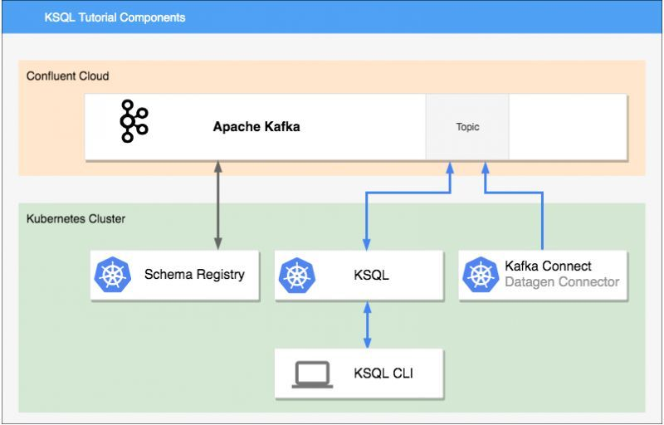

PagerDuty: The Nerve Center for Incident Response.  
  
As a DevOps/SRE, nothing screams “production alert” quite like a PagerDuty notification at 2 AM. But beyond the wake-up calls, PagerDuty is an essential tool for incident management, real-time alerting, and keeping SLAs intact. Here's a quick breakdown based on my experience:  
  
What is PagerDuty?  
PagerDuty is a real-time operations platform that helps tech teams respond to incidents faster, reduce downtime, and maintain service reliability. It connects monitoring tools to human responders with smart alert routing, escalation policies, and incident automation.  
  
My Real-World Experience  
--> Integrated PagerDuty with Datadog, Prometheus, and Splunk to trigger alerts based on system metrics, logs, and synthetic tests.  
-->Created on-call schedules and escalation policies to ensure the right team is alerted at the right time—no more all-hands-on-deck for every alert.  
-->Used event rules and auto-tagging to route non-critical alerts to Slack, while only critical ones paged the on-call SRE.  
-->Leveraged Postmortem templates and incident analytics to reduce MTTR and improve team response over time.  
  
1) Why It’s Essential  
2) Reduces Mean Time to Acknowledge (MTTA) and Mean Time to Resolve (MTTR).  
3) Automates on-call rotations & avoids burnout.  
4) Provides data-driven insights into incident patterns.  
5) Integrates seamlessly with tools like ServiceNow, Jira, GitHub, AWS CloudWatch, and more.  
  
Takeaway:  
PagerDuty turns chaos into coordination during production incidents. For teams aiming to improve uptime, response efficiency, and sleep quality. So it’s a game-changer.  
  
Are you using PagerDuty or something else for incident management? Let’s share war stories.   
  
  
[**hashtag#PagerDuty**](https://www.linkedin.com/search/results/all/?keywords=%23pagerduty&origin=HASH_TAG_FROM_FEED) [**hashtag#IncidentManagement**](https://www.linkedin.com/search/results/all/?keywords=%23incidentmanagement&origin=HASH_TAG_FROM_FEED) [**hashtag#DevOps**](https://www.linkedin.com/search/results/all/?keywords=%23devops&origin=HASH_TAG_FROM_FEED) [**hashtag#SRE**](https://www.linkedin.com/search/results/all/?keywords=%23sre&origin=HASH_TAG_FROM_FEED) [**hashtag#MTTR**](https://www.linkedin.com/search/results/all/?keywords=%23mttr&origin=HASH_TAG_FROM_FEED)   
[**hashtag#OnCallLife**](https://www.linkedin.com/search/results/all/?keywords=%23oncalllife&origin=HASH_TAG_FROM_FEED) [**hashtag#Alerting**](https://www.linkedin.com/search/results/all/?keywords=%23alerting&origin=HASH_TAG_FROM_FEED)   
[**hashtag#ServiceReliability**](https://www.linkedin.com/search/results/all/?keywords=%23servicereliability&origin=HASH_TAG_FROM_FEED) [**hashtag#Observability**](https://www.linkedin.com/search/results/all/?keywords=%23observability&origin=HASH_TAG_FROM_FEED) [**hashtag#C2C**](https://www.linkedin.com/search/results/all/?keywords=%23c2c&origin=HASH_TAG_FROM_FEED)

Activate to view larger image,

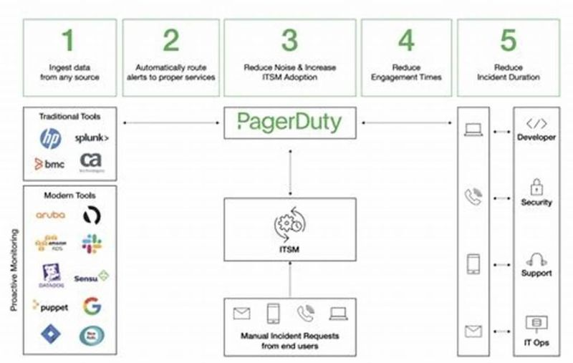

\*\* 𝗞𝘂𝗯𝗲𝗿𝗻𝗲𝘁𝗲𝘀 𝗣𝗼𝗱𝘀 𝗦𝗵𝗼𝘂𝗹𝗱𝗻’𝘁 𝗔𝗹𝗹 𝗧𝗮𝗹𝗸 𝘁𝗼 𝗘𝗮𝗰𝗵 𝗢𝘁𝗵𝗲𝗿 \*\*  
Here’s something I learned the hard way   
By default in Kubernetes, every Pod can talk to every other Pod.  
Sounds convenient… until you realize:  
--> One compromised Pod can become a launchpad for 𝐜𝐥𝐮𝐬𝐭𝐞𝐫-𝐰𝐢𝐝𝐞 𝐜𝐡𝐚𝐨𝐬.  
 A few weeks ago, I faced this exact challenge:  
\*\* How do I make sure only 𝘁𝗿𝘂𝘀𝘁𝗲𝗱 𝗣𝗼𝗱𝘀 can communicate, and everything else is locked down?  
The answer wasn’t just “slap on a NetworkPolicy.”  
It was about mastering the details like selectors, labels, namespaces, even DNS behavior.  
Here’s what my final approach looked like:  
\*\* Accept incoming traffic only from Pods labeled trusted  
\*\* Allow outgoing traffic to internal Pods — but no external leaks  
--> Deny all other ingress & egress by default  
Why this matters in real-world SRE/DevOps work:  
 1) Shrinks the attack surface of your cluster  
 2) Limits the blast radius if a Pod is compromised  
 3) Keeps sensitive microservices isolated  
 4) Builds customer trust in your platform’s resilience  
After testing, breaking things, and validating with real kubectl run scenarios, this went to production and it’s been a game changer for cluster security.  
\*\* I’m curious: how do you handle Pod-to-Pod security in your Kubernetes clusters? Do you go strict with NetworkPolicies, or keep it flexible?  
hashtag  
  
[**hashtag#Kubernetes**](https://www.linkedin.com/search/results/all/?keywords=%23kubernetes&origin=HASH_TAG_FROM_FEED) [**hashtag#DevOps**](https://www.linkedin.com/search/results/all/?keywords=%23devops&origin=HASH_TAG_FROM_FEED)   
[**hashtag#CloudNative**](https://www.linkedin.com/search/results/all/?keywords=%23cloudnative&origin=HASH_TAG_FROM_FEED) [**hashtag#Security**](https://www.linkedin.com/search/results/all/?keywords=%23security&origin=HASH_TAG_FROM_FEED)   
[**hashtag#SRE**](https://www.linkedin.com/search/results/all/?keywords=%23sre&origin=HASH_TAG_FROM_FEED)   
[**hashtag#PlatformEngineering**](https://www.linkedin.com/search/results/all/?keywords=%23platformengineering&origin=HASH_TAG_FROM_FEED) [**hashtag#Docker**](https://www.linkedin.com/search/results/all/?keywords=%23docker&origin=HASH_TAG_FROM_FEED)  
[**hashtag#DevOpsEngineer**](https://www.linkedin.com/search/results/all/?keywords=%23devopsengineer&origin=HASH_TAG_FROM_FEED) [**hashtag#Observability**](https://www.linkedin.com/search/results/all/?keywords=%23observability&origin=HASH_TAG_FROM_FEED)   
[**hashtag#IAM**](https://www.linkedin.com/search/results/all/?keywords=%23iam&origin=HASH_TAG_FROM_FEED) [**hashtag#Monitoring**](https://www.linkedin.com/search/results/all/?keywords=%23monitoring&origin=HASH_TAG_FROM_FEED) [**hashtag#Automation**](https://www.linkedin.com/search/results/all/?keywords=%23automation&origin=HASH_TAG_FROM_FEED) [**hashtag#C2C**](https://www.linkedin.com/search/results/all/?keywords=%23c2c&origin=HASH_TAG_FROM_FEED)  
[**hashtag#C2H**](https://www.linkedin.com/search/results/all/?keywords=%23c2h&origin=HASH_TAG_FROM_FEED) [**hashtag#Dynatrace**](https://www.linkedin.com/search/results/all/?keywords=%23dynatrace&origin=HASH_TAG_FROM_FEED) [**hashtag#Datadog**](https://www.linkedin.com/search/results/all/?keywords=%23datadog&origin=HASH_TAG_FROM_FEED)

Activate to view larger image,

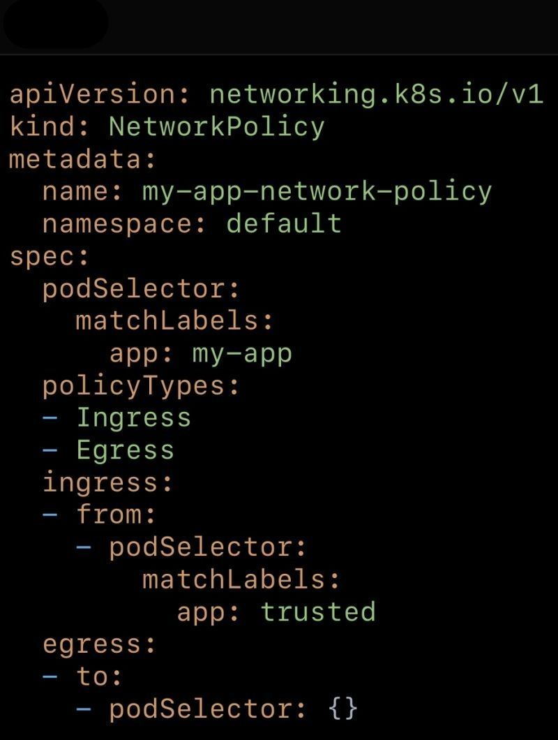

Most DevOps engineers dont know this.  
  
Microsoft Azure is currently the only cloud provider that offers OpenAI’s models as a fully managed, hosted native service through Azure OpenAI.  
  
This means,  
  
You get direct, enterprise-grade access to specific, well-known OpenAI models, with native integration into Azure's security and virtual networks.  
  
So, how is Azure OpenAI different from OpenAI's direct API?  
  
Azure OpenAI runs on Microsoft Azure’s secure cloud infrastructure, with private endpoints, enterprise-grade compliance and enterprise-level uptime commitments.  
  
While the OpenAI API operates on OpenAI’s own servers.  
  
This makes Azure OpenAI a better fit for enterprise environments when data location and compliance are key concerns.  
  
We just published a step-by-step blog to help you get started with Azure OpenAI.  
  
It covers,  
  
What is Azure OpenAI?  
Deploying a OpenAI Model  
Testing model endpoint using curl & python  
Monitoring Token Usage  
Configuring Security and Compliance and more  
  
  
[**hashtag#devops**](https://www.linkedin.com/search/results/all/?keywords=%23devops&origin=HASH_TAG_FROM_FEED) [**hashtag#AIML**](https://www.linkedin.com/search/results/all/?keywords=%23aiml&origin=HASH_TAG_FROM_FEED) [**hashtag#azure**](https://www.linkedin.com/search/results/all/?keywords=%23azure&origin=HASH_TAG_FROM_FEED) [**hashtag#Cloud**](https://www.linkedin.com/search/results/all/?keywords=%23cloud&origin=HASH_TAG_FROM_FEED) [**hashtag#Sre**](https://www.linkedin.com/search/results/all/?keywords=%23sre&origin=HASH_TAG_FROM_FEED) [**hashtag#C2C**](https://www.linkedin.com/search/results/all/?keywords=%23c2c&origin=HASH_TAG_FROM_FEED) [**hashtag#Python**](https://www.linkedin.com/search/results/all/?keywords=%23python&origin=HASH_TAG_FROM_FEED) [**hashtag#monitoring**](https://www.linkedin.com/search/results/all/?keywords=%23monitoring&origin=HASH_TAG_FROM_FEED) [**hashtag#Security**](https://www.linkedin.com/search/results/all/?keywords=%23security&origin=HASH_TAG_FROM_FEED) [**hashtag#VirtualMachine**](https://www.linkedin.com/search/results/all/?keywords=%23virtualmachine&origin=HASH_TAG_FROM_FEED) [**hashtag#Microswoft**](https://www.linkedin.com/search/results/all/?keywords=%23microswoft&origin=HASH_TAG_FROM_FEED) [**hashtag#CloudEngineering**](https://www.linkedin.com/search/results/all/?keywords=%23cloudengineering&origin=HASH_TAG_FROM_FEED) [**hashtag#Innovation**](https://www.linkedin.com/search/results/all/?keywords=%23innovation&origin=HASH_TAG_FROM_FEED) [**hashtag#TechLife**](https://www.linkedin.com/search/results/all/?keywords=%23techlife&origin=HASH_TAG_FROM_FEED) [**hashtag#ContinuousImprovement**](https://www.linkedin.com/search/results/all/?keywords=%23continuousimprovement&origin=HASH_TAG_FROM_FEED) [**hashtag#Reliability**](https://www.linkedin.com/search/results/all/?keywords=%23reliability&origin=HASH_TAG_FROM_FEED) [**hashtag#OnCall**](https://www.linkedin.com/search/results/all/?keywords=%23oncall&origin=HASH_TAG_FROM_FEED) [**hashtag#IncidentManagement**](https://www.linkedin.com/search/results/all/?keywords=%23incidentmanagement&origin=HASH_TAG_FROM_FEED) [**hashtag#DigitalTransformation**](https://www.linkedin.com/search/results/all/?keywords=%23digitaltransformation&origin=HASH_TAG_FROM_FEED)

Activate to view larger image,

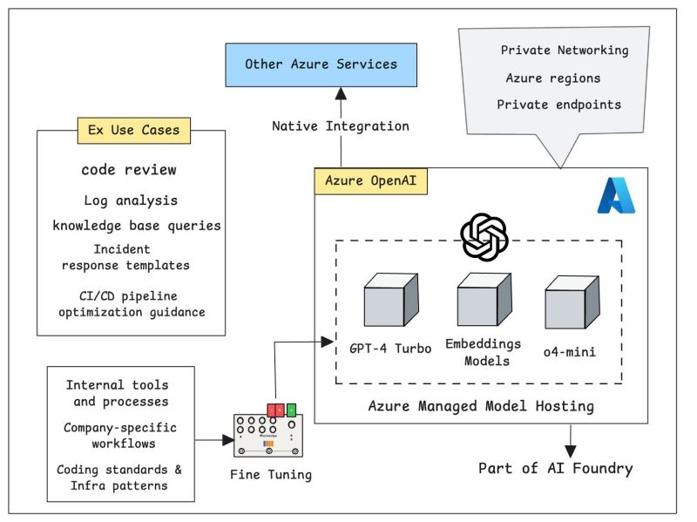

\*\* Azure DevOps is a Software as a service (SaaS) platform from Microsoft that provides an end-to-end DevOps toolchain for developing and deploying software.   
  
\*\* It also integrates with most leading tools on the market and is a great option for orchestrating a DevOps toolchain.   
  
\*\* DevOps Group, we have lots of customers who have found Azure DevOps fits their needs irrespective of their language, platform, or cloud.  
  
\*\* Azure DevOps comprises a range of services covering the full development life-cycle. At the time of writing these are:  
  
--> 𝗔𝘇𝘂𝗿𝗲 𝗕𝗼𝗮𝗿𝗱𝘀: A work tracking system with Kanban boards, dashboards, and reporting.  
  
--> 𝗔𝘇𝘂𝗿𝗲 𝗥𝗲𝗽𝗼𝘀: A cloud-hosted private Git repository service.  
  
--> 𝗔𝘇𝘂𝗿𝗲 𝗣𝗶𝗽𝗲𝗹𝗶𝗻𝗲𝘀: A CI/CD, testing, and deployment system that can connect to any Git repository.  
  
--> A𝘇𝘂𝗿𝗲 𝗧𝗲𝘀𝘁 𝗣𝗹𝗮𝗻𝘀: A solution for tests and capturing data about defects.  
  
--> 𝗔𝘇𝘂𝗿𝗲 𝗔𝗿𝘁𝗶𝗳𝗮𝗰𝘁𝘀: A hosting facility for Maven, npm, and NuGet packages.  
  
--> Azure DevOps can also be used to 𝗼𝗿𝗰𝗵𝗲𝘀𝘁𝗿𝗮𝘁𝗲 third-party tools.  
  
𝗦𝗼𝗳𝘁𝘄𝗮𝗿𝗲 𝗱𝗲𝘃𝗲𝗹𝗼𝗽𝗺𝗲𝗻𝘁 (𝗗𝗲𝘃) 𝗮𝗻𝗱 𝗜𝗧 𝗼𝗽𝗲𝗿𝗮𝘁𝗶𝗼𝗻𝘀 𝗮𝗿𝗲 𝗰𝗼𝗺𝗯𝗶𝗻𝗲𝗱 𝗶𝗻 𝗮 𝘀𝗲𝘁 𝗼𝗳 𝗽𝗿𝗼𝗰𝗲𝗱𝘂𝗿𝗲𝘀 𝗰𝗮𝗹𝗹𝗲𝗱 "𝗗𝗲𝘃𝗢𝗽𝘀" (𝗢𝗽𝘀).  
  
[**hashtag#AzureDevOps**](https://www.linkedin.com/search/results/all/?keywords=%23azuredevops&origin=HASH_TAG_FROM_FEED)  
[**hashtag#Azure**](https://www.linkedin.com/search/results/all/?keywords=%23azure&origin=HASH_TAG_FROM_FEED) [**hashtag#DevOps**](https://www.linkedin.com/search/results/all/?keywords=%23devops&origin=HASH_TAG_FROM_FEED) [**hashtag#SiteReliabilityEngineering**](https://www.linkedin.com/search/results/all/?keywords=%23sitereliabilityengineering&origin=HASH_TAG_FROM_FEED) [**hashtag#GitOps**](https://www.linkedin.com/search/results/all/?keywords=%23gitops&origin=HASH_TAG_FROM_FEED) [**hashtag#Git**](https://www.linkedin.com/search/results/all/?keywords=%23git&origin=HASH_TAG_FROM_FEED) [**hashtag#Maven**](https://www.linkedin.com/search/results/all/?keywords=%23maven&origin=HASH_TAG_FROM_FEED)  
[**hashtag#CI**](https://www.linkedin.com/search/results/all/?keywords=%23ci&origin=HASH_TAG_FROM_FEED) [**hashtag#CD**](https://www.linkedin.com/search/results/all/?keywords=%23cd&origin=HASH_TAG_FROM_FEED) [**hashtag#CICD**](https://www.linkedin.com/search/results/all/?keywords=%23cicd&origin=HASH_TAG_FROM_FEED) [**hashtag#CloudEngineering**](https://www.linkedin.com/search/results/all/?keywords=%23cloudengineering&origin=HASH_TAG_FROM_FEED) [**hashtag#Innovation**](https://www.linkedin.com/search/results/all/?keywords=%23innovation&origin=HASH_TAG_FROM_FEED) [**hashtag#TechLife**](https://www.linkedin.com/search/results/all/?keywords=%23techlife&origin=HASH_TAG_FROM_FEED) [**hashtag#Saas**](https://www.linkedin.com/search/results/all/?keywords=%23saas&origin=HASH_TAG_FROM_FEED) [**hashtag#ContinuousImprovement**](https://www.linkedin.com/search/results/all/?keywords=%23continuousimprovement&origin=HASH_TAG_FROM_FEED) [**hashtag#Reliability**](https://www.linkedin.com/search/results/all/?keywords=%23reliability&origin=HASH_TAG_FROM_FEED) [**hashtag#OnCall**](https://www.linkedin.com/search/results/all/?keywords=%23oncall&origin=HASH_TAG_FROM_FEED) [**hashtag#IncidentManagement**](https://www.linkedin.com/search/results/all/?keywords=%23incidentmanagement&origin=HASH_TAG_FROM_FEED) [**hashtag#DigitalTransformation**](https://www.linkedin.com/search/results/all/?keywords=%23digitaltransformation&origin=HASH_TAG_FROM_FEED)

Amazon SQS + MWAA: Building Reliable & Scalable Workflows  
In modern cloud-native systems, scalability and orchestration are critical. Two AWS services—Amazon SQS (Simple Queue Service) and Amazon MWAA (Managed Workflows for Apache Airflow)—work hand in hand to solve these challenges.  
🔹 Amazon SQS provides fully managed message queuing, handling millions of messages with features like message retention (up to 14 days), monitoring, and logging. It ensures decoupling between producers and consumers for seamless scaling.  
🔹 Amazon MWAA brings the power of Apache Airflow in a managed way, allowing you to build, schedule, and monitor complex workflows with strong security (IAM, VPC, encryption at rest, network isolation).  
-->Together, they enable:  
Event-driven e-commerce order processing  
Reliable data pipeline orchestration  
Scalable workflow automation across services like Lambda, EC2, S3, Redshift, Athena, and Step Functions  
-->The combination of queue-based decoupling + DAG-driven orchestration is a game-changer for building fault-tolerant, scalable, and secure systems in the cloud.  
-->Curious to know: How are you leveraging SQS and MWAA (Airflow) in your projects?  
[**hashtag#AWS**](https://www.linkedin.com/search/results/all/?keywords=%23aws&origin=HASH_TAG_FROM_FEED) [**hashtag#SRE**](https://www.linkedin.com/search/results/all/?keywords=%23sre&origin=HASH_TAG_FROM_FEED) [**hashtag#DevOps**](https://www.linkedin.com/search/results/all/?keywords=%23devops&origin=HASH_TAG_FROM_FEED) [**hashtag#Cloud**](https://www.linkedin.com/search/results/all/?keywords=%23cloud&origin=HASH_TAG_FROM_FEED) [**hashtag#ApacheAirflow**](https://www.linkedin.com/search/results/all/?keywords=%23apacheairflow&origin=HASH_TAG_FROM_FEED) [**hashtag#AmazonSQS**](https://www.linkedin.com/search/results/all/?keywords=%23amazonsqs&origin=HASH_TAG_FROM_FEED) [**hashtag#Automation**](https://www.linkedin.com/search/results/all/?keywords=%23automation&origin=HASH_TAG_FROM_FEED)

Activate to view larger image,

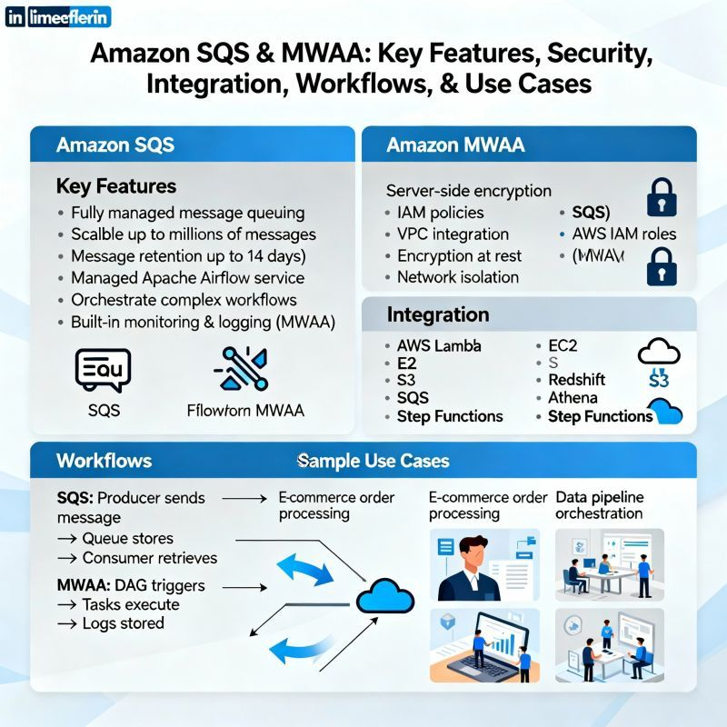

🎯 [**hashtag#MicroservicesMondays**](https://www.linkedin.com/search/results/all/?keywords=%23microservicesmondays&origin=HASH_TAG_FROM_FEED) – Episode 15  
👀 Observability Made Simple: Seeing Inside Your Microservices  
  
Your system’s healthy.  
Dashboards are green. ✅  
But users are complaining. 😩  
Where’s the issue?  
  
That’s when you realize —  
monitoring tells you what broke,  
but observability tells you why.  
  
💡 What Is Observability?  
It’s the ability to understand what’s happening inside your system — just by looking at its outputs.  
  
In microservices, that means connecting:  
🧾 Logs → What happened  
📈 Metrics → How often it happens  
🕵️ Traces → Where it happens across services  
  
Together, they tell the whole story.  
  
  
📦 Example:  
A user’s checkout fails.  
 • Logs show a timeout  
 • Metrics reveal PaymentService latency spikes  
 • Trace pinpoints the slow DB query inside it  
  
➡️ Problem found in minutes, not hours.  
  
  
🧰 Tools That Make It Easy  
 • 📊 Prometheus + Grafana (metrics)  
 • 📜 ELK / OpenSearch (logs)  
 • 🕵️ Jaeger / Zipkin (traces)  
 • 🌐 OpenTelemetry (collects all three)  
  
  
✅ Pro Tips  
 • Add correlation IDs to trace a request across services  
 • Set up alerts based on symptoms, not just thresholds  
 • Visualize dependencies to spot bottlenecks early  
  
[**hashtag#Microservices**](https://www.linkedin.com/search/results/all/?keywords=%23microservices&origin=HASH_TAG_FROM_FEED) [**hashtag#Observability**](https://www.linkedin.com/search/results/all/?keywords=%23observability&origin=HASH_TAG_FROM_FEED) [**hashtag#DevOps**](https://www.linkedin.com/search/results/all/?keywords=%23devops&origin=HASH_TAG_FROM_FEED) [**hashtag#Logging**](https://www.linkedin.com/search/results/all/?keywords=%23logging&origin=HASH_TAG_FROM_FEED) [**hashtag#Tracing**](https://www.linkedin.com/search/results/all/?keywords=%23tracing&origin=HASH_TAG_FROM_FEED) [**hashtag#Monitoring**](https://www.linkedin.com/search/results/all/?keywords=%23monitoring&origin=HASH_TAG_FROM_FEED) [**hashtag#OpenTelemetry**](https://www.linkedin.com/search/results/all/?keywords=%23opentelemetry&origin=HASH_TAG_FROM_FEED) [**hashtag#CloudNative**](https://www.linkedin.com/search/results/all/?keywords=%23cloudnative&origin=HASH_TAG_FROM_FEED) [**hashtag#MicroservicesMondays**](https://www.linkedin.com/search/results/all/?keywords=%23microservicesmondays&origin=HASH_TAG_FROM_FEED)

Activate to view larger image,

When people ask me what an Observability Engineer does, I sometimes say:  
--> “We give systems a voice.”  
Without observability, systems are silent. Outages happen in the dark. Teams guess instead of knowing.  
With observability, every trace, metric, and log becomes a signal. Suddenly, systems are telling us where it hurts and why.  
It’s not just dashboards and alerts—it’s about creating clarity in complexity, turning noise into insight, and helping teams solve problems faster.  
At the end of the day, observability isn’t just about uptime.  
 It’s about building trust—between systems, teams, and the people who rely on them.  
--> Curious: what’s the most unexpected insight you’ve ever discovered thanks to observability?  
[**hashtag#ObservabilityEngineer**](https://www.linkedin.com/search/results/all/?keywords=%23observabilityengineer&origin=HASH_TAG_FROM_FEED)   
[**hashtag#Observability**](https://www.linkedin.com/search/results/all/?keywords=%23observability&origin=HASH_TAG_FROM_FEED)   
[**hashtag#Monitoring**](https://www.linkedin.com/search/results/all/?keywords=%23monitoring&origin=HASH_TAG_FROM_FEED)   
[**hashtag#SystemsReliability**](https://www.linkedin.com/search/results/all/?keywords=%23systemsreliability&origin=HASH_TAG_FROM_FEED)   
[**hashtag#PerformanceEngineering**](https://www.linkedin.com/search/results/all/?keywords=%23performanceengineering&origin=HASH_TAG_FROM_FEED)   
[**hashtag#Telemetry**](https://www.linkedin.com/search/results/all/?keywords=%23telemetry&origin=HASH_TAG_FROM_FEED)   
[**hashtag#LogsMetricsTraces**](https://www.linkedin.com/search/results/all/?keywords=%23logsmetricstraces&origin=HASH_TAG_FROM_FEED)   
[**hashtag#SoftwareReliability**](https://www.linkedin.com/search/results/all/?keywords=%23softwarereliability&origin=HASH_TAG_FROM_FEED)   
[**hashtag#DevOps**](https://www.linkedin.com/search/results/all/?keywords=%23devops&origin=HASH_TAG_FROM_FEED)   
[**hashtag#SRE**](https://www.linkedin.com/search/results/all/?keywords=%23sre&origin=HASH_TAG_FROM_FEED)   
[**hashtag#SiteReliability**](https://www.linkedin.com/search/results/all/?keywords=%23sitereliability&origin=HASH_TAG_FROM_FEED)

Activate to view larger image,

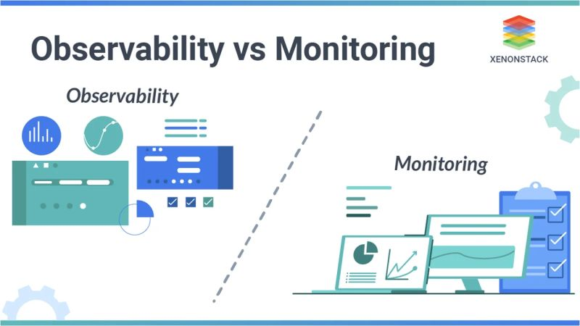

A funny thing about being a Sr. Site Reliability Engineer…  
 If everything is running smoothly, most people don’t even realize you exist.  
 But the moment something breaks, suddenly all eyes are on you.   
That’s the paradox of SRE:  
\*\*Invisible when things work.  
\*\*Indispensable when things don’t.  
Over time, I’ve learned that reliability isn’t just about fixing outages. It’s about:  
\*\*Designing systems that expect failure.  
\*\*Automating away the “boring” work.  
\*\*Building a culture where stability and speed can coexist.  
It’s not glamorous work, but it’s the backbone of user trust. And at the end of the day, there’s nothing more satisfying than knowing millions of people can rely on a system you helped make resilient.  
  
Curious—what’s the toughest lesson you learned in keeping systems reliable?  
  
[**hashtag#SRE**](https://www.linkedin.com/search/results/all/?keywords=%23sre&origin=HASH_TAG_FROM_FEED) [**hashtag#SiteReliabilityEngineering**](https://www.linkedin.com/search/results/all/?keywords=%23sitereliabilityengineering&origin=HASH_TAG_FROM_FEED) [**hashtag#DevOps**](https://www.linkedin.com/search/results/all/?keywords=%23devops&origin=HASH_TAG_FROM_FEED) [**hashtag#Reliability**](https://www.linkedin.com/search/results/all/?keywords=%23reliability&origin=HASH_TAG_FROM_FEED) [**hashtag#Automation**](https://www.linkedin.com/search/results/all/?keywords=%23automation&origin=HASH_TAG_FROM_FEED)

Activate to view larger image,

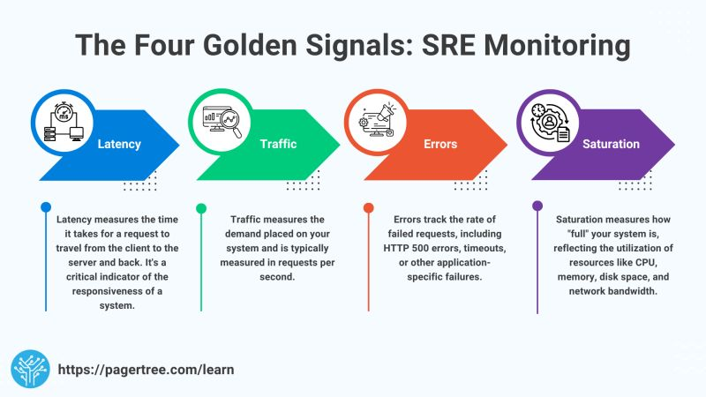

The future is cloud-native.  
  
Cloud computing has shifted from being an option to being the foundation of modern business. Organizations that embrace the cloud aren’t just moving servers—they’re unlocking:  
--> Faster innovation  
--> Smarter scalability  
--> Stronger resilience  
It’s not about if companies adopt the cloud, but how quickly and effectively they can do it.  
--> Curious to hear: what’s the biggest benefit you’ve seen from the cloud in your work?  
[**hashtag#CloudComputing**](https://www.linkedin.com/search/results/all/?keywords=%23cloudcomputing&origin=HASH_TAG_FROM_FEED) [**hashtag#DigitalTransformation**](https://www.linkedin.com/search/results/all/?keywords=%23digitaltransformation&origin=HASH_TAG_FROM_FEED) [**hashtag#TechInnovation**](https://www.linkedin.com/search/results/all/?keywords=%23techinnovation&origin=HASH_TAG_FROM_FEED)

In today’s fast-paced world, speed and reliability aren’t opposites—they go hand in hand. That’s where DevOps makes all the difference.  
\*\* Automating repetitive tasks to free up innovation  
\*\* Building CI/CD pipelines to ship faster with confidence  
\*\* Breaking silos between development & operations for true collaboration  
\*\* Focusing on culture as much as technology  
The real value of DevOps isn’t just deploying code faster it’s about delivering customer value continuously and sustainably.   
--> What’s one DevOps practice or tool that has transformed the way you work?  
[**hashtag#DevOps**](https://www.linkedin.com/search/results/all/?keywords=%23devops&origin=HASH_TAG_FROM_FEED) [**hashtag#Automation**](https://www.linkedin.com/search/results/all/?keywords=%23automation&origin=HASH_TAG_FROM_FEED) [**hashtag#CICD**](https://www.linkedin.com/search/results/all/?keywords=%23cicd&origin=HASH_TAG_FROM_FEED) [**hashtag#Cloud**](https://www.linkedin.com/search/results/all/?keywords=%23cloud&origin=HASH_TAG_FROM_FEED) [**hashtag#Collaboration**](https://www.linkedin.com/search/results/all/?keywords=%23collaboration&origin=HASH_TAG_FROM_FEED)

Activate to view larger image,

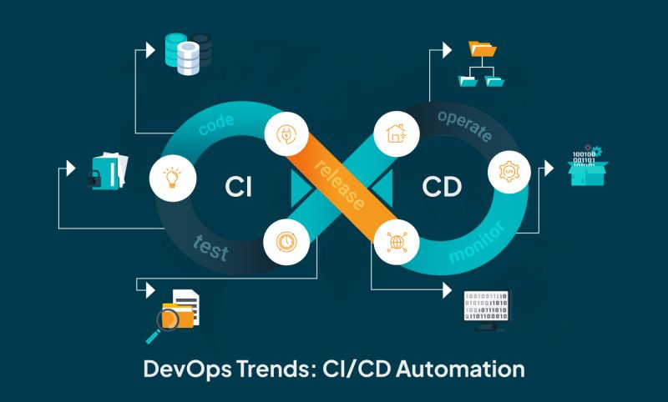

[(20) Activity | Shubham Pawar | LinkedIn](https://www.linkedin.com/in/pawarshubham/recent-activity/all/)

Tired of being the "kubectl guy"? 😅  
   
 As a DevOps Engineer, I spent "hours daily" helping developers troubleshoot basic Kubernetes issues.  
   
 "Can you check why my pod is failing?"  
 "What's in the logs?"  
 "Can you restart this deployment?"  
   
 So I built "Kubectl Web UI" - a self-service troubleshooting dashboard that empowers developers to debug K8s themselves.  
   
 "But doesn't the Kubernetes Dashboard already exist?"  
   
 Yes! But it's a general-purpose management tool. What I needed was a focused troubleshooting companion that do 🔧:  
   
 • Complete pod diagnostics & log analysis  
 • One-click restarts, scaling & cleanup  
 • Resource & network monitoring  
 • No kubectl expertise needed  
   
 Note: The App is not perfect but we can make it:)  
   
 🤖 "Built entirely using AI" and published on GitHub - so anyone who is facing this problem can use it, modify it.  
   
 Because our time is better spent on innovation, not repetitive troubleshooting.   
   
 👉 Check out the demo video & grab the code:  
 🔗[**https://lnkd.in/dAZX5ARu**](https://lnkd.in/dAZX5ARu)  
   
 [**hashtag#DevOps**](https://www.linkedin.com/search/results/all/?keywords=%23devops&origin=HASH_TAG_FROM_FEED) [**hashtag#Kubernetes**](https://www.linkedin.com/search/results/all/?keywords=%23kubernetes&origin=HASH_TAG_FROM_FEED) [**hashtag#CloudNative**](https://www.linkedin.com/search/results/all/?keywords=%23cloudnative&origin=HASH_TAG_FROM_FEED) [**hashtag#OpenSource**](https://www.linkedin.com/search/results/all/?keywords=%23opensource&origin=HASH_TAG_FROM_FEED) [**hashtag#AI**](https://www.linkedin.com/search/results/all/?keywords=%23ai&origin=HASH_TAG_FROM_FEED) [**hashtag#DevOpsLife**](https://www.linkedin.com/search/results/all/?keywords=%23devopslife&origin=HASH_TAG_FROM_FEED)

Officially a KUBESTRONAUT! Ready to navigate the Kubernetes galaxy!🚀  
  
After an intense journey, I've successfully completed all 5 Kubernetes certifications:  
✅CKA ✅CKAD ✅CKS ✅KCNA ✅KCSA  
  
This milestone represents countless hours of learning, hands-on practice, and dedication to mastering cloud-native technologies. The journey wasn't just about collecting certificates – it was about mastering the tools and practices that drive today's cloud-native environments.  
  
Key learnings along the way:  
🔹 Deep dive into Kubernetes architecture  
🔹 Advanced security practices in cloud-native environments  
🔹 Container orchestration mastery  
🔹 Cloud-native application development  
🔹 Security-first mindset in DevOps  
  
A huge thank you to [**Mumshad Mannambeth**](https://www.linkedin.com/in/mmumshad/), 4 years back, I started my DevOps journey when I didn't even know what DevOps and containerization were. It all began with your course 'Docker for Absolute Beginners'. I'm also grateful to the amazing Kubernetes community for their continuous support and knowledge sharing. 🤝  
  
Looking forward to contributing more to the cloud-native ecosystem and helping others in their Kubernetes journey!   
  
[**hashtag#Kubestronaut**](https://www.linkedin.com/search/results/all/?keywords=%23kubestronaut&origin=HASH_TAG_FROM_FEED) [**hashtag#CNCF**](https://www.linkedin.com/search/results/all/?keywords=%23cncf&origin=HASH_TAG_FROM_FEED) [**hashtag#Kubernetes**](https://www.linkedin.com/search/results/all/?keywords=%23kubernetes&origin=HASH_TAG_FROM_FEED) [**hashtag#CloudNative**](https://www.linkedin.com/search/results/all/?keywords=%23cloudnative&origin=HASH_TAG_FROM_FEED) [**hashtag#DevOps**](https://www.linkedin.com/search/results/all/?keywords=%23devops&origin=HASH_TAG_FROM_FEED) [**hashtag#K8s**](https://www.linkedin.com/search/results/all/?keywords=%23k8s&origin=HASH_TAG_FROM_FEED) [**hashtag#CKA**](https://www.linkedin.com/search/results/all/?keywords=%23cka&origin=HASH_TAG_FROM_FEED) [**hashtag#CKAD**](https://www.linkedin.com/search/results/all/?keywords=%23ckad&origin=HASH_TAG_FROM_FEED) [**hashtag#CKS**](https://www.linkedin.com/search/results/all/?keywords=%23cks&origin=HASH_TAG_FROM_FEED) [**hashtag#KCNA**](https://www.linkedin.com/search/results/all/?keywords=%23kcna&origin=HASH_TAG_FROM_FEED) [**hashtag#KCSA**](https://www.linkedin.com/search/results/all/?keywords=%23kcsa&origin=HASH_TAG_FROM_FEED) [**hashtag#TechAchievement**](https://www.linkedin.com/search/results/all/?keywords=%23techachievement&origin=HASH_TAG_FROM_FEED) [**hashtag#CloudComputing**](https://www.linkedin.com/search/results/all/?keywords=%23cloudcomputing&origin=HASH_TAG_FROM_FEED) [**hashtag#Certification**](https://www.linkedin.com/search/results/all/?keywords=%23certification&origin=HASH_TAG_FROM_FEED) [**hashtag#TechExcellence**](https://www.linkedin.com/search/results/all/?keywords=%23techexcellence&origin=HASH_TAG_FROM_FEED)  
  
[**https://lnkd.in/dV5jPB-E**](https://lnkd.in/dV5jPB-E)

Activate to view larger image,

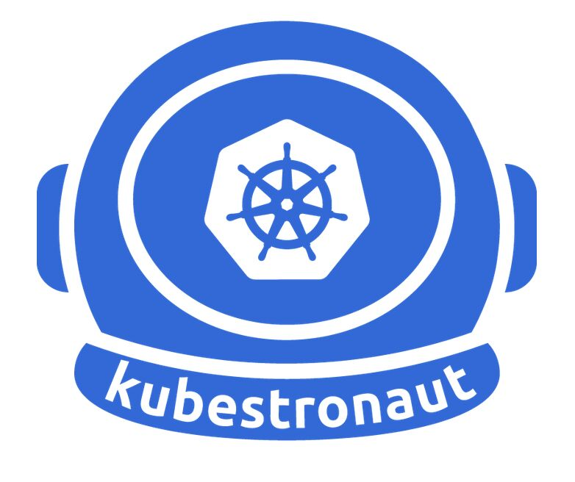

[(20) Kim Wüstkamp | LinkedIn](https://www.linkedin.com/in/kimwuestkamp/)

Certified Kubernetes Security Specialist (CKS)  
Certified Kubernetes Administrator (CKA)  
Certified Kubernetes Application Developer (CKAD)  
  
Creator of the CKS|CKA|CKAD|LFCS|LFCT simulators on https://killer.sh  
  
Creator of a CKS video e-learning course https://killer.sh/r?d=cks-course  
  
Writing, teaching and connecting about it all on medium.com/@wuestkamp  
  
I love building highly functional and maintainable modern software architecture using various technologies like Kubernetes, Managed Cloud (Gcloud AWS DigitalOcean), Terraform, Microservices, GO, Python, PHP JS etc.  
  
Really amazed by Kubernetes, modern cloud infrastructure, IaC and how software and infrastructure are merging more and more together.

Tip of the Day: Mastering CI/CD Pipelines! 🔥  
  
CI/CD (Continuous Integration & Continuous Deployment) automates software development, ensuring faster releases, fewer bugs, and smoother deployments! Let's break it down:  
  
🔹 Source 📝 – Developers commit code to repositories like GitHub, GitLab, or BitBucket, triggering the pipeline.  
🔹 Build 🏗️ – Code is compiled, dependencies resolved, and artifacts created using Jenkins, Gradle, CircleCI, Buildkite.  
🔹 Test 🧪 – Automated tests (Selenium, Jest, Pytest, Cypress) validate functionality to prevent failures.  
🔹 Staging 🛠️ – The application is deployed to a test environment for final validation before release (AWS CodeDeploy, GitHub Actions, Argo CD, Azure DevOps).  
🔹 Deploy 🚀 – The app is pushed to production with monitoring tools ensuring performance & issue tracking (GitHub Actions, Argo CD, AWS CodeDeploy, Azure DevOps Releases).  
💡 Pro Tip: Automating your CI/CD pipeline boosts efficiency, reduces human errors, and ensures fast feedback loops. Mastering it supercharges your DevOps skills! ⚡  
📌 What's your favorite CI/CD tool? Drop your thoughts in the comments! 👇

[**#DevOps**](https://www.linkedin.com/search/results/all/?keywords=%23devops&origin=HASH_TAG_FROM_FEED) [**hashtag#CICD**](https://www.linkedin.com/search/results/all/?keywords=%23cicd&origin=HASH_TAG_FROM_FEED) [**hashtag#Automation**](https://www.linkedin.com/search/results/all/?keywords=%23automation&origin=HASH_TAG_FROM_FEED) [**hashtag#SoftwareEngineering**](https://www.linkedin.com/search/results/all/?keywords=%23softwareengineering&origin=HASH_TAG_FROM_FEED) [**hashtag#Cloud**](https://www.linkedin.com/search/results/all/?keywords=%23cloud&origin=HASH_TAG_FROM_FEED) [**hashtag#TechTips**](https://www.linkedin.com/search/results/all/?keywords=%23techtips&origin=HASH_TAG_FROM_FEED) 🚀

Activate to view larger image,



Tip of the Day: Mastering RESTful API Design 🌐  
APIs are the backbone of modern technology, connecting systems and empowering innovation. Want to build RESTful APIs ?   
  
Here's your cheat sheet! 🛠️✨  
1️⃣ 🖇️ Domain Model-Driven Design: Structure your API based on your domain model for clarity. Example: /orders/{id}/items.  
2️⃣ 🚦 Choose HTTP Methods Wisely: Use GET, POST, PUT, and DELETE smartly. Keep things simple—PATCH can be confusing!  
3️⃣ ♻️ Implement Idempotency: Make operations like PUT and DELETE resilient to duplicate requests. Design with care!  
4️⃣ 📊 Leverage HTTP Status Codes: Communicate effectively with codes like 200 (Success), 201 (Created), and 404 (Not Found). APIs that "talk" well win hearts! 💙  
5️⃣ 🔢 Versioning for Stability: Use paths (/v1/users) or query parameters (?v1) to evolve your API gracefully.  
6️⃣ 📚 Semantic Paths Matter: Use nouns, not verbs! Example: /users, not /getUsers. Keep it clean and professional.  
7️⃣ ⚡ Batch Processing for Efficiency: Allow bulk operations like /users/batch to speed things up. Performance matters! 🚀  
8️⃣ 🔍 Query Language is Key: Add pagination, sorting, and filtering to give users what they need fast! Example: /users?page=1&sort=name:asc.  
  
🚀 Pro Tip: Design APIs that are intuitive, scalable, and developer-friendly—the key to long-term success!  
  
  
💬 Let’s make API design smarter together. What’s your favorite RESTful API best practice? Share it in the comments!  
✨ Let’s grow and learn together—one API at a time! 🌟  
📚 [**hashtag#TechTips**](https://www.linkedin.com/search/results/all/?keywords=%23techtips&origin=HASH_TAG_FROM_FEED) [**hashtag#RESTfulAPI**](https://www.linkedin.com/search/results/all/?keywords=%23restfulapi&origin=HASH_TAG_FROM_FEED) [**hashtag#APIDesign**](https://www.linkedin.com/search/results/all/?keywords=%23apidesign&origin=HASH_TAG_FROM_FEED) [**hashtag#ProfessionalGrowth**](https://www.linkedin.com/search/results/all/?keywords=%23professionalgrowth&origin=HASH_TAG_FROM_FEED) [**hashtag#ProgrammingWithHeart**](https://www.linkedin.com/search/results/all/?keywords=%23programmingwithheart&origin=HASH_TAG_FROM_FEED)

Activate to view larger image,

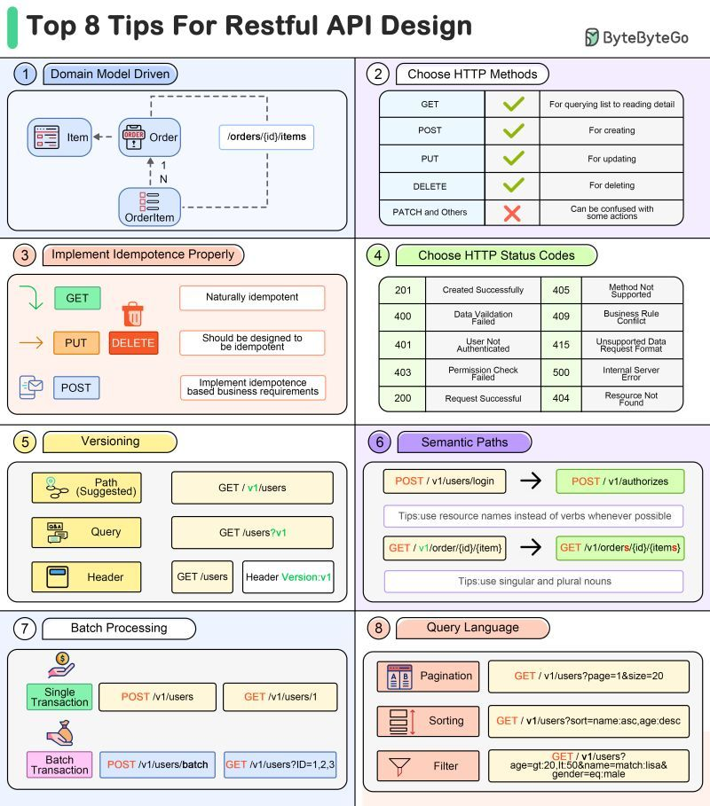

Best Practices for 𝙺̲𝚞̲𝚋̲𝚎̲𝚛̲𝚗̲𝚎̲𝚝̲𝚎̲𝚜̲ Management ☁️  
  
1️⃣ 𝗜𝗻𝗳𝗿𝗮𝘀𝘁𝗿𝘂𝗰𝘁𝘂𝗿𝗲 𝗮𝘀 𝗖𝗼𝗱𝗲 (𝗜𝗮𝗖)  
Use Terraform or similar tools to define and deploy your Kubernetes cluster in the cloud. This approach ensures consistency, reliability, and repeatability by discouraging manual deployments.  
  
2️⃣ 𝗠𝗼𝗻𝗶𝘁𝗼𝗿𝗶𝗻𝗴 𝗮𝗻𝗱 𝗖𝗲𝗻𝘁𝗿𝗮𝗹𝗶𝘇𝗲𝗱 𝗟𝗼𝗴𝗴𝗶𝗻𝗴  
Implement a robust monitoring stack to proactively manage alerts and prevent outages. Use tools like Grafana Loki for centralized logging to enhance development speed and troubleshooting.  
  
3️⃣ 𝗖𝗲𝗻𝘁𝗿𝗮𝗹𝗶𝘇𝗲𝗱 𝗜𝗻𝗴𝗿𝗲𝘀𝘀 𝘄𝗶𝘁𝗵 𝗦𝗦𝗟 𝗢𝗳𝗳𝗹𝗼𝗮𝗱𝗶𝗻𝗴  
Set up a central ingress controller to route traffic to Kubernetes apps using Ingress resources. This simplifies load balancing and SSL certificate management with tools like Cert Manager.  
  
4️⃣ 𝗥𝗼𝗹𝗲-𝗕𝗮𝘀𝗲𝗱 𝗔𝗰𝗰𝗲𝘀𝘀 𝗖𝗼𝗻𝘁𝗿𝗼𝗹 (𝗥𝗕𝗔𝗖)  
Implement RBAC to secure your cluster by limiting access. Integrate OIDC/OAuth2 for easier authentication and authorization.  
  
5️⃣ 𝗚𝗶𝘁𝗢𝗽𝘀 𝗗𝗲𝗽𝗹𝗼𝘆𝗺𝗲𝗻𝘁𝘀  
Use GitOps tools like ArgoCD to automate deployments from Git repositories. This approach ensures traceability, reversion, and automation.  
  
6️⃣ 𝗦𝗲𝗰𝗿𝗲𝘁 𝗠𝗮𝗻𝗮𝗴𝗲𝗺𝗲𝗻𝘁  
Manage secrets effectively using tools like External Secrets or HashiCorp Vault. This helps maintain best practices for secret rotation, RBAC, and security.  
  
By following these tips, you can choose and use the 𝗿𝗶𝗴𝗵𝘁 𝗞𝘂𝗯𝗲𝗿𝗻𝗲𝘁𝗲𝘀 𝘁𝗼𝗼𝗹𝘀 to orchestrate your containerized applications in 𝗽𝗿𝗼𝗱𝘂𝗰𝘁𝗶𝗼𝗻.

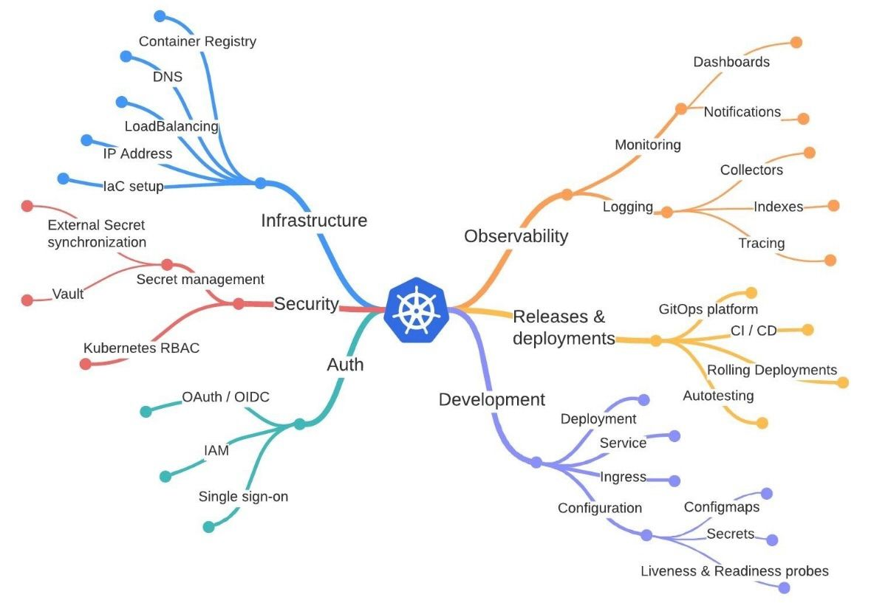



[**#Advanced**](https://www.linkedin.com/search/results/all/?keywords=%23advanced&origin=HASH_TAG_FROM_FEED) [**#Kubernetes**](https://www.linkedin.com/search/results/all/?keywords=%23kubernetes&origin=HASH_TAG_FROM_FEED) – The Big Picture 🖤!  
◾️ ◽️◾️ ◽️◾️ ◽️◾️ ◽️◾️ ◽️◾️ ◽️◾️ ◽️◾️ ◽️◾️ ◽️◾️ ◽️  
This visual breaks down the most important areas every Kubernetes engineer should master:  
  
● Cluster Management & Scaling  
● Observability & Reliability  
● GitOps & Platform Engineering  
● Networking & Traffic Control  
● Workload Optimization  
● Security & Governance  
● Extensibility  
● Storage & Stateful Workloads  
  
A great reminder that Kubernetes isn’t just about Pods and Deployments — it’s an entire ecosystem of tools, patterns, and best practices that help teams build reliable, scalable, and secure platforms.  
  
Perfect map for anyone aiming to go from Intermediate ➜ Advanced in Kubernetes.  
  
◾️ ◽️◾️ ◽️◾️ ◽️◾️ ◽️◾️ ◽️◾️ ◽️◾️ ◽️◾️ ◽️◾️ ◽️  
[**#Kubernetes**](https://www.linkedin.com/search/results/all/?keywords=%23kubernetes&origin=HASH_TAG_FROM_FEED) [**#DevOps**](https://www.linkedin.com/search/results/all/?keywords=%23devops&origin=HASH_TAG_FROM_FEED) [**#CloudNative**](https://www.linkedin.com/search/results/all/?keywords=%23cloudnative&origin=HASH_TAG_FROM_FEED) [**#SRE**](https://www.linkedin.com/search/results/all/?keywords=%23sre&origin=HASH_TAG_FROM_FEED) [**#PlatformEngineering**](https://www.linkedin.com/search/results/all/?keywords=%23platformengineering&origin=HASH_TAG_FROM_FEED) [**#GitOps**](https://www.linkedin.com/search/results/all/?keywords=%23gitops&origin=HASH_TAG_FROM_FEED) [**#Observability**](https://www.linkedin.com/search/results/all/?keywords=%23observability&origin=HASH_TAG_FROM_FEED) [**#CKA**](https://www.linkedin.com/search/results/all/?keywords=%23cka&origin=HASH_TAG_FROM_FEED) [**#CKAD**](https://www.linkedin.com/search/results/all/?keywords=%23ckad&origin=HASH_TAG_FROM_FEED) [**#CKS**](https://www.linkedin.com/search/results/all/?keywords=%23cks&origin=HASH_TAG_FROM_FEED)

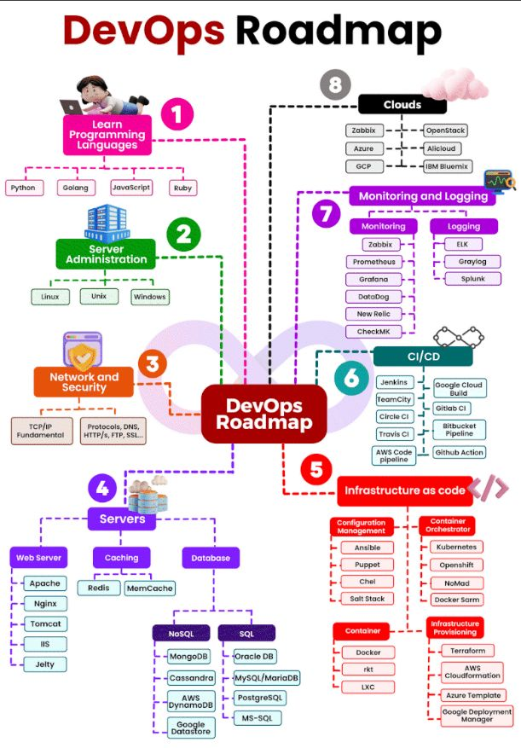

What is DevOps?  
DevOps = Development + Operations  
It’s a culture and practice that helps software and IT teams collaborate efficiently.  
The main goal of DevOps is to make software delivery faster, more reliable, and easier to manage.  
At the heart of DevOps lies automation, continuous testing, rapid delivery, and quick feedback.  
  
🗺️ DevOps Learning Roadmap (Step-by-Step)  
  
1. Programming  
Languages: Python, Bash, Ruby, Go, JavaScript  
Version Control: Git (GitHub, GitLab, Bitbucket)  
  
2. Server Administration  
Operating Systems: Linux (Ubuntu, CentOS, Debian)  
Configuration Management: Ansible, Puppet, Chef  
Containers: Docker  
  
3. Networking & Security  
Firewalls: iptables, pf, Cloud Firewalls  
VPN Tools: OpenVPN, IPsec  
Security Practices: Regular security checks, vulnerability scanning  
  
4. Servers (Web, Database, Cache)  
Web Servers: Apache, Nginx  
Databases: MySQL, PostgreSQL, MongoDB  
Cache Tools: Redis, Memcached  
  
5. Cloud Infrastructure (IaaS)  
Cloud Providers: AWS, Azure, Google Cloud  
Infrastructure Automation: Terraform  
  
6. CI/CD (Continuous Integration & Deployment)  
CI Tools: Jenkins, GitLab CI, Travis CI  
CD Tools: Ansible, Kubernetes, Docker  
  
7. Monitoring & Logging  
Monitoring Tools: Prometheus, Grafana, Nagios  
Logging Tools: ELK Stack (Elasticsearch, Logstash, Kibana), Splunk  
  
8. Cloud & Serverless  
Cloud Platforms: AWS, Azure, Google Cloud  
Serverless Services: AWS Lambda, Azure Functions  
[**#DevOps**](https://www.linkedin.com/search/results/all/?keywords=%23devops&origin=HASH_TAG_FROM_FEED) [**#DevOpsEngineer**](https://www.linkedin.com/search/results/all/?keywords=%23devopsengineer&origin=HASH_TAG_FROM_FEED) [**#DevOpsLife**](https://www.linkedin.com/search/results/all/?keywords=%23devopslife&origin=HASH_TAG_FROM_FEED) [**#DevOpsCommunity**](https://www.linkedin.com/search/results/all/?keywords=%23devopscommunity&origin=HASH_TAG_FROM_FEED) [**#CloudComputing**](https://www.linkedin.com/search/results/all/?keywords=%23cloudcomputing&origin=HASH_TAG_FROM_FEED) [**#Automation**](https://www.linkedin.com/search/results/all/?keywords=%23automation&origin=HASH_TAG_FROM_FEED) [**#CI\_CD**](https://www.linkedin.com/search/results/all/?keywords=%23ci_cd&origin=HASH_TAG_FROM_FEED) [**#GitOps**](https://www.linkedin.com/search/results/all/?keywords=%23gitops&origin=HASH_TAG_FROM_FEED) [**#DevSecOps**](https://www.linkedin.com/search/results/all/?keywords=%23devsecops&origin=HASH_TAG_FROM_FEED) [**#Kubernetes**](https://www.linkedin.com/search/results/all/?keywords=%23kubernetes&origin=HASH_TAG_FROM_FEED) [**#AWS**](https://www.linkedin.com/search/results/all/?keywords=%23aws&origin=HASH_TAG_FROM_FEED) [**#Docker**](https://www.linkedin.com/search/results/all/?keywords=%23docker&origin=HASH_TAG_FROM_FEED) [**#InfrastructureAsCode**](https://www.linkedin.com/search/results/all/?keywords=%23infrastructureascode&origin=HASH_TAG_FROM_FEED) [**#TechRoadmap**](https://www.linkedin.com/search/results/all/?keywords=%23techroadmap&origin=HASH_TAG_FROM_FEED) [**#LearnDevOps**](https://www.linkedin.com/search/results/all/?keywords=%23learndevops&origin=HASH_TAG_FROM_FEED) [**#CloudSecurity**](https://www.linkedin.com/search/results/all/?keywords=%23cloudsecurity&origin=HASH_TAG_FROM_FEED) [**#SysAdmin**](https://www.linkedin.com/search/results/all/?keywords=%23sysadmin&origin=HASH_TAG_FROM_FEED) [**#ITInfrastructure**](https://www.linkedin.com/search/results/all/?keywords=%23itinfrastructure&origin=HASH_TAG_FROM_FEED) [**#SoftwareEngineering**](https://www.linkedin.com/search/results/all/?keywords=%23softwareengineering&origin=HASH_TAG_FROM_FEED)

𝗧𝗵𝗲 𝗞𝘂𝗯𝗲𝗿𝗻𝗲𝘁𝗲𝘀 𝗨𝗻𝗶𝘃𝗲𝗿𝘀𝗲 𝗘𝘅𝗽𝗹𝗮𝗶𝗻𝗲𝗱 𝗶𝗻 𝗢𝗻𝗲 𝗪𝗵𝗲𝗲𝗹   
  
Kubernetes isn’t a tool.  
It’s an ecosystem.  
And this wheel perfectly shows why so many teams feel both amazed, and overwhelmed, when they dive in. 😅  
  
From 𝗧𝗲𝗿𝗿𝗮𝗳𝗼𝗿𝗺 𝘁𝗼 𝗣𝗿𝗼𝗺𝗲𝘁𝗵𝗲𝘂𝘀, 𝗜𝘀𝘁𝗶𝗼, 𝗮𝗻𝗱 𝗔𝗿𝗴𝗼𝗖𝗗, every slice of this wheel represents one mission-critical piece of modern cloud infrastructure:  
  
🧱 𝗜𝗻𝗳𝗿𝗮𝘀𝘁𝗿𝘂𝗰𝘁𝘂𝗿𝗲 𝗢𝗿𝗰𝗵𝗲𝘀𝘁𝗿𝗮𝘁𝗶𝗼𝗻:  Terraform, Pulumi, Ansible  
🌐 𝗡𝗲𝘁𝘄𝗼𝗿𝗸𝗶𝗻𝗴: Calico, Cilium, Istio, Linkerd  
☁️ 𝗖𝗹𝘂𝘀𝘁𝗲𝗿 𝗠𝗮𝗻𝗮𝗴𝗲𝗺𝗲𝗻𝘁: EKS, GKE, AKS, Rancher, K3s  
🔒 𝗦𝗲𝗰𝘂𝗿𝗶𝘁𝘆: Trivy, OPA, Kyverno, Aqua  
🛠️ 𝗠𝗼𝗻𝗶𝘁𝗼𝗿𝗶𝗻𝗴 & 𝗢𝗯𝘀𝗲𝗿𝘃𝗮𝗯𝗶𝗹𝗶𝘁𝘆: Grafana, Prometheus, Datadog, ELK  
  
It’s no wonder “learning Kubernetes” often turns into “learning the entire cloud stack.”  
  
💡 The key takeaway?  
You don’t need to master every tool, you need to understand how they connect.  
Because true DevOps mastery isn’t memorizing logos, it’s 𝗯𝘂𝗶𝗹𝗱𝗶𝗻𝗴 𝗿𝗲𝗹𝗶𝗮𝗯𝗹𝗲 𝘀𝘆𝘀𝘁𝗲𝗺𝘀 from them. ⚙️  
  
If you’re starting your Kubernetes journey, here’s a tip:  
👉 Pick 𝗼𝗻𝗲 𝘁𝗼𝗼𝗹 𝗽𝗲𝗿 𝗰𝗮𝘁𝗲𝗴𝗼𝗿𝘆 and get hands-on.  
Depth > breadth.  
  
This wheel is your map.  
Now it’s time to explore the territory. 🌍  
  
👇 Which tools are non-negotiable in your Kubernetes stack?  
  
[**#Kubernetes**](https://www.linkedin.com/search/results/all/?keywords=%23kubernetes&origin=HASH_TAG_FROM_FEED) [**#DevOps**](https://www.linkedin.com/search/results/all/?keywords=%23devops&origin=HASH_TAG_FROM_FEED) [**#CloudComputing**](https://www.linkedin.com/search/results/all/?keywords=%23cloudcomputing&origin=HASH_TAG_FROM_FEED) [**#Containers**](https://www.linkedin.com/search/results/all/?keywords=%23containers&origin=HASH_TAG_FROM_FEED) [**#InfrastructureAsCode**](https://www.linkedin.com/search/results/all/?keywords=%23infrastructureascode&origin=HASH_TAG_FROM_FEED) [**#SRE**](https://www.linkedin.com/search/results/all/?keywords=%23sre&origin=HASH_TAG_FROM_FEED) [**#PlatformEngineering**](https://www.linkedin.com/search/results/all/?keywords=%23platformengineering&origin=HASH_TAG_FROM_FEED)

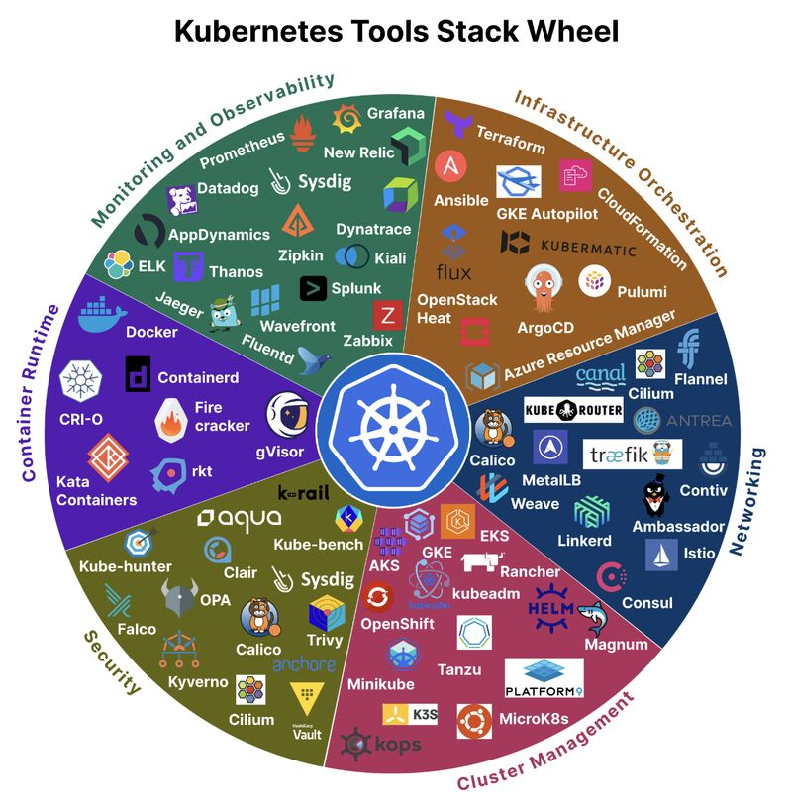

Ansible Handbook 2025 – DevOps Automation From Zero to Advanced  
  
🚀 Still configuring servers manually?  
This Ansible 2025 Handbook is a complete DevOps automation guide covering playbooks, roles, inventories, templates, modules, vaults, and CI/CD integration — everything you need for real-world infra automation.  
  
📘 What’s Inside:  
✅ Ansible basics — inventory, ad-hoc commands, YAML syntax  
✅ Playbooks — tasks, handlers, loops, conditionals  
✅ Jinja2 templates & filters  
✅ Roles — modular, reusable automation structure  
✅ Ansible Vault — encrypting keys, passwords & sensitive files  
✅ Dynamic inventory for AWS, Azure, GCP  
✅ CI/CD with Jenkins, GitLab, GitHub Actions  
✅ SSH hardening, privilege escalation, idempotency  
✅ Real scenarios — web server deploy, user mgmt, Docker automation  
✅ Advanced topics — Molecule testing, custom modules, best practices  
  
💡 Why this matters:  
Ansible remains the #1 automation tool for DevOps, Cloud, and SRE teams — agentless, simple, powerful, and cloud-agnostic.  
  
🎯 Perfect for:  
🔹 DevOps & Cloud Engineers  
🔹 Beginners learning automation  
🔹 Teams standardizing infra & app deployment  
🔹 Anyone preparing for interviews  
  
🧩 Pro Tip:  
Combine this with your Terraform, GitOps, and DevSecOps PDFs — together, they form a complete Infra-as-Code automation pipeline.  
  
⸻  
  
✨ Follow [**Prasanjit Sahoo**](https://www.linkedin.com/in/iamprasanjitsahoo/) for full DevOps certification guides, scenario-based PDFs, and hands-on blueprints.  
[**#Ansible**](https://www.linkedin.com/search/results/all/?keywords=%23ansible&origin=HASH_TAG_FROM_FEED) [**#DevOps**](https://www.linkedin.com/search/results/all/?keywords=%23devops&origin=HASH_TAG_FROM_FEED) [**#Automation**](https://www.linkedin.com/search/results/all/?keywords=%23automation&origin=HASH_TAG_FROM_FEED) [**#InfrastructureAsCode**](https://www.linkedin.com/search/results/all/?keywords=%23infrastructureascode&origin=HASH_TAG_FROM_FEED) [**#CI\_CD**](https://www.linkedin.com/search/results/all/?keywords=%23ci_cd&origin=HASH_TAG_FROM_FEED) [**#Terraform**](https://www.linkedin.com/search/results/all/?keywords=%23terraform&origin=HASH_TAG_FROM_FEED) [**#CloudEngineering**](https://www.linkedin.com/search/results/all/?keywords=%23cloudengineering&origin=HASH_TAG_FROM_FEED) [**#Linux**](https://www.linkedin.com/search/results/all/?keywords=%23linux&origin=HASH_TAG_FROM_FEED) [**#psworldvibes**](https://www.linkedin.com/search/results/all/?keywords=%23psworldvibes&origin=HASH_TAG_FROM_FEED)

Ansible :

Ansible is an open-source automation engine used for IT automation tasks like software provisioning, configuration management, and application deployment. It simplifies complex tasks by using a human-readable language called [YAML](https://www.google.com/search?sca_esv=6c99d299773109c4&sxsrf=AE3TifMCLKlV8JLKPdk6k8OIk0K6Ehm3_Q%3A1763776935315&q=YAML&sa=X&ved=2ahUKEwiy8sSN1YSRAxVrTWwGHUREAhYQxccNegQIERAB&mstk=AUtExfAKE8VXPEEgUm6E6-zTbx2eldL2c9YmErmBz5S4r3gkawBXsnEKQKtS-Y9o4WAIt7dzk8Z4pCn5Zjztgx9eMZEROTSZpKBJnAt14WCgwervMIuvxpQCdB2qLo4I5qVrhiOkOMc2m_iMCmhR8efrfux-r9GaEmVtwIKdT8HzLTwTxZw&csui=3) to describe the desired state of systems, and it does not require agents to be installed on managed nodes, which makes it easy to deploy.

**What Ansible does**

* **Configuration Management:** Ensures that systems are configured consistently and helps prevent configuration drift.
* **Application Deployment:** Deploys applications across multiple servers.
* **Orchestration:** Manages complex workflows that involve multiple systems and services.
* **Cloud Provisioning:** Automates the setup and configuration of cloud resources.
* **Task Execution:** Executes ad-hoc tasks and advanced workflows across an infrastructure.

**How it works**

* **Agentless:** It connects to managed nodes, typically over [SSH](https://www.google.com/search?sca_esv=6c99d299773109c4&sxsrf=AE3TifMCLKlV8JLKPdk6k8OIk0K6Ehm3_Q%3A1763776935315&q=SSH&sa=X&ved=2ahUKEwiy8sSN1YSRAxVrTWwGHUREAhYQxccNegUIqQIQAQ&mstk=AUtExfAKE8VXPEEgUm6E6-zTbx2eldL2c9YmErmBz5S4r3gkawBXsnEKQKtS-Y9o4WAIt7dzk8Z4pCn5Zjztgx9eMZEROTSZpKBJnAt14WCgwervMIuvxpQCdB2qLo4I5qVrhiOkOMc2m_iMCmhR8efrfux-r9GaEmVtwIKdT8HzLTwTxZw&csui=3), without needing to install any software agents on them.
* [**Control Node**](https://www.google.com/search?sca_esv=6c99d299773109c4&sxsrf=AE3TifMCLKlV8JLKPdk6k8OIk0K6Ehm3_Q%3A1763776935315&q=Control+Node&sa=X&ved=2ahUKEwiy8sSN1YSRAxVrTWwGHUREAhYQxccNegUIhAIQAQ&mstk=AUtExfAKE8VXPEEgUm6E6-zTbx2eldL2c9YmErmBz5S4r3gkawBXsnEKQKtS-Y9o4WAIt7dzk8Z4pCn5Zjztgx9eMZEROTSZpKBJnAt14WCgwervMIuvxpQCdB2qLo4I5qVrhiOkOMc2m_iMCmhR8efrfux-r9GaEmVtwIKdT8HzLTwTxZw&csui=3)**:** A central computer that runs Ansible commands.
* [**Managed Nodes**](https://www.google.com/search?sca_esv=6c99d299773109c4&sxsrf=AE3TifMCLKlV8JLKPdk6k8OIk0K6Ehm3_Q%3A1763776935315&q=Managed+Nodes&sa=X&ved=2ahUKEwiy8sSN1YSRAxVrTWwGHUREAhYQxccNegUIkAIQAQ&mstk=AUtExfAKE8VXPEEgUm6E6-zTbx2eldL2c9YmErmBz5S4r3gkawBXsnEKQKtS-Y9o4WAIt7dzk8Z4pCn5Zjztgx9eMZEROTSZpKBJnAt14WCgwervMIuvxpQCdB2qLo4I5qVrhiOkOMc2m_iMCmhR8efrfux-r9GaEmVtwIKdT8HzLTwTxZw&csui=3)**:** The computers or servers that Ansible manages.
* [**Inventory**](https://www.google.com/search?sca_esv=6c99d299773109c4&sxsrf=AE3TifMCLKlV8JLKPdk6k8OIk0K6Ehm3_Q%3A1763776935315&q=Inventory&sa=X&ved=2ahUKEwiy8sSN1YSRAxVrTWwGHUREAhYQxccNegUIjAIQAQ&mstk=AUtExfAKE8VXPEEgUm6E6-zTbx2eldL2c9YmErmBz5S4r3gkawBXsnEKQKtS-Y9o4WAIt7dzk8Z4pCn5Zjztgx9eMZEROTSZpKBJnAt14WCgwervMIuvxpQCdB2qLo4I5qVrhiOkOMc2m_iMCmhR8efrfux-r9GaEmVtwIKdT8HzLTwTxZw&csui=3)**:** A file that lists the managed nodes to be managed.
* [**Playbooks**](https://www.google.com/search?sca_esv=6c99d299773109c4&sxsrf=AE3TifMCLKlV8JLKPdk6k8OIk0K6Ehm3_Q%3A1763776935315&q=Playbooks&sa=X&ved=2ahUKEwiy8sSN1YSRAxVrTWwGHUREAhYQxccNegUIhgIQAQ&mstk=AUtExfAKE8VXPEEgUm6E6-zTbx2eldL2c9YmErmBz5S4r3gkawBXsnEKQKtS-Y9o4WAIt7dzk8Z4pCn5Zjztgx9eMZEROTSZpKBJnAt14WCgwervMIuvxpQCdB2qLo4I5qVrhiOkOMc2m_iMCmhR8efrfux-r9GaEmVtwIKdT8HzLTwTxZw&csui=3)**:** A set of instructions written in YAML that describes the tasks to be executed.

**Key benefits**

* **Simplicity:** Uses a human-readable language (YAML) that has a low learning curve.
* **Agentless architecture:** Reduces setup time and security concerns.
* **"Infrastructure as Code":** Allows IT infrastructure to be treated like software, with version control and self-documenting solutions.
* **Flexibility:** Supports a wide range of use cases, from simple task execution to complex orchestration

[Ansible and How Does it Work](https://www.spiceworks.com/tech/devops/articles/what-is-ansible/)

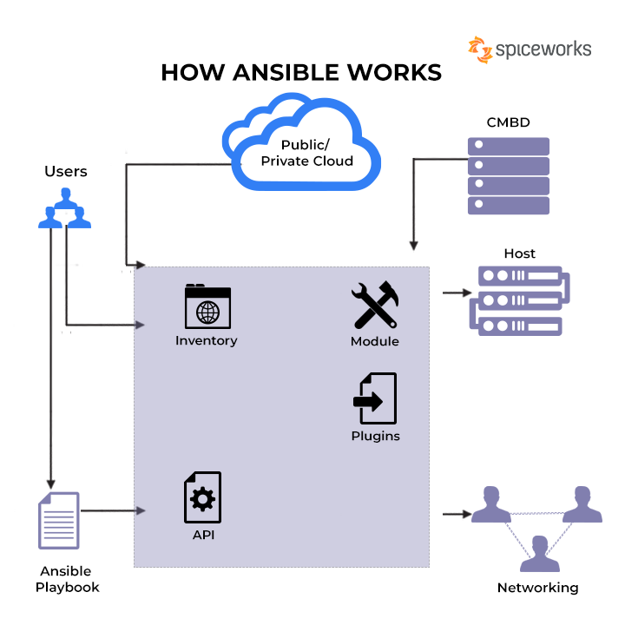

1. Ansible for DevOps

Ansible helps automate the implementation of internally generated applications to your production programs to make DevOps easier. For orchestration, automation, configuration, and management of IT infrastructure, Ansible is the most popular [DevOps tool](https://www.spiceworks.com/tech/devops/articles/what-is-devops-lifecycle/). Ansible’s advantages in DevOps include adapting and scaling in response to demand. The following are the benefits of Ansible in DevOps using Ansible: the feedback loop is accelerated quicker, installations are dependable, IT architecture is coordinated, and deployments are faster.

2. Managing Docker containers using Ansible

Docker is a high-performance framework for efficiently constructing and executing containers on local devices and servers. One can compare Docker containers to lightweight virtual devices. Ansible delivers a robust collection of capabilities and built-in modules that make building automation scripts easier thanks to its straightforward design. This makes it possible to create tasks and run them in your preferred setting. In the form of playbooks, Ansible uses the “yet another markup language” or YAML language.

3. Utilizing Ansible for automation

Automating the deployment of any hardware will be the first step toward automating the operational service lifecycle of your application. Ansible can automate IT infrastructures on bare metal servers, virtualization platforms, and cloud servers. Moreover, it can automate the setup of various systems, devices, databases, storage devices, networks, and [firewalls](https://www.spiceworks.com/it-security/network-security/articles/what-is-firewall-definition-key-components-best-practices/).

4. Configuration management

Ansible is a simple, trustworthy, and consistent configuration management solution. You can set it up quickly if you have prior experience in IT. Ansible configurations are descriptions of fundamental infrastructure data humans can read and process by computers. You only require passwords or an SSH (Secure Socket Shell) key to begin monitoring machines.

5. Installing web application using Ansible

Ansible enables rapid and simple deployment of applications with several tiers. One does not have to develop a code base to manage processes; instead, one can just define the required actions in a playbook, and Ansible will determine how to get the processes to the desired outcome. In other words, there will be no need to set up applications on each machine manually. Ansible uses SSH to communicate with remote networks and implement all instructions when a module is launched from a control device.

**See More:**[**DevOps Roadmap: 7-Step Complete Guide**](https://www.spiceworks.com/tech/devops/articles/devops-roadmap-guide/)

6. Other ansible uses

Other reasons to use ansible include:

* **Provisioning:**The first step toward automating the life cycle of your applications is to set up your hardware. One can use Ansible to set up cloud platforms, network hardware devices, virtualized hosts, and bare metal servers, among other equipment. Users can set up the numerous servers needed in the [computer network](https://www.spiceworks.com/tech/networking/articles/what-is-a-computer-network/) during provisioning.
* **Compliance and security –**Site-wide security policies, like rules for [firewall software](https://www.spiceworks.com/it-security/network-security/articles/top-10-firewall-software-for-desktops/), can be used with other automated processes. When you set up the security information on the control device and run the playbook that goes with it, the security information is automatically adjusted on the various connected servers.

**See More:**[**DevOps Engineer: Job Description, Key Skills, and Salary in 2022**](https://www.spiceworks.com/tech/devops/articles/devops-engineer/)

How Does Ansible Work?

Ansible interacts with your networks and sends little programs, known as modules, to them. These modules are utilized to complete automated tasks as systems designed to be resource models for the functioning at the desired state. Ansible runs these modules and eliminates them after they’re done. If modules weren’t available, you would have to depend on ad-hoc procedures and scripting to complete tasks. Ansible’s management node is the primary node overseeing the Playbook’s implementation.

The management node sets up an SSH connection before executing the modules and installing the product on the host workstations. Once the modules have been deployed, it eliminates them. So that’s how it works with Ansible. Python is used to create an Ansible script and connects remote hosts through SSH, specified in the inventory file. Ansible is agentless – implying that it doesn’t need any program to be installed on the nodes it controls.

Ansible takes inventory data to determine which machines you wish to control. It has a default inventory file, but users can customize it to manage the servers they want to. To link to servers and conduct tasks, Ansible employs the SSH protocol. Ansible establishes a connection with the remote system and distributes the modules required for command or playbook execution. Ansible uses human-readable YAML templates to allow the automation of repetitive processes without the need to master a complex programming language.

You could use Ansible’s built-in modules to automate, or you can develop your own processes. Creating Ansible modules is possible using any programming language that can return JSON, including Ruby, Python, and shell. Powershell is used to develop Windows automation modules. It also stores your application’s history information, enabling you to repeal to a previous standard or update it simply. It provides the following advantages:

* Ansible is a free and open-source software tool that all can access.
* Ansible’s playbooks do not need coding expertise for installation and usage; they are straightforward to configure and use.
* Ansible enables the modeling of even the most complex IT processes.
* You can orchestrate the whole app environment regardless of where the application is deployed.
* It has no agent in the client machines you desire to automate, and one must open no additional software or firewall ports.
* Since no extra software is necessary, servers have a greater capacity for app resources, resulting in increased efficiency.

**See More:**[**Scrum vs. DevOps: Understanding the Key Differences**](https://www.spiceworks.com/tech/devops/articles/scrum-vs-devops/)

Understanding the Architecture of Ansible

Here is a look at the many components that make up the Ansible framework.

1. Modules

Modules are essential software that Ansible delivers from the command computer to all nodal network points or distant hosts. They are predetermined instructions that are executed directly on remote hosts. Playbooks run modules that manage applications, packages, and files. Ansible executes all modules for delivering updates or performing the required activity and then eliminates them after they’re through. Ansible has over 450 modules for typical tasks. Ansible has hundreds of built-in modules, the pieces of code that are run when a playbook is launched. A playbook has plays, containing various tasks that include modules.

2. Playbooks

Playbooks for Ansible are task-specific user guides. Playbooks dictate your workflow since functions written in them are executed in the order they are written. They are simple text documents created in YAML, a data serialization language that humans understand. They are at the heart of what makes Ansible so attractive since they describe the tasks one must perform quickly without requiring the user to remember particular terminology. In addition to being able to describe settings, they may also orchestrate the stages of any manually arranged task and conduct tasks concurrently or sequentially.

3. Plugins

Plugins are little pieces of code that augment a website’s functionality. Ansible comes with several of these, but one can create their own. Plugins are a specific type of module in this case. Before a module is performed on the nodes, the plugins are run. For logging reasons, plugins are executed on the primary control unit. You have call-back plugins because they allow you to connect to various Ansible events for display and reporting. To minimize the costs of fact-gathering processes, cache plugins are used. Action plugins are front-end modules that perform operations on the controller system prior to invoking the modules directly.

4. Inventories

The inventory comprises all the nodes or hosts that need to be taken care of, along with their IP addresses, server details, databases, and other information. All machines (control and nodes) used with Ansible are listed in a single, easy-to-read file containing this comprehensive data. After registering the inventory, you can assign parameters to multiple hosts using a simple text-based format.

5. Application programming interfaces (APIs)

One may use application programming interfaces or APIs to enhance Ansible’s connection choices. This covers more than just using SSH for transmission and extends to callbacks and other functionalities. The Ansible APIs serve as a conduit for public and private cloud applications.

**See More:**[**What Is DevSecOps? Definition, Pipeline, Framework, and Best Practices for 2022**](https://www.spiceworks.com/tech/devops/articles/what-is-devsecops/)

6. Hosts and networking

In the Ansible architecture, hosts are the nodal structures that Ansible manages, as well as any computer (RedHat, Linux, Windows, etc.). It leverages a data model unique to the Ansible automation engines and can traverse multiple hardware platforms without any difficulties.

7. Cloud

A private or [public cloud](https://www.spiceworks.com/tech/cloud/articles/what-is-public-cloud/) is a collection of distant servers that one may use to collect, organize, and process information. Rather than keeping data on a local server, these systems are hosted over the internet. It simply deploys the cloud resources and instances, links them to the databases, and you’re ready to handle your job remotely.

8. Configuration management database (CMDB)

A CMDB is a database serving as a data repository for IT systems. By deploying the Ansible-CMDB code, users may automatically transform the results of Ansible’s data-collecting function into a static HTML summary page.

**See More:**[**What Is DevOps Lifecycle? Definition, Key Components, and Management Best Practices**](https://www.spiceworks.com/tech/devops/articles/what-is-devops-lifecycle/)

Features of Ansible

Here are the core features of Ansible that one should remember:

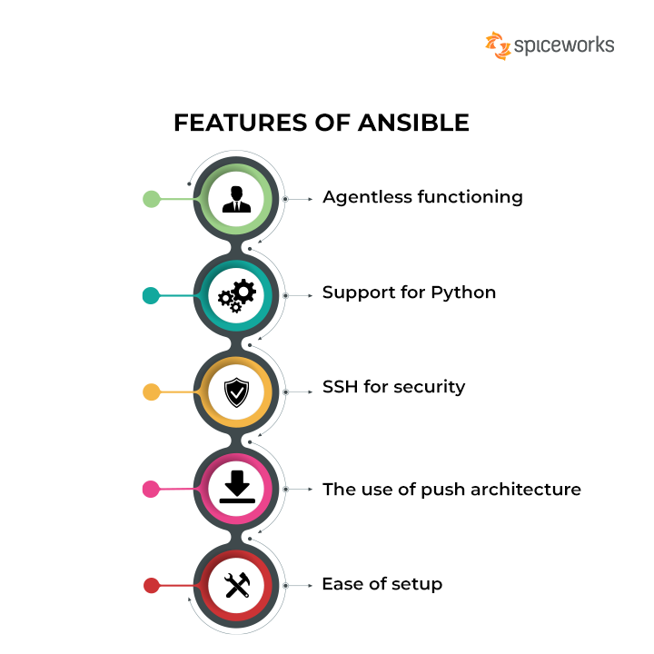

**Features of Ansible**

1. Agentless functioning

Ansible is an agentless system, which means it doesn’t install software on the machines it controls. This eliminates possible faults and [cyber threats](https://www.spiceworks.com/it-security/vulnerability-management/articles/what-is-cyber-threat/) while also conserving server resources. Ansible is responsible for managing all master-agent interactions. It does so by using either standard SSH or the Paramiko module, of which the latter is a Python implementation of SSH2. The tool does not need the installation of agents on remote networks to be controlled, resulting in lower maintenance costs and performance deterioration.

Ansible’s agentless usage is made possible via SSH and Windows Remote Management. This sends micro, auto-generated modules to remote workstations that “self-destruct” instead of running Unix commands. These modules deliver JSON data and specify desirable states and organized procedures.

This highly efficient strategy can repurpose connections and requires very little network traffic because of how activities are carried out. This strategy makes users and the central management server more efficient with their resources and eliminates all the problems that come with agent-based systems. For example, “who will manage the management” is no longer an issue with Ansible. Non-root access and a smaller attack surface are two other features that add to this configuration’s desirability.

2. Support for Python

One may use Ansible in a variety of ways from an API standpoint. You may control nodes using the Ansible Python API, expand Ansible to respond to different Python events, develop plugins, and import inventory information from external data sources. Ansible is built in Python and has a relatively low learning curve.

Ansible has a straightforward installation process that requires no extra software, servers, or client daemons. It is parallel by design and maintains nodes through SSH. Ansible was developed in Python, unlike competing options built in languages like Ruby. As a consequence, setting it up and operating it is easier, as Python libraries come preinstalled on most [Linux PCs](https://www.spiceworks.com/it-security/cyber-risk-management/articles/is-linux-secure/). More programmers and sys admin are likely to be familiar with Python than Ruby. Further, Users may write Ansible modules extending the tool’s capabilities in any language as long as the data is in JSON format.

3. SSH for security

A secure network authentication mechanism that does not require a password. So, it’s up to you to transmit this key to the user. Ansible works by connecting to clients over SSH, eliminating the need for a dedicated client agent, and pushing modules to the clients, which are then performed locally on the client side. The result is delivered back to the Ansible server. Ansible uses the SSH protocol to connect with distant computers. Ansible links to remote computers using native OpenSSH and your current user’s name, much like SSH.

SSH simplifies the entire setup procedure. Client information, such as hostnames, IP addresses, and SSH ports, are saved in inventory files. Ansible may utilize an inventory file once it has been built and filled. You can confirm how you can interact with all inventory nodes over SSH with the identical username. Moreover, if necessary, you can add your public SSH key to the authorized\_keys file on those systems. For running tasks against local Linux systems, Ansible uses SSH. To use Ansible, you must set up the software’s SSH connection so that it can automatically bypass a password request.

4. The use of push architecture

Ansible allows users to jot down all settings and push them to the nodes simultaneously. One can see how efficient it is to make adjustments to thousands of servers in a matter of minutes. Within the context of systems for managing configurations in this manner, the main server sends “or pushes” the configuration to nodes. As a result, communication is initiated by the primary server rather than the nodes. This implies that each node may or may not have an agent/client installed. Ansible is a push-based configuration management solution that does not require the installation of an agent on the nodes.

The central server initiates contact and delivers configuration information to the nodes without requesting it in both circumstances. Because the central server pushes the design to the nodes, you have greater control over which nodes need to be set, the operations are more synchronous, and error management is much easier because you can detect and solve errors immediately.

5. Ease of setup

Playbooks, roles, inventories, and variables files are organized by functions in the setup feature, with tags at the play and task level for further specificity and control. Although this is a robust and adaptable method, there are alternative options for organizing Ansible data. Ansible makes it simple to complete tasks by automating them and eliminating the need for manual deployment. It can configure systems, install software, and organize more complex operations like continuous delivery and zero downtime while rolling out new features, among other things.

After [continuous integration and continuous deployment](https://www.spiceworks.com/tech/devops/articles/what-is-ci-cd/), continuous deployment refers to the software deployment process to a server. Simply install the Ansible package on one system to utilize it from the command line to set up ansible. There’s no need to set up a database or start any daemons. Two machines are required. The first machine is referred the ‘Server’, and it serves as a managed node, while the second is referred to as a ‘Node’, and it serves as a controller node.

**See More:**[**DevOps vs. Agile Methodology: Key Differences and Similarities**](https://www.spiceworks.com/tech/devops/articles/devops-vs-agile/)

Takeaway

Ansible is among the most popular technologies in the DevOps toolchain in 2022. Indeed, OpenLogic’s *2022 State of Open Source Survey*found that Ansible is one of the top five DevOps tools for automation and orchestration, second only to Puppet. Nearly one in four DevOps teams use the technology to automate the delivery of software code, owing to its powerful yet free features. This 2013 launched [DevOps automation](https://www.spiceworks.com/tech/devops/articles/devops-automation-tools/) platform will remain popular worldwide even as new solutions emerge.

***Did this article help you understand what Ansible is and how it works? Tell us on [Facebook](https://www.facebook.com/SpiceworksNews/" \o "Opens a new window" \t "_blank)***[Opens a new window](https://www.facebook.com/SpiceworksNews/" \o "Opens a new window" \t "_blank)***,***[***Twitter***Opens a new window](https://x.com/SpiceworksNews)***, and***[***LinkedIn***Opens a new window](https://www.linkedin.com/company/spiceworksdotcom/)***. We’d love to hear from you!***

**MORE ON DEVOPS**

* [Top 10 CI/CD Tools in 2022](https://www.spiceworks.com/tech/devops/articles/best-cicd-tools/)
* [What Are Microservices? Definition, Examples, Architecture, and Best Practices for 2022](https://www.spiceworks.com/tech/devops/articles/what-are-microservices/)
* [What Is Serverless? Definition, Architecture, Examples, and Applications](https://www.spiceworks.com/tech/devops/articles/what-is-serverless/)
* [Site Reliability Engineer: Job Description, Key Skills, and Salary in 2022](https://www.spiceworks.com/tech/devops/articles/site-reliability-engineer/)
* [What Is DevSecOps? Definition, Pipeline, Framework, and Best Practices for 2022](https://www.spiceworks.com/tech/devops/articles/what-is-devsecops/)

[Automation](https://www.spiceworks.com/tags/automation/) [DevOps](https://www.spiceworks.com/tags/devops/)

**Share This Article:**



**Chiradeep BasuMallick**

Technical Writer

Chiradeep is a content marketing professional, a startup incubator, and a tech journalism specialist. He has over 11 years of experience in mainline advertising, marketing communications, corporate communications, and content marketing. He has worked with a number of global majors and Indian MNCs, and currently manages his content marketing startup based out of Kolkata, India. He writes extensively on areas such as IT, BFSI, healthcare, manufacturing, hospitality, and financial analysis & stock markets. He studied literature, has a degree in public relations and is an independent contributor for several leading publications.



Do you still have questions? Head over to the Spiceworks Community to find answers.  
[Take me to Community](https://community.spiceworks.com/)

**Spiceworks Community**

[Login personal outlook account on outlook 2016](https://community.spiceworks.com/t/login-personal-outlook-account-on-outlook-2016/1246248)

I have office 2016 installed on windows server 2019. A user wants to use outlook.com account on outlook 2016 on the server but I am not s...

[Our team keeps losing tribal knowledge between tickets, how do you solve this?](https://community.spiceworks.com/t/our-team-keeps-losing-tribal-knowledge-between-tickets-how-do-you-solve-this/1246156)

i’m part of a small MSP, and we’re struggling with how scattered our troubleshooting info has become.When an engineer gets a ticket, ...

[Stupid Friday ?'s | 11/21/25](https://community.spiceworks.com/t/stupid-friday-s-11-21-25/1246260)

Hello, and happy Friday everyone! Thanksgiving (US) is coming up so unlikely I will be posting next Friday. I hope everyone has a great h...

[Check out the Community](https://community.spiceworks.com/)

**Table of Contents**

* [What Is Ansible?](https://www.spiceworks.com/tech/devops/articles/what-is-ansible/#_001)
* [What Is Ansible used for?](https://www.spiceworks.com/tech/devops/articles/what-is-ansible/#_002)
* [How Does Ansible Work?](https://www.spiceworks.com/tech/devops/articles/what-is-ansible/#_003)
* [Understanding the Architecture of Ansible](https://www.spiceworks.com/tech/devops/articles/what-is-ansible/#_004)
* [Features of Ansible](https://www.spiceworks.com/tech/devops/articles/what-is-ansible/#_005)

CI/CD with AWS Fargate: My End-to-End DevOps Project Deployment Journey  
  
I recently completed a hands-on project where I built and automated the deployment of a Flask-based web application using:  
🔹 Docker  
🔹 Amazon ECR  
🔹 ECS Fargate (Serverless Containers)  
🔹 Application Load Balancer  
🔹 Jenkins CI/CD Pipeline  
🔹 GitHub Webhook  
  
💡 What I Built  
I created a full CI/CD pipeline that automatically:  
1️⃣ Triggers when code is pushed to GitHub  
2️⃣ Builds a Docker image using Jenkins  
3️⃣ Pushes the image to Amazon ECR  
4️⃣ Registers a new ECS Task Definition  
5️⃣ Automatically updates ECS Fargate Service  
6️⃣ Deploys app behind an ALB for public access  
7️⃣ Ensures zero-downtime rollout using services-stable wait  
  
🧠 What I Learned  
✔ Real DevOps pipeline implementation  
✔ AWS ECS vs Fargate — when, why, how  
✔ Jenkinsfile automation (Pipeline as Code)  
✔ Task Definition revisions in ECS  
✔ ALB configuration, networking, IAM, CI/CD best practices  
✔ Deploying containers without managing servers (Thank you Fargate!)  
  
📌 Why I’m Sharing This  
I strongly believe that projects like this are the best way to learn DevOps, because they combine:  
🌐 Cloud  
🐳 Containers  
⚙ Automation  
🚀 CI/CD  
🔐 Security  
📈 Scalability  
If you're learning AWS, DevOps, or Cloud Engineering — this is a perfect beginner-to-intermediate project to build and showcase!  
  
📄 I've uploaded my detailed project documentation + diagrams, including:  
✔ AWS architecture  
✔ Jenkinsfile  
✔ Deployment flow  
✔ Screenshots & explanations  
✔ Resume / portfolio-friendly summary  
👉 Feel free to download, study, and even recreate it yourself!  
[📎 Upload your project document / PDF here]  
  
🙌 Let’s Connect & Learn Together  
If you’d like help in doing this project, or want to learn DevOps hands-on —  
💬 Comment “Guide me” or DM me — I’ll be happy to help.  
Let’s grow together in our Cloud & DevOps journey 🚀  
  
[**#DevOps**](https://www.linkedin.com/search/results/all/?keywords=%23devops&origin=HASH_TAG_FROM_FEED) [**#AWS**](https://www.linkedin.com/search/results/all/?keywords=%23aws&origin=HASH_TAG_FROM_FEED) [**#Fargate**](https://www.linkedin.com/search/results/all/?keywords=%23fargate&origin=HASH_TAG_FROM_FEED) [**#Jenkins**](https://www.linkedin.com/search/results/all/?keywords=%23jenkins&origin=HASH_TAG_FROM_FEED) [**#ECR**](https://www.linkedin.com/search/results/all/?keywords=%23ecr&origin=HASH_TAG_FROM_FEED) [**#ECS**](https://www.linkedin.com/search/results/all/?keywords=%23ecs&origin=HASH_TAG_FROM_FEED) [**#Docker**](https://www.linkedin.com/search/results/all/?keywords=%23docker&origin=HASH_TAG_FROM_FEED) [**#CloudComputing**](https://www.linkedin.com/search/results/all/?keywords=%23cloudcomputing&origin=HASH_TAG_FROM_FEED) [**#CI**](https://www.linkedin.com/search/results/all/?keywords=%23ci&origin=HASH_TAG_FROM_FEED)/CD [**#Flask**](https://www.linkedin.com/search/results/all/?keywords=%23flask&origin=HASH_TAG_FROM_FEED) [**#Projects**](https://www.linkedin.com/search/results/all/?keywords=%23projects&origin=HASH_TAG_FROM_FEED) [**#LearningByDoing**](https://www.linkedin.com/search/results/all/?keywords=%23learningbydoing&origin=HASH_TAG_FROM_FEED) [**#HandsOn**](https://www.linkedin.com/search/results/all/?keywords=%23handson&origin=HASH_TAG_FROM_FEED) [**#ContainerOrchestration**](https://www.linkedin.com/search/results/all/?keywords=%23containerorchestration&origin=HASH_TAG_FROM_FEED) [**#webhook**](https://www.linkedin.com/search/results/all/?keywords=%23webhook&origin=HASH_TAG_FROM_FEED) [**#Repository**](https://www.linkedin.com/search/results/all/?keywords=%23repository&origin=HASH_TAG_FROM_FEED) [**#GitHub**](https://www.linkedin.com/search/results/all/?keywords=%23github&origin=HASH_TAG_FROM_FEED) [**#Declarative**](https://www.linkedin.com/search/results/all/?keywords=%23declarative&origin=HASH_TAG_FROM_FEED) [**#ALB**](https://www.linkedin.com/search/results/all/?keywords=%23alb&origin=HASH_TAG_FROM_FEED) [**#Task**](https://www.linkedin.com/search/results/all/?keywords=%23task&origin=HASH_TAG_FROM_FEED) [**#Serverless**](https://www.linkedin.com/search/results/all/?keywords=%23serverless&origin=HASH_TAG_FROM_FEED) | [**Pavan GT**](https://www.linkedin.com/in/pavan-cloud-gt/)

 Enhanced Monitoring & Performance Insights at Scale  
Excited to share that I have successfully implemented Prometheus and Grafana for monitoring all our EC2 servers — consolidated into a single, centralized dashboard through our own self-hosted setup.  
  
This upgrade has transformed the way we track and maintain our infrastructure:  
  
✨ Key Outcomes  
📊 Real-time visibility into system performance (CPU, RAM, Disk, Network)  
🔎 Faster and more efficient troubleshooting & incident response  
🚨 Smart alerting for proactive issue detection  
📈 Historical trends to support capacity planning and cost optimization  
🔐 Fully controlled, secure internal monitoring environment  
  
🛠️ Tech Stack  
Prometheus for metrics collection  
Grafana for dynamic visualization  
Node Exporters for EC2 telemetry  
  
This implementation already helps our team monitor resource utilization more effectively and make data-driven decisions — especially around performance tuning and AWS cost optimization.  
  
Looking forward to building more automation and observability enhancements in the upcoming weeks! 💡  
  
#DevOps #AWS #Grafana #Prometheus #Observability #Monitoring #Infrastructure #EC2 #CloudEngineering #SRE #Automation #CostOptimization